**Cyber Security**

**(CSL 422)**

**Lab Workbook**



Faculty name: Dr. Anand Sehgal Student Name: Piyush Gambhir

Roll No.: 21CSU349

Semester: Semester IV

Group: AL-3 (AIML-B)

**Department of Computer Science and Engineering**

**NorthCap University, Gurugram- 122001, India**

**Session 2022-23**

**INDEX**

|  |  |  |  |  |  |  |  |
| --- | --- | --- | --- | --- | --- | --- | --- |
| **S.No** | **Experiment** | **Page No.** | **Date of Experiment** | **Date of Submission** | **Marks** | **CO Covered** | **Sign** |
| **1** | Perform reconnaissance to find all the relevant information on selected websites using 10 network information gathering tools. |  |  |  |  |  |  |
| **2** | Gather information using Social Networking sites and google Dorks |  |  |  |  |  |  |
| **3** | Perform Network Scanning using NMAP and ZENMAP |  |  |  |  |  |  |
| **4** | Use Nessus tool to find all the vulnerabilities with its level and generate a report for an organization |  |  |  |  |  |  |
| **5** | Install Wireshark and apply filters to gather different information  Perform Session hijacking/ find credentials of unsecure real time website using Wireshark |  |  |  |  |  |  |
| **6** | Create Trojan and Exploit victim’s machine by taking its complete access |  |  |  |  |  |  |
| **7** | Track keystrokes of victim machine using Keylogger |  |  |  |  |  |  |
| **8** | Execute basic commands of Linux. Use CHMOD command to change the privileges and permissions  Generate Word list from using wordlist generator ZAP |  |  |  |  |  |  |
| **9** | Perform Windows Login Bypass in virtual machine |  |  |  |  |  |  |
| **10** | Perform Kali Linux Login Bypass in virtual machine |  |  |  |  |  |  |
| **11** | Exploit windows to gain access of victim’s machine using Metasploit framework |  |  |  |  |  |  |
| **12** | Exploit Windows 7 using Metasploit |  |  |  |  |  |  |

**EXPERIMENT NO. 1**

|  |
| --- |
| **Student Name and Roll Number:** Piyush Gambhir – 21CSU349 |
| **Semester /Section:** Semester-IV – AIML-B (AL-3) |
| **Link to Code:** |
| **Date:** |
| **Faculty Signature:** |
| **Marks:** |

|  |
| --- |
| **Objective(s):**  To familiarize the students with the first phase of Penetration Testing. |
| **Outcome:**  The students will understand which type of passive information can be gathered to exploit the target machine |
| **Problem Statement:**  Perform reconnaissance to find all the relevant information on selected website using 10 information gathering tools.(Including 4 Kali Linux Tools) |
| **Background Study:**   * OSINT gathering is an important first step in penetration testing. * Gathering as much intelligence on your organization and the potential targets for exploit. * Clear understanding of the client’s systems and operations before you begin exploiting. * How a target works and its potential vulnerabilities. |
| **Question Bank:**   1. In which topology there is a central controller or hub?   The topology in which there is a central controller or hub is the Star topology.   1. Which topology covers security, robust and eliminating traffic factor?   The Mesh topology covers security and robustness, as it provides multiple paths for data to travel between devices, ensuring that if one path is blocked or damaged, the data can still reach its destination. Additionally, because data is not forced to travel through a central hub, it can eliminate traffic bottlenecks.   1. Video streaming is done through which protocol??   Video streaming can be done through a variety of protocols, such as HTTP, RTMP, or HLS, depending on the specific application and requirements.   1. Which command is used to find the IP address of your system?   The command used to find the IP address of your system depends on the operating system. On Windows, you can use the command "ipconfig" in the Command Prompt. On macOS or Linux, you can use the command "ifconfig" in the Terminal.   1. Why are systems vulnerable?   Systems are vulnerable for a variety of reasons, including:   1. Outdated software that contains known security vulnerabilities 2. Weak passwords or authentication mechanisms 3. Lack of proper security controls, such as firewalls or intrusion detection systems 4. Social engineering attacks, such as phishing or spear-phishing, which can trick users into revealing sensitive 5. information 6. Malware infections, which can be introduced through email attachments, malicious websites, or other means. |

**Student Work Area**

**Algorithm/Flowchart/Code/Sample Outputs**

**IP2LOCATION**

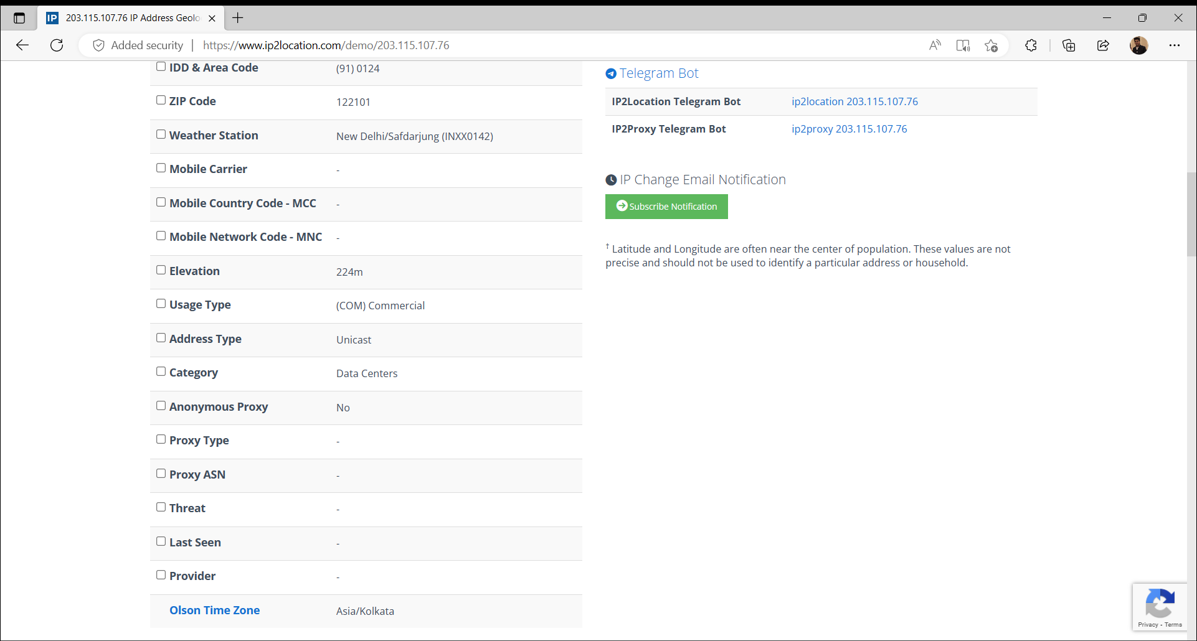

**MXLOOKUP**

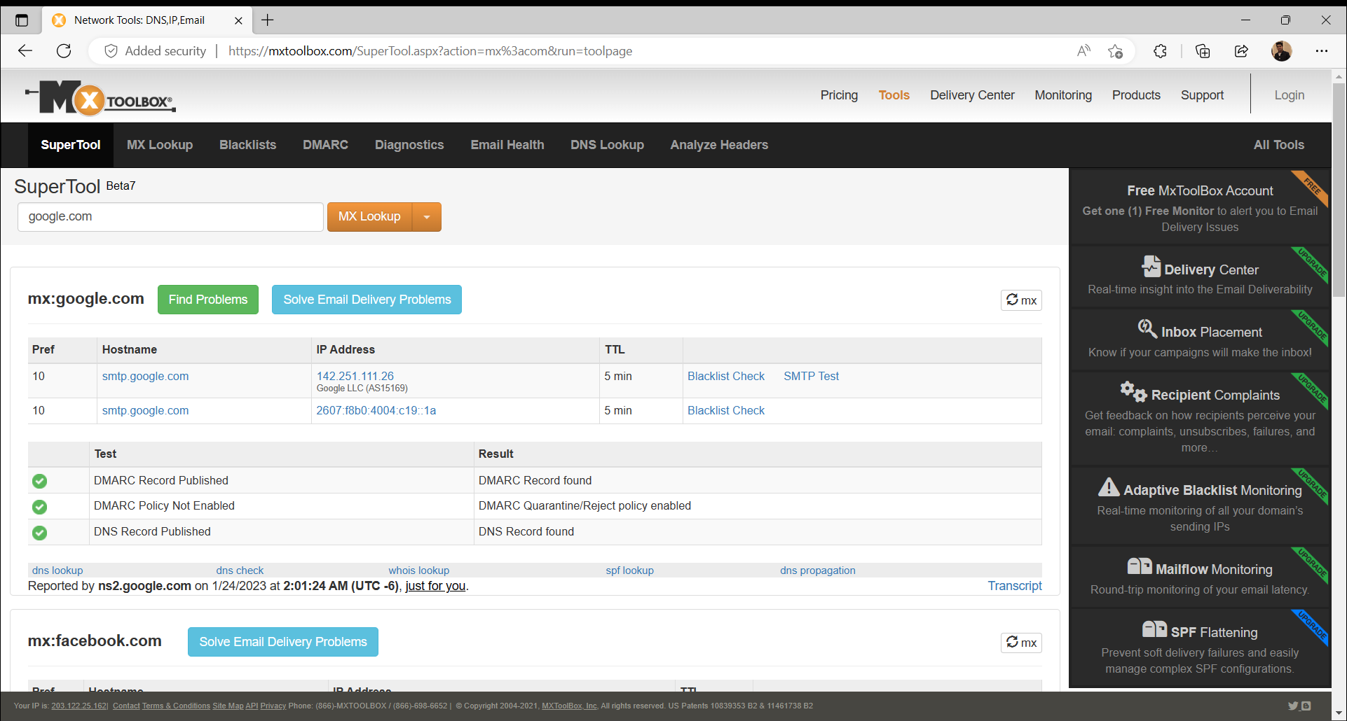

**NETCRAFT**

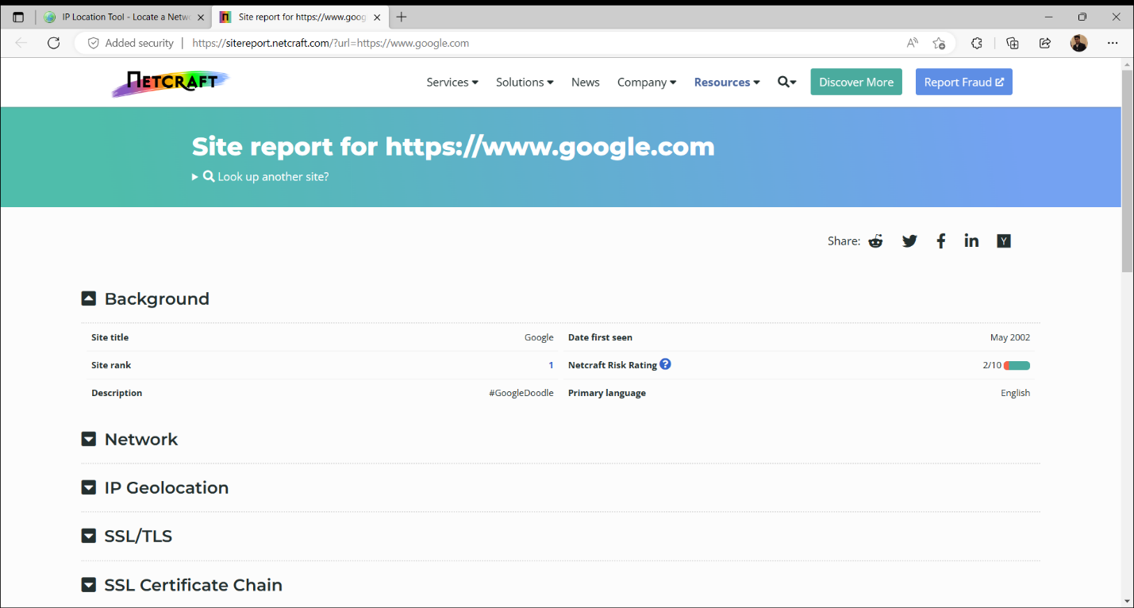

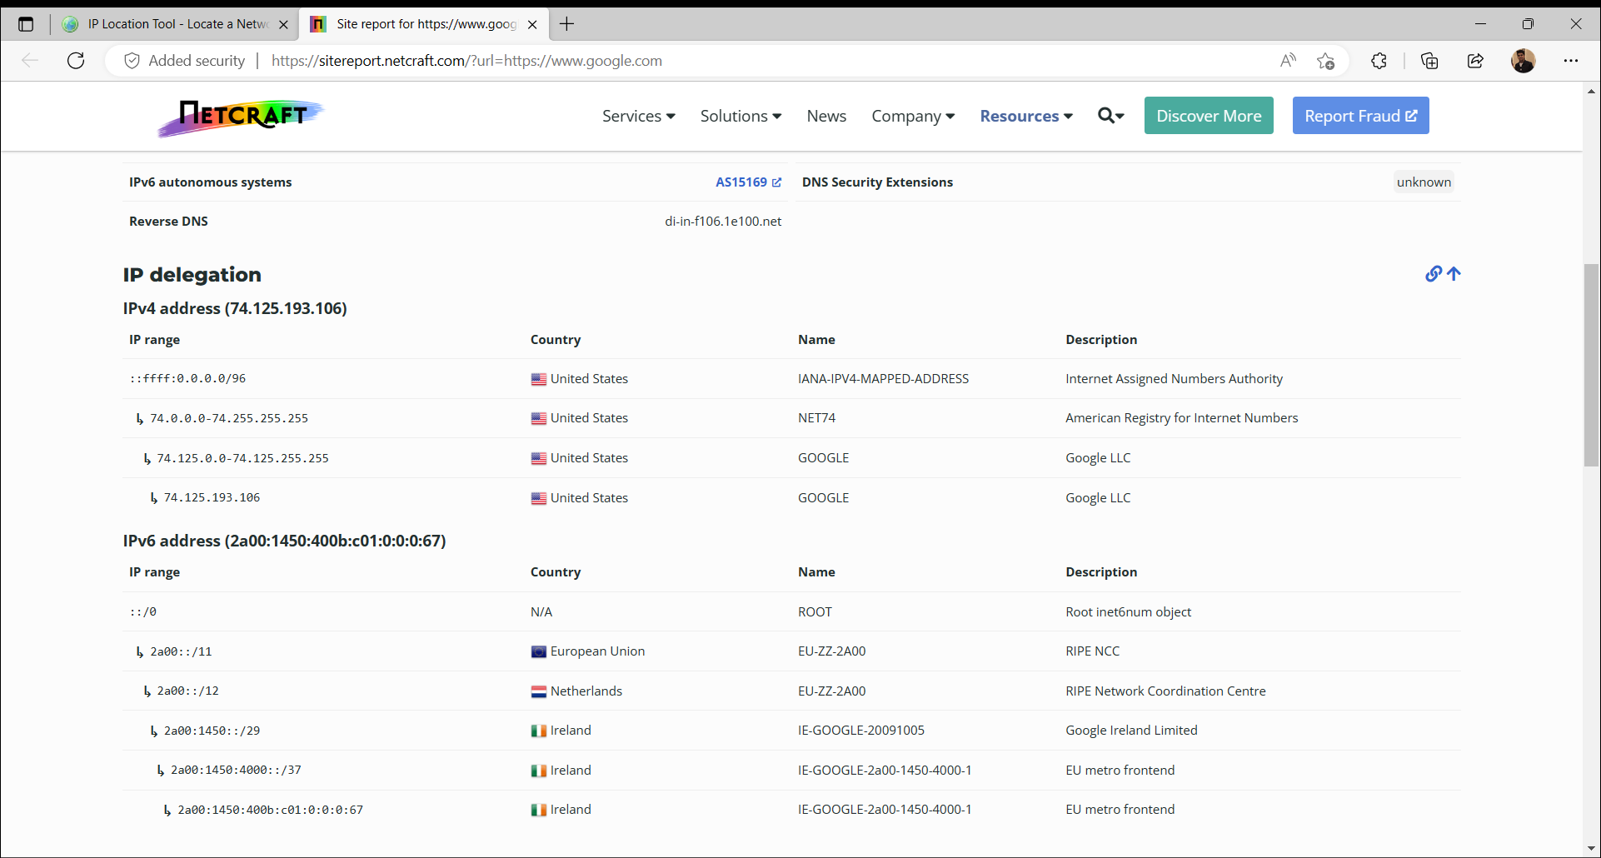

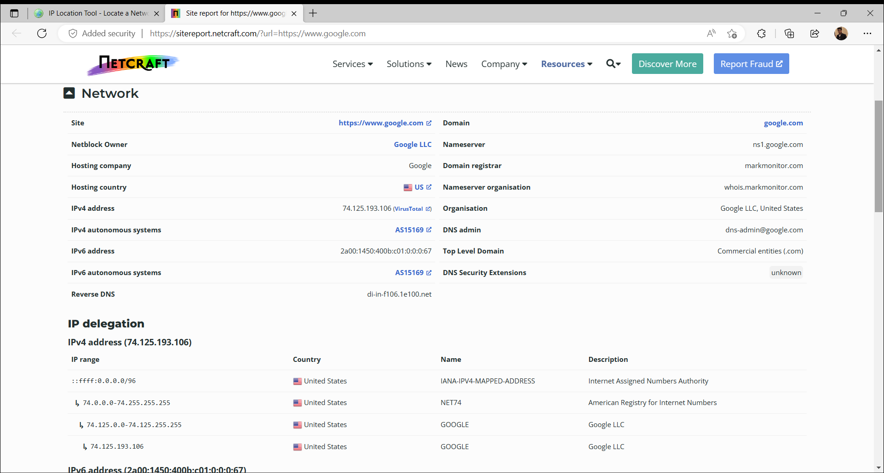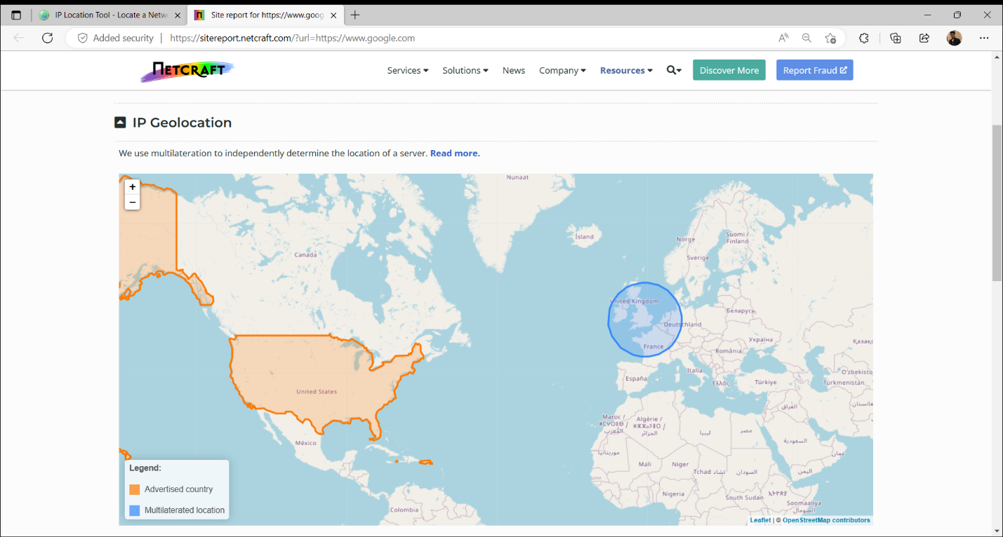

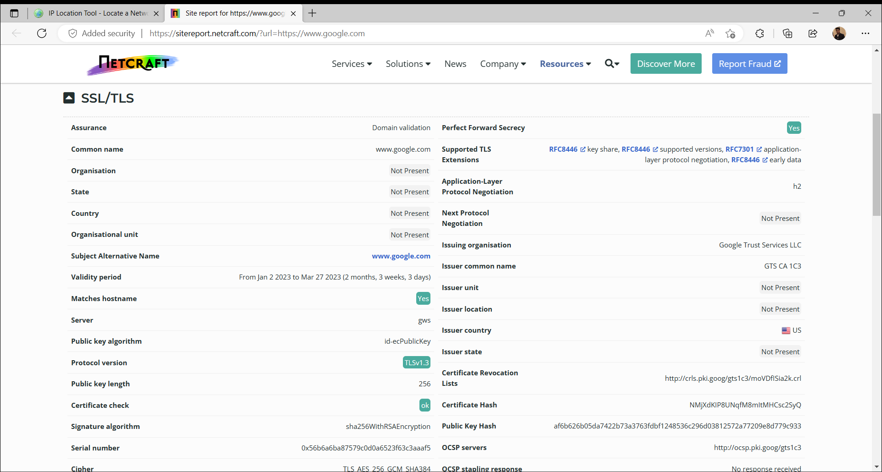



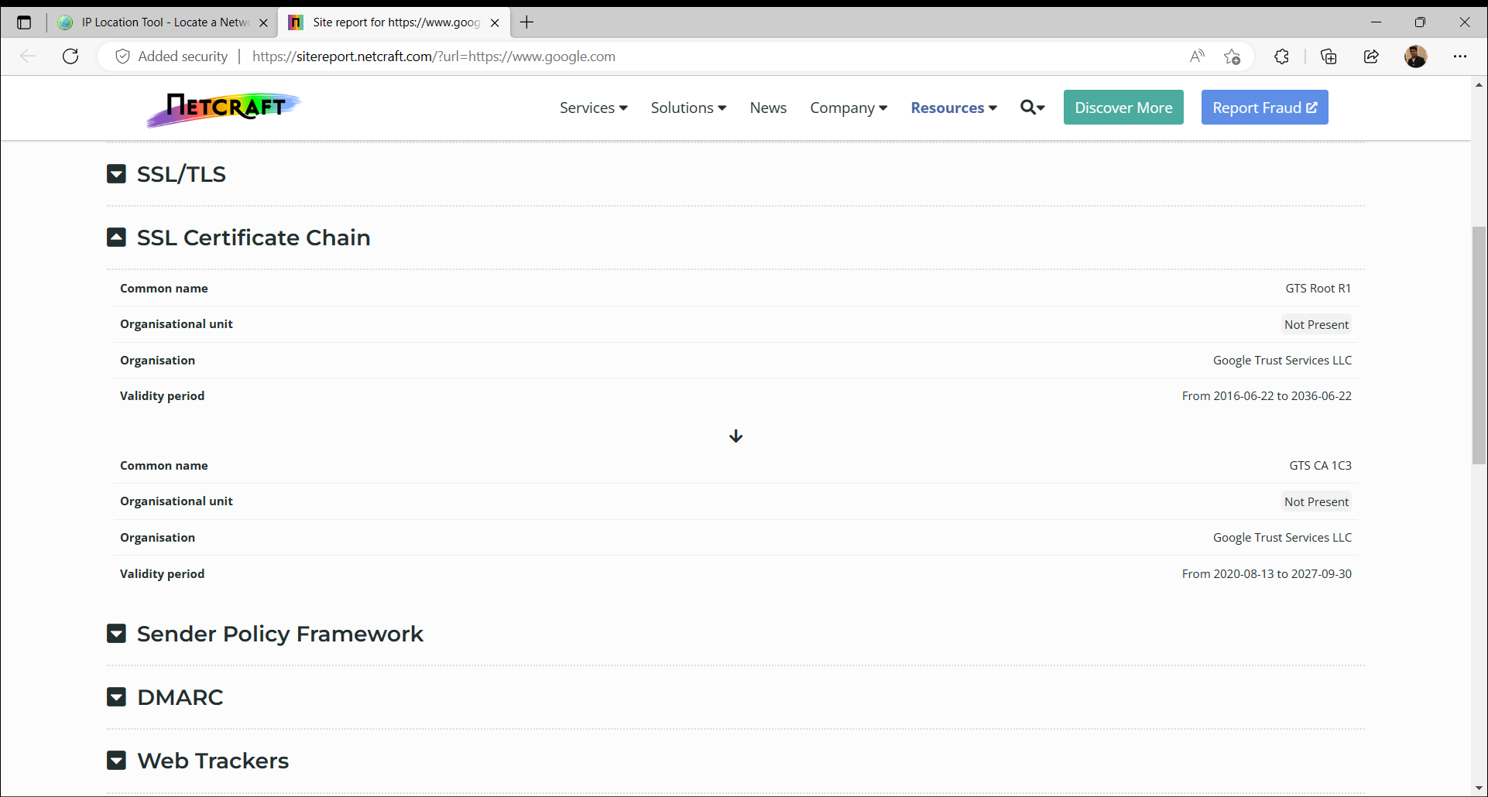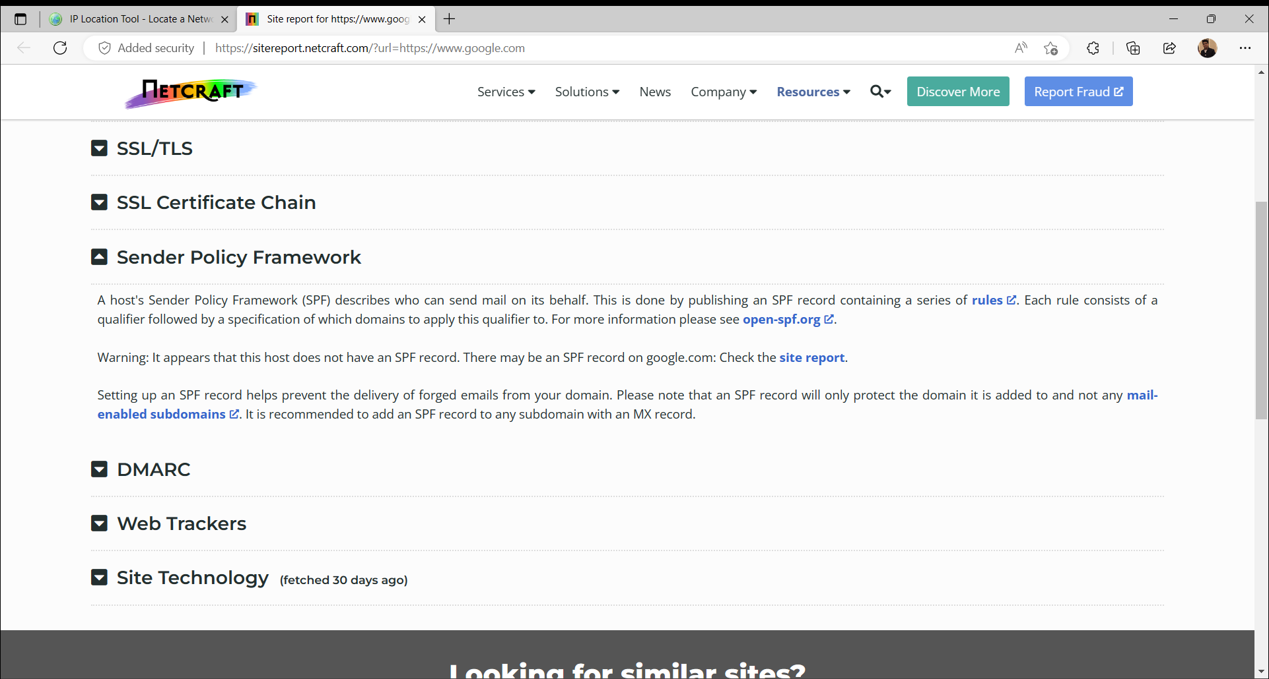

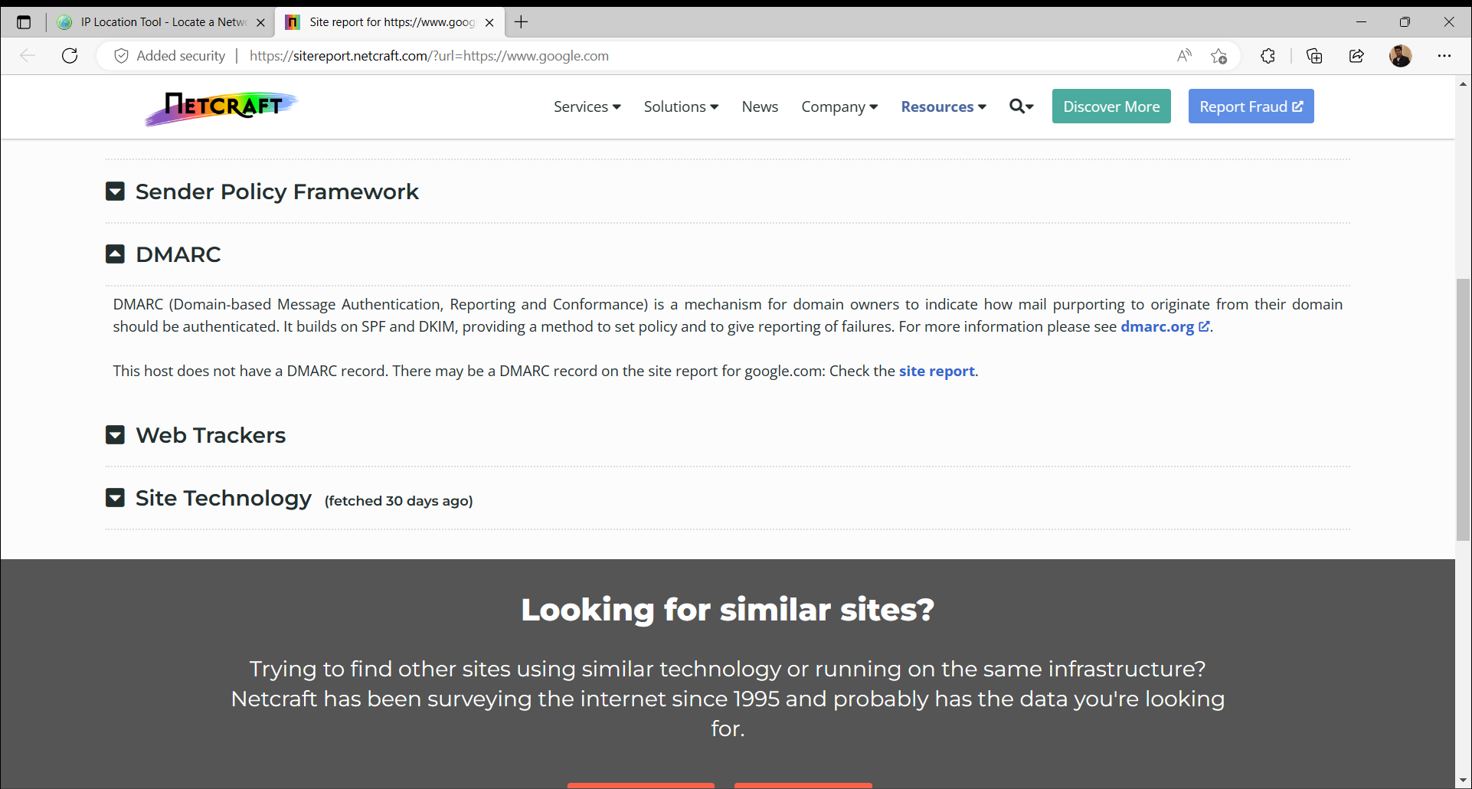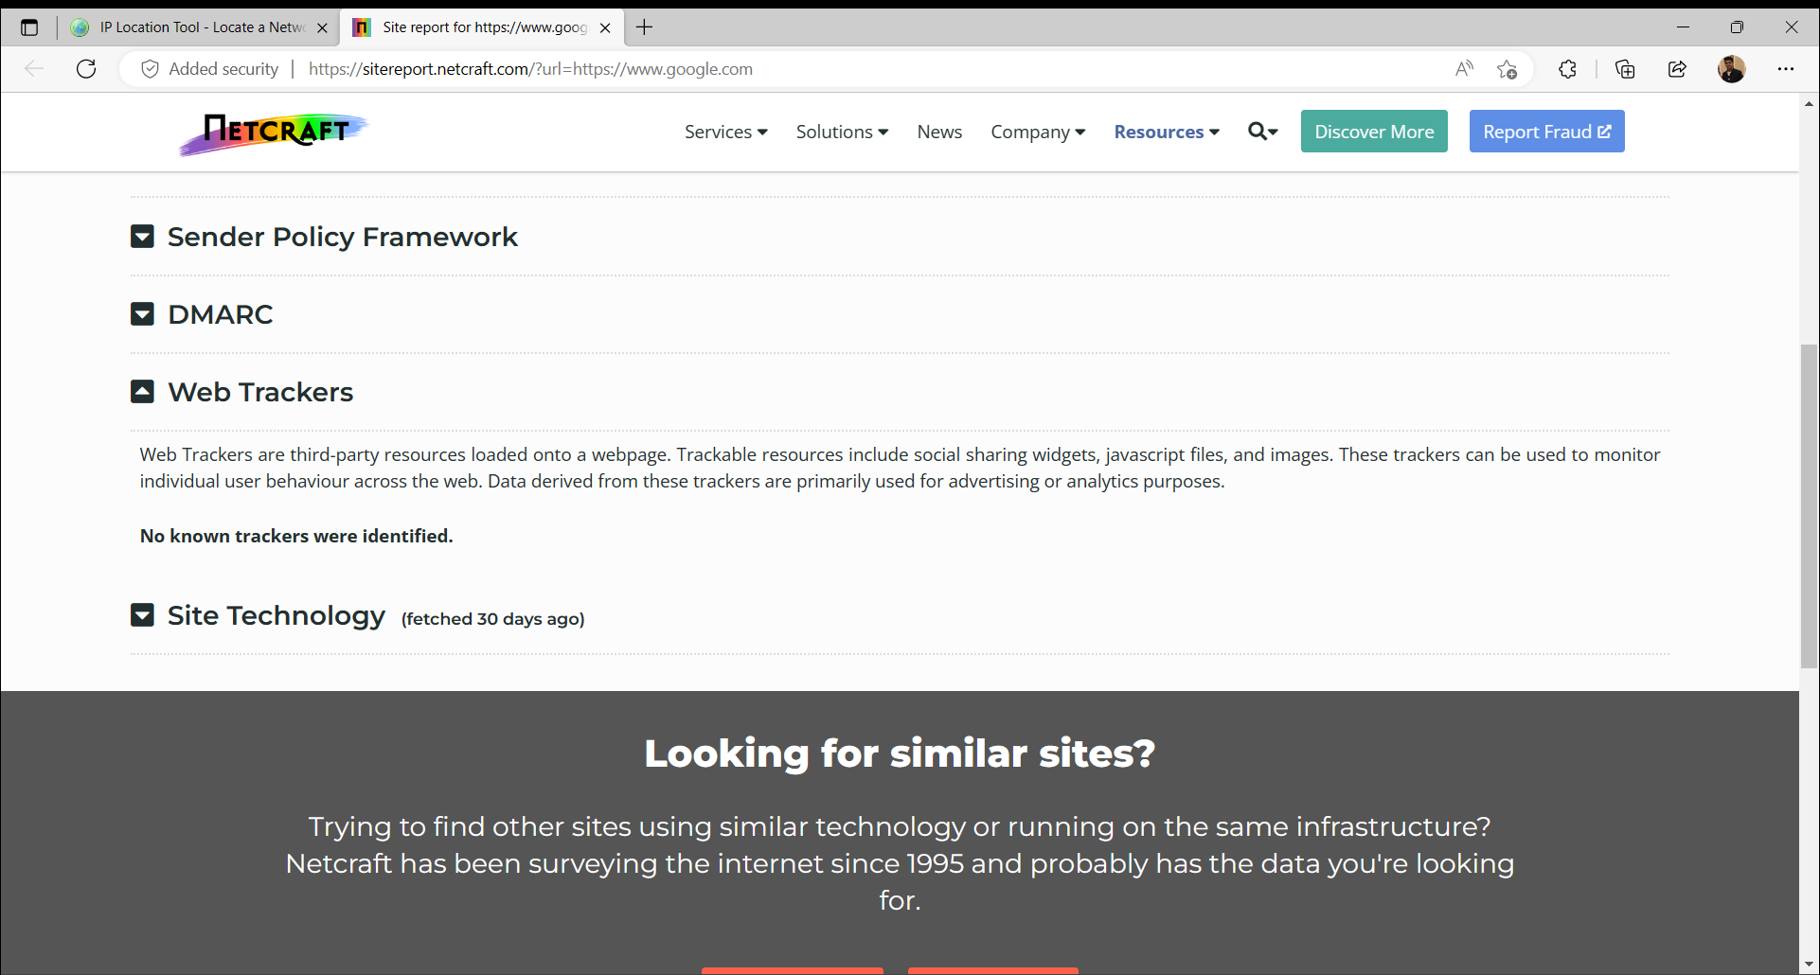

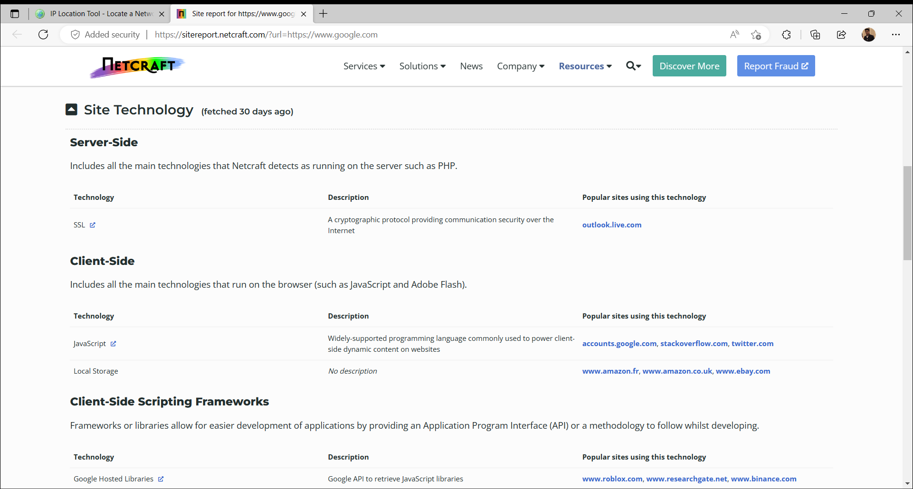

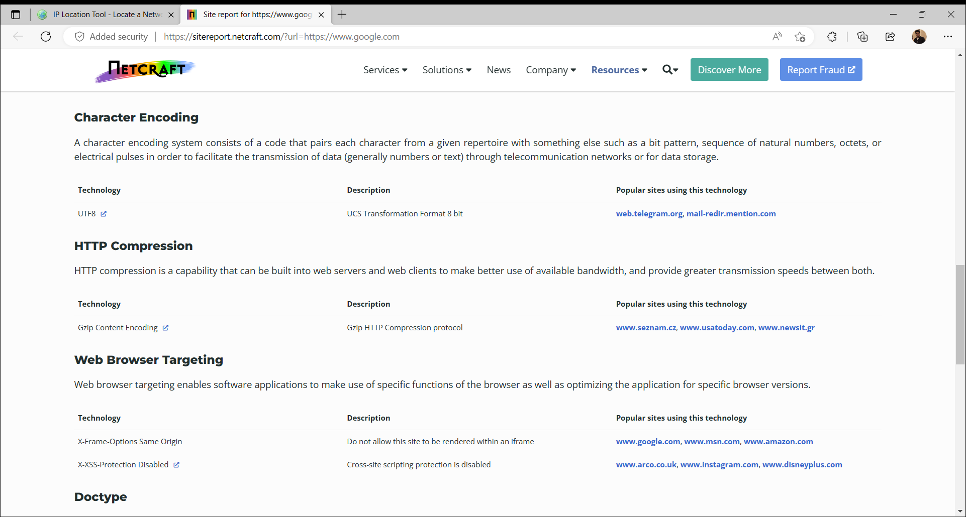

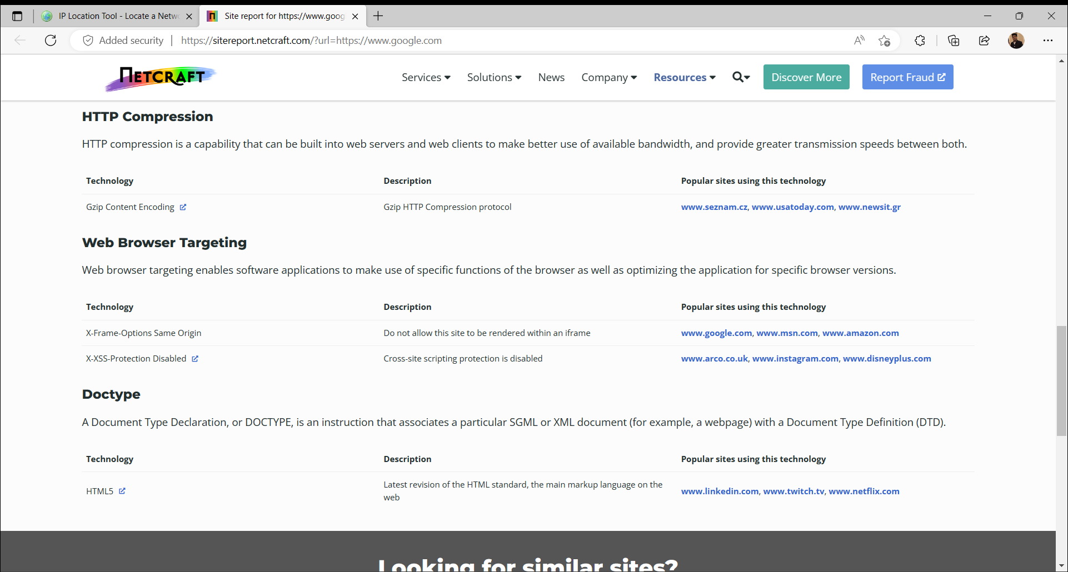

**YOUGETSIGNAL**

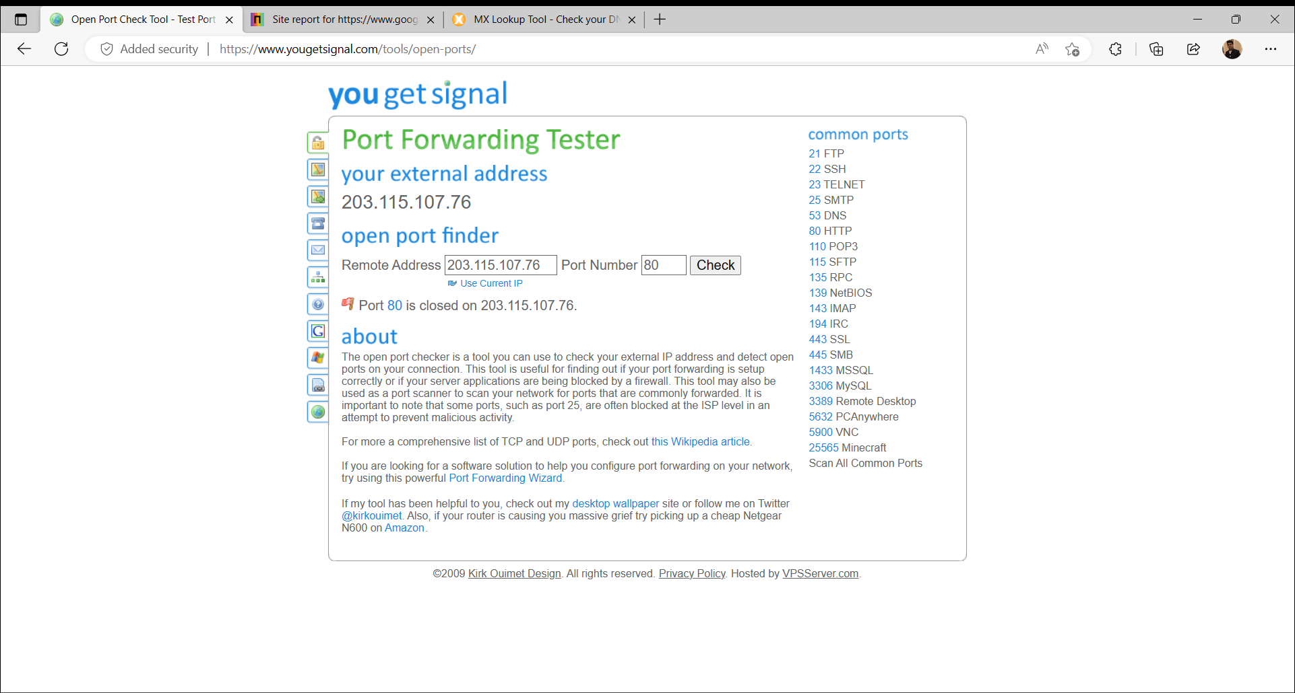

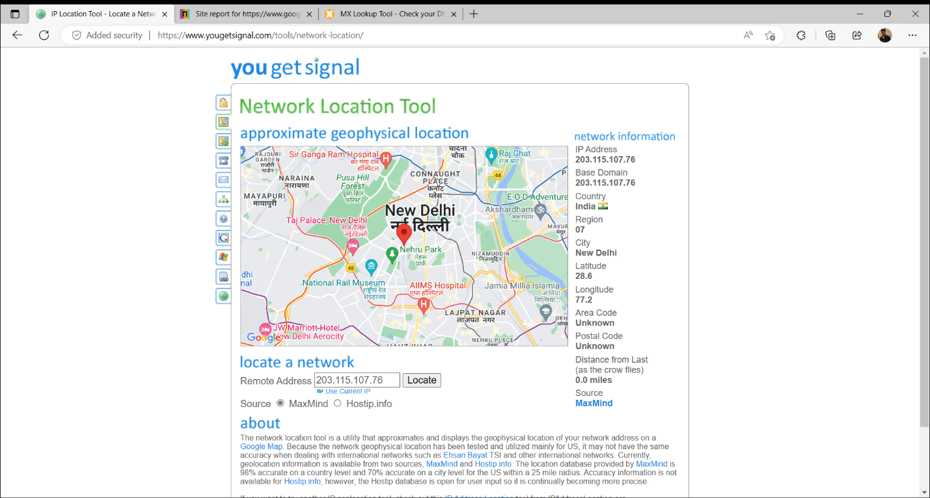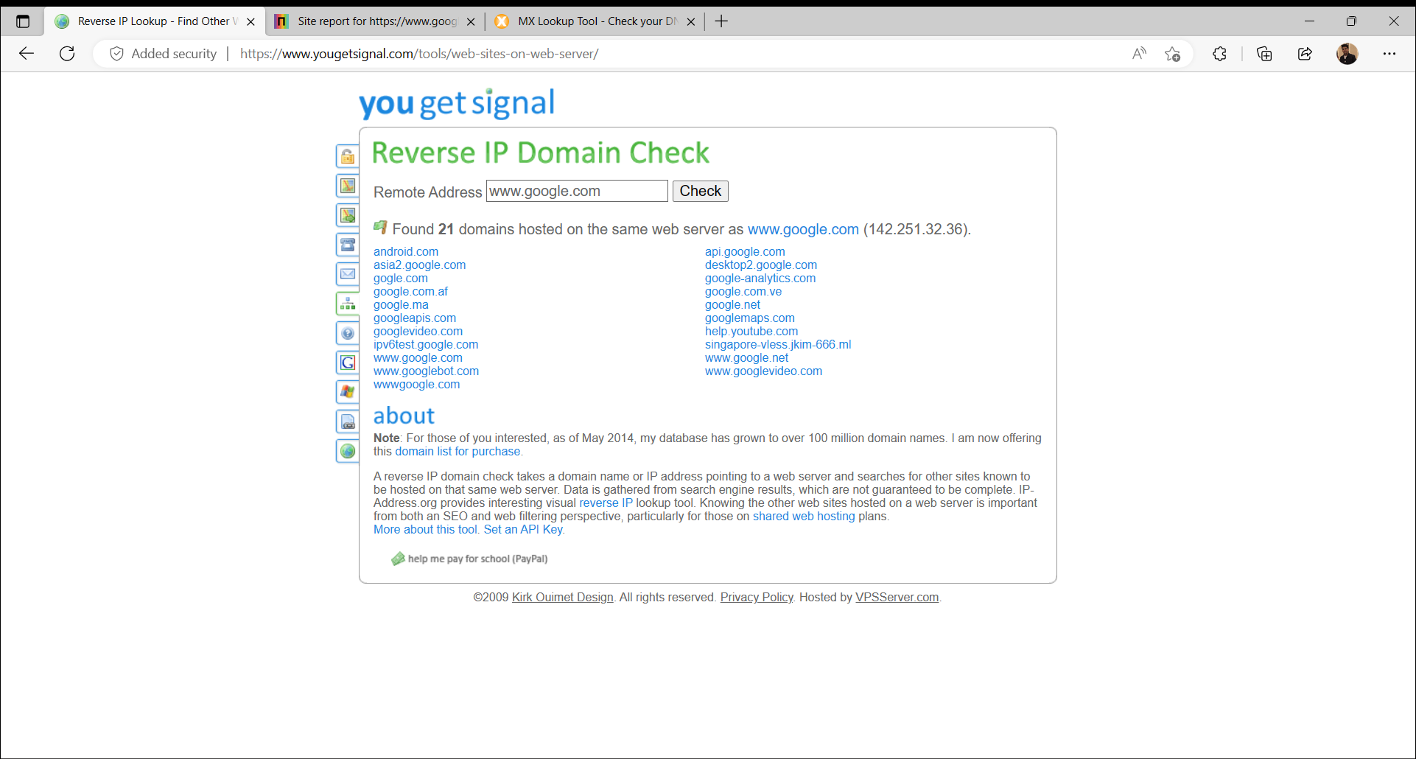

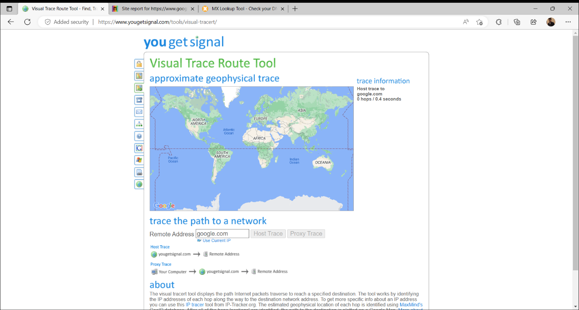

**WAPPALYZER**

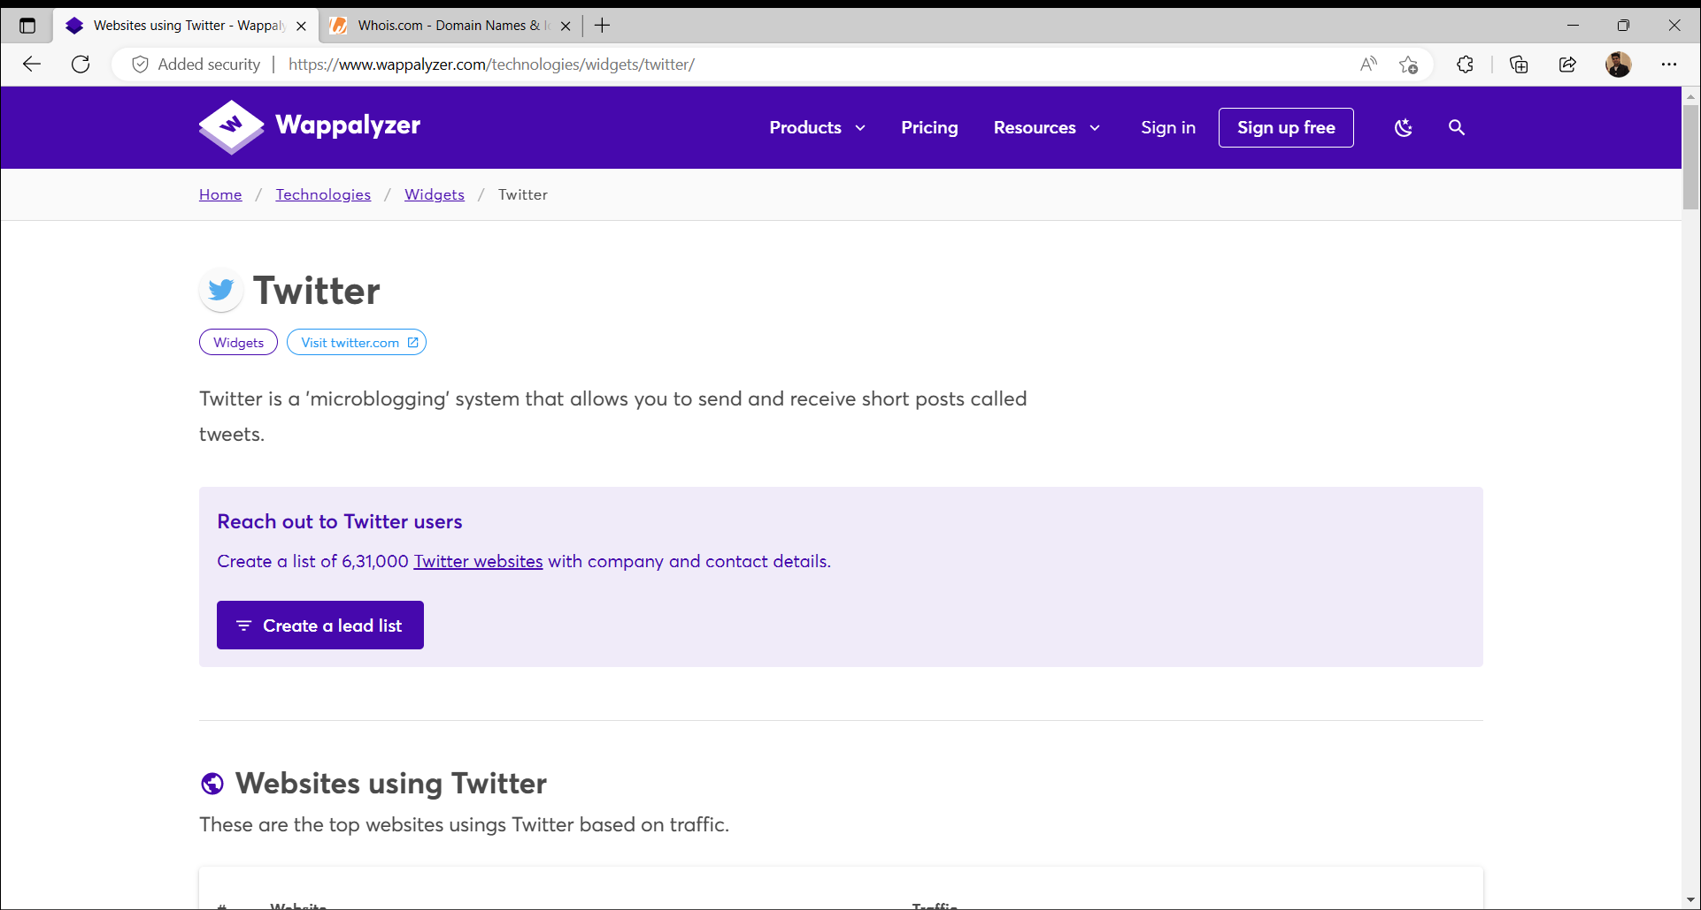

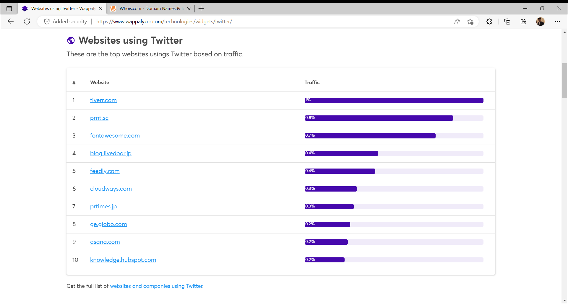

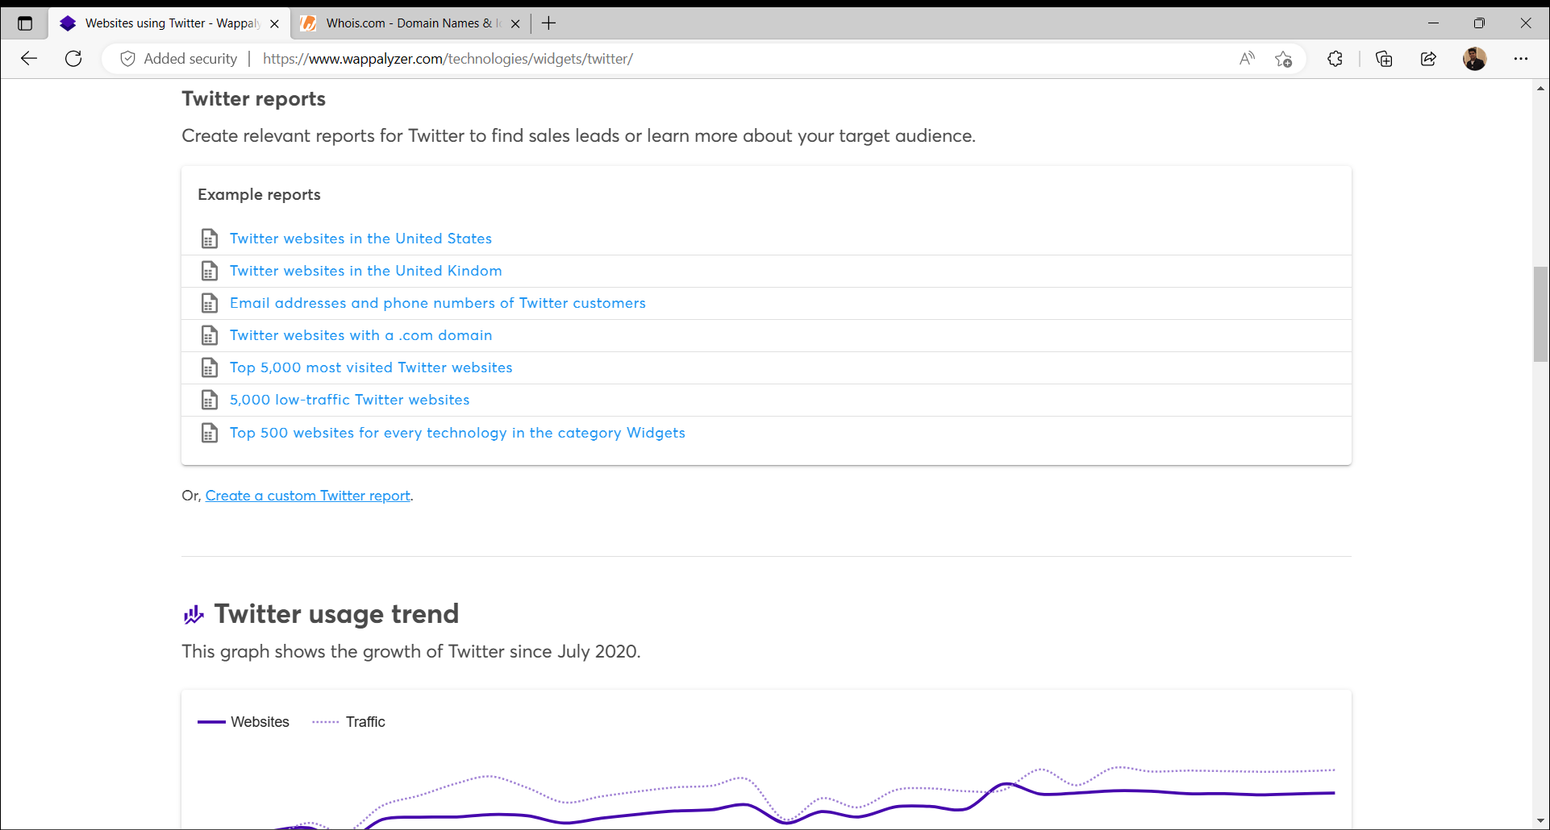

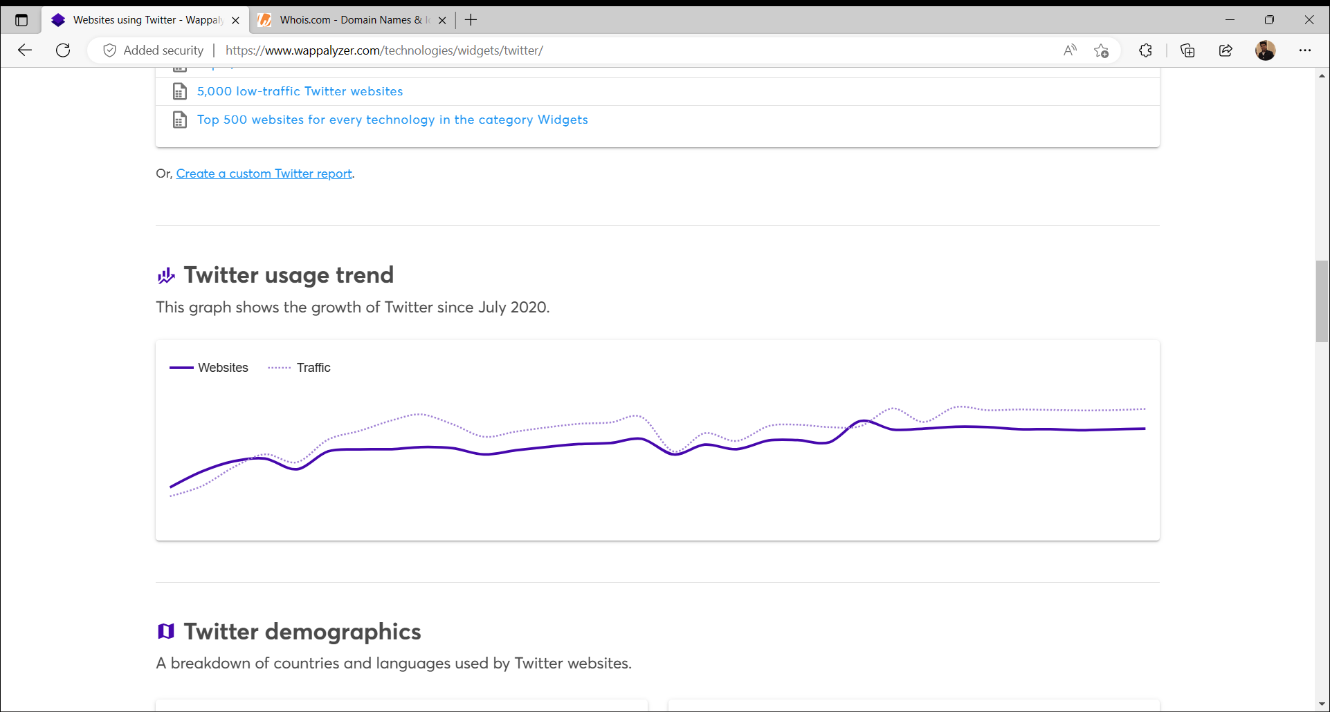

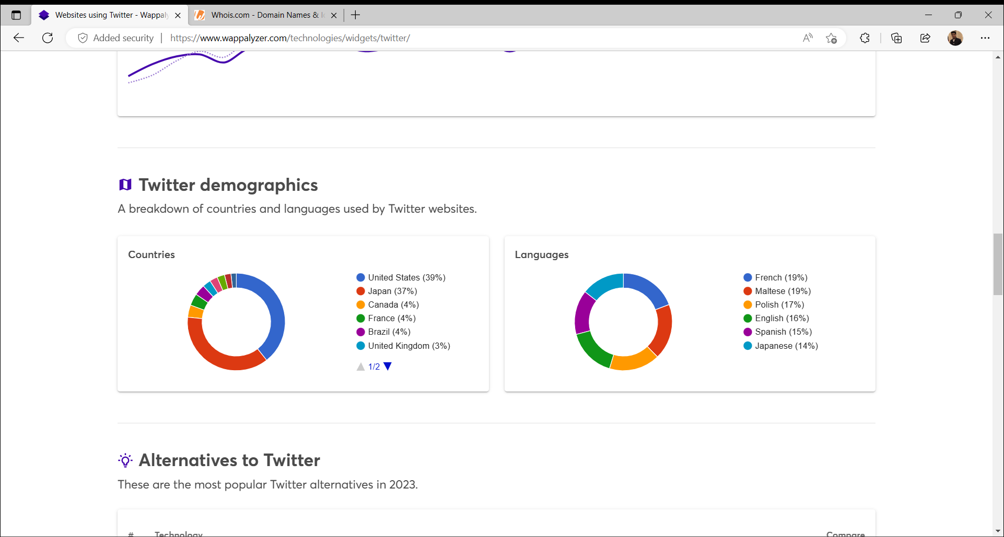

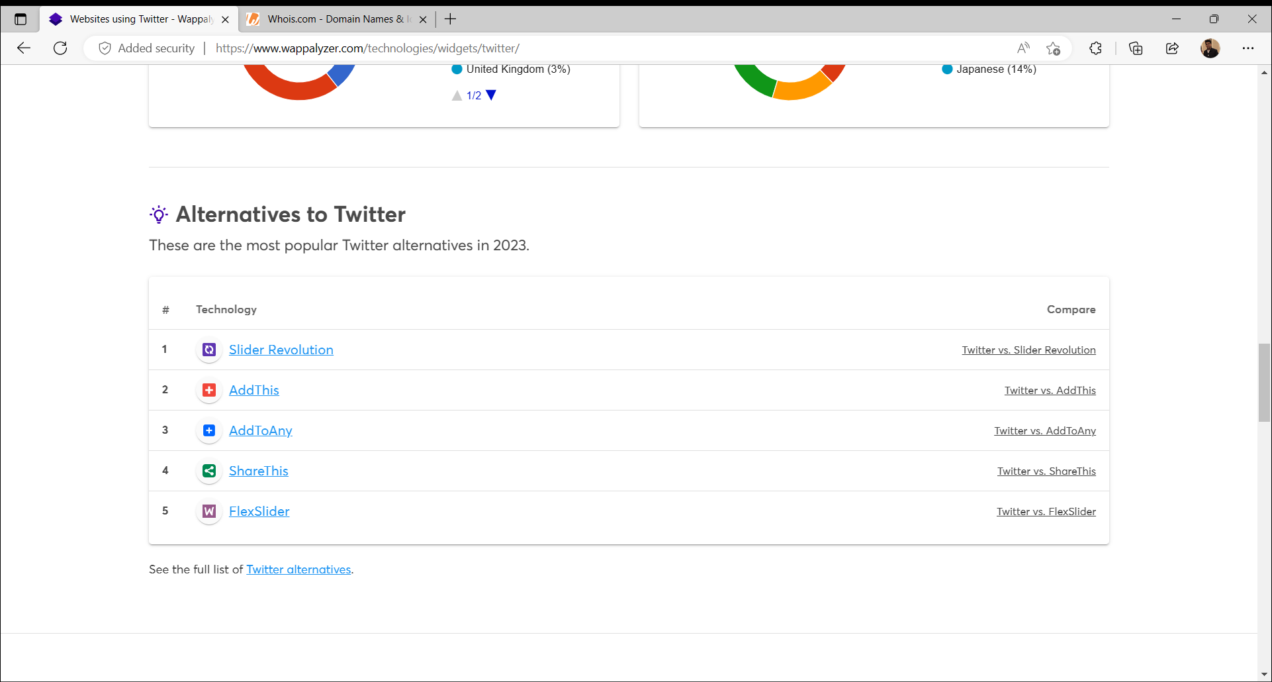

**WHOIS**

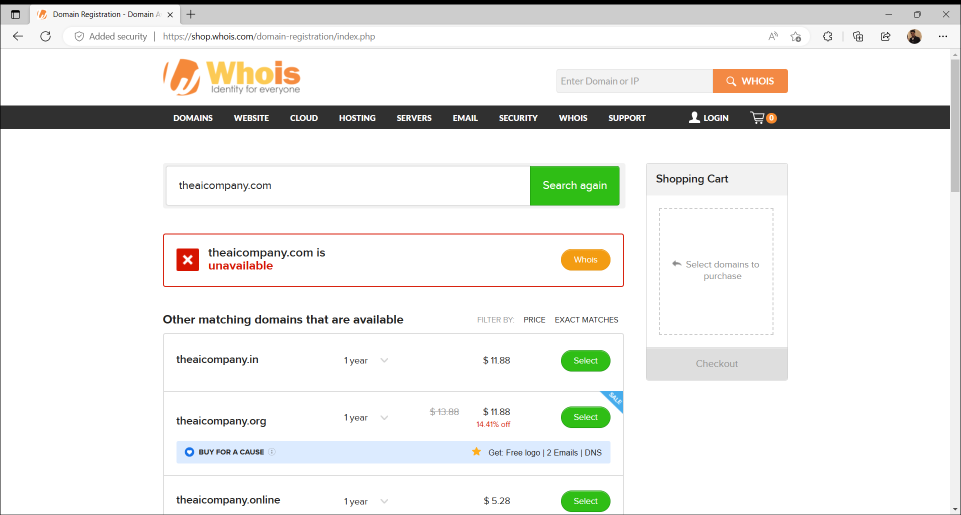

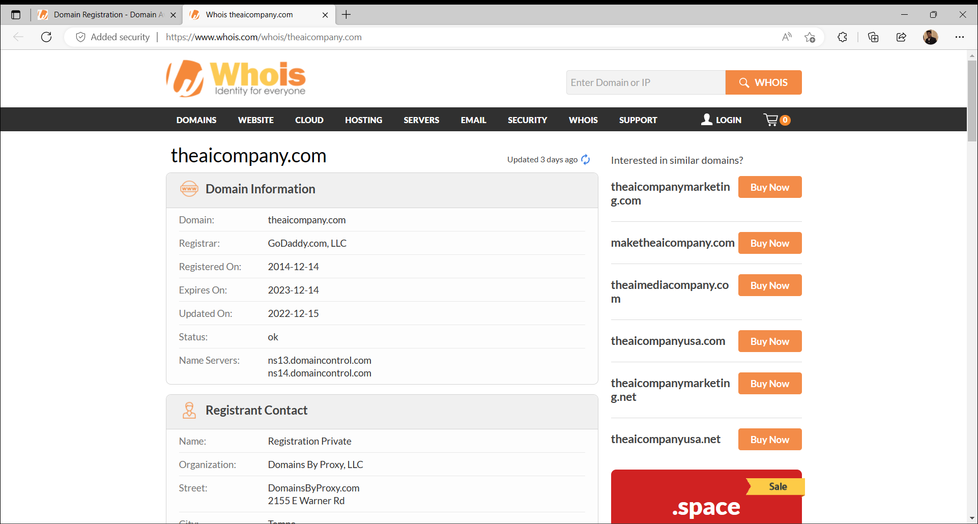

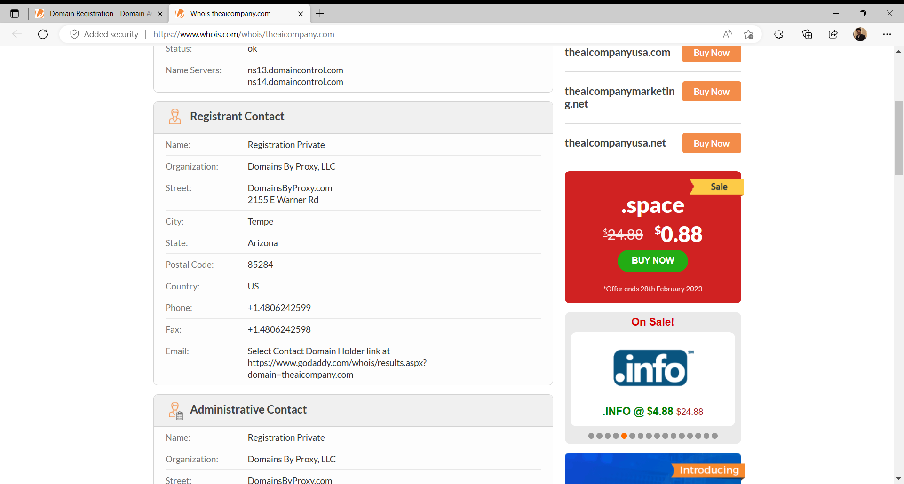

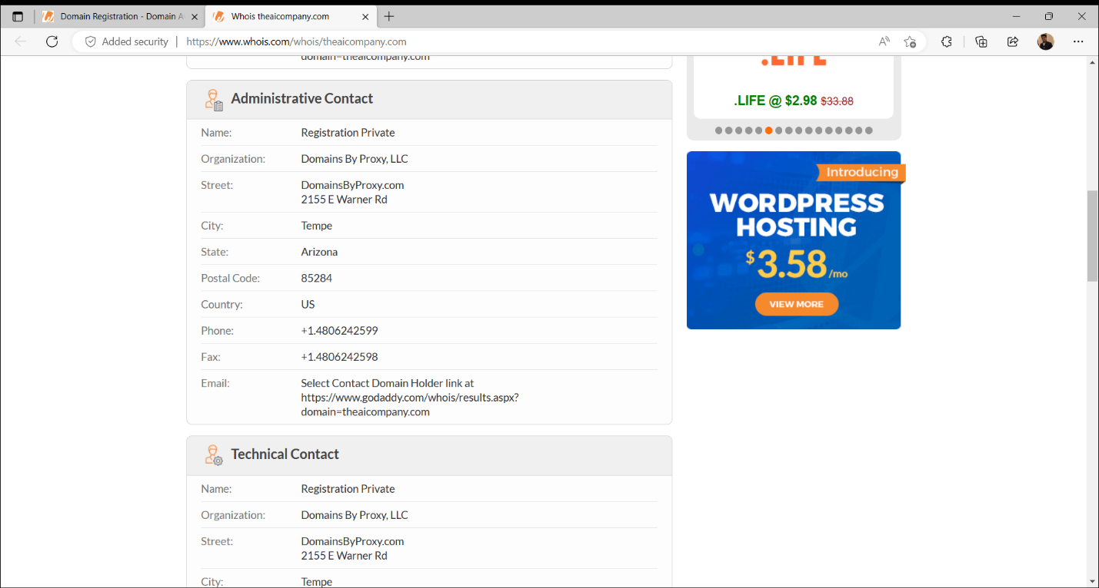

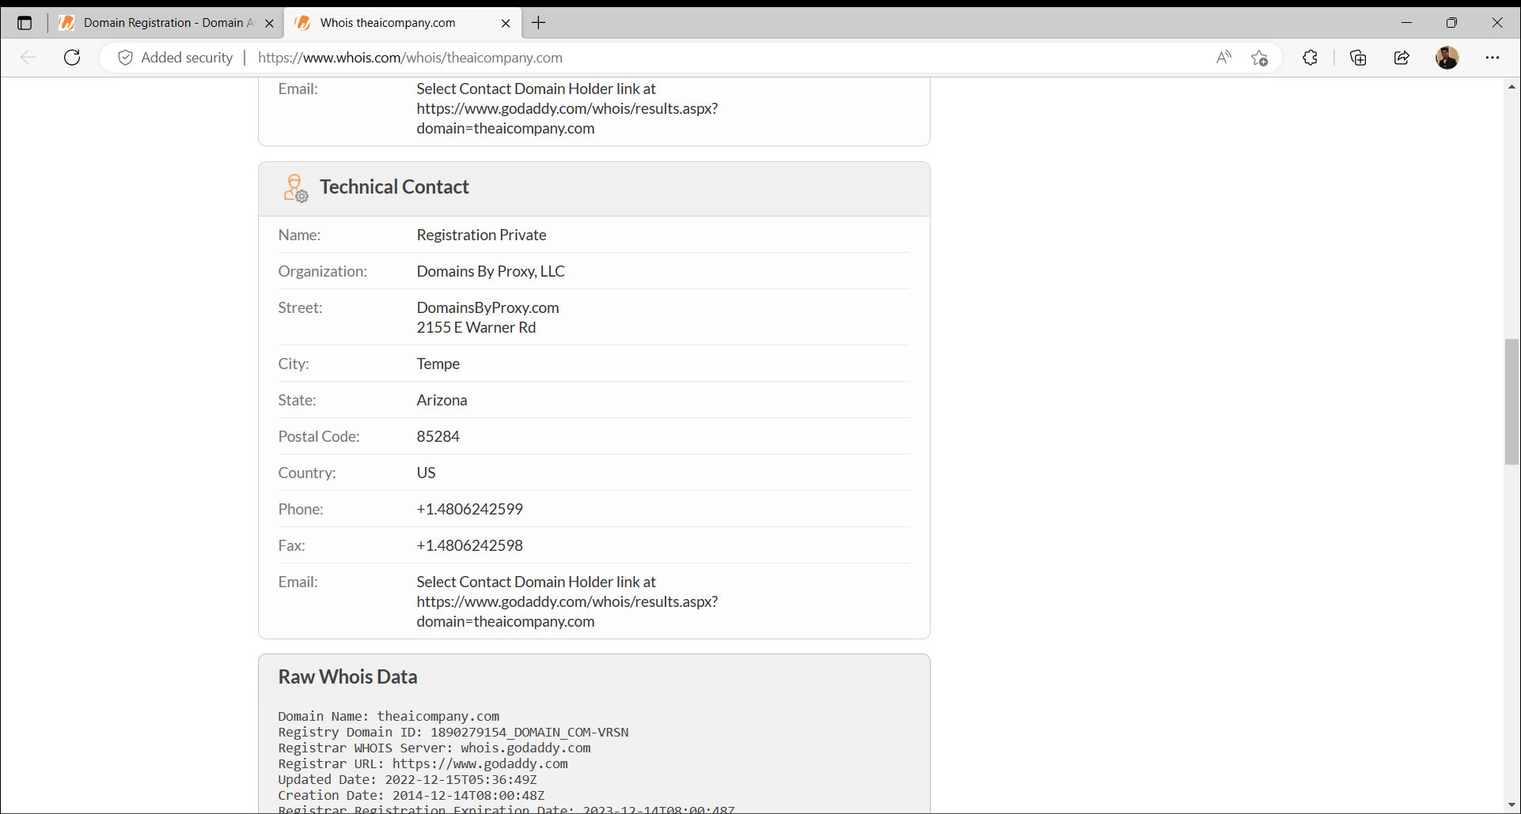

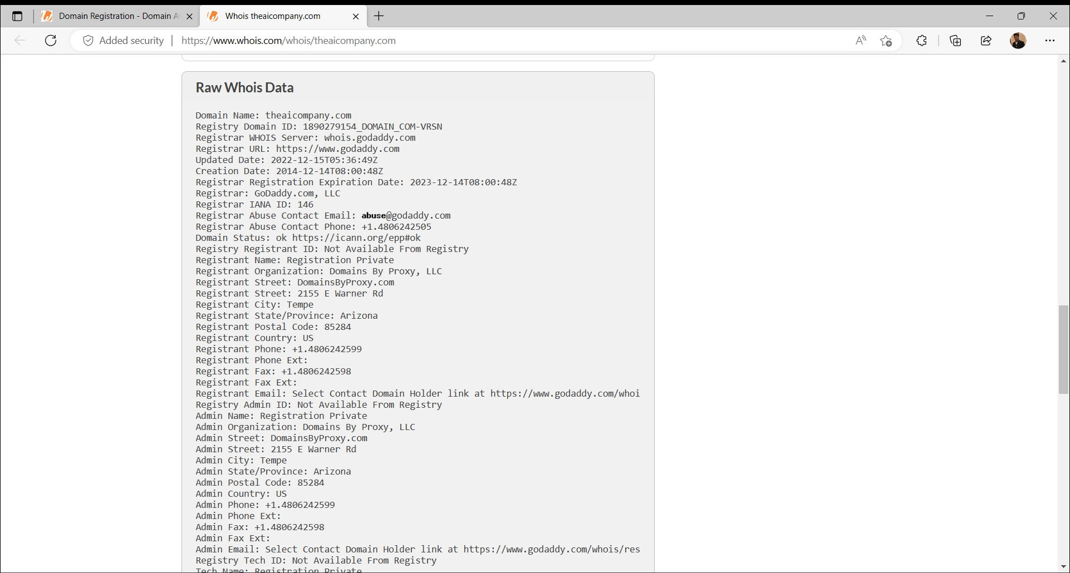

**MXTOOLBOX**

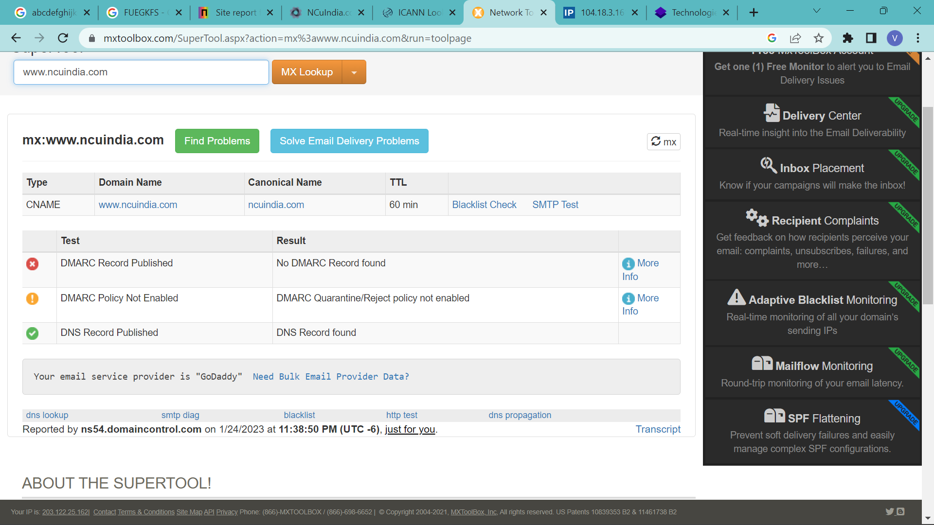

**ICANN**

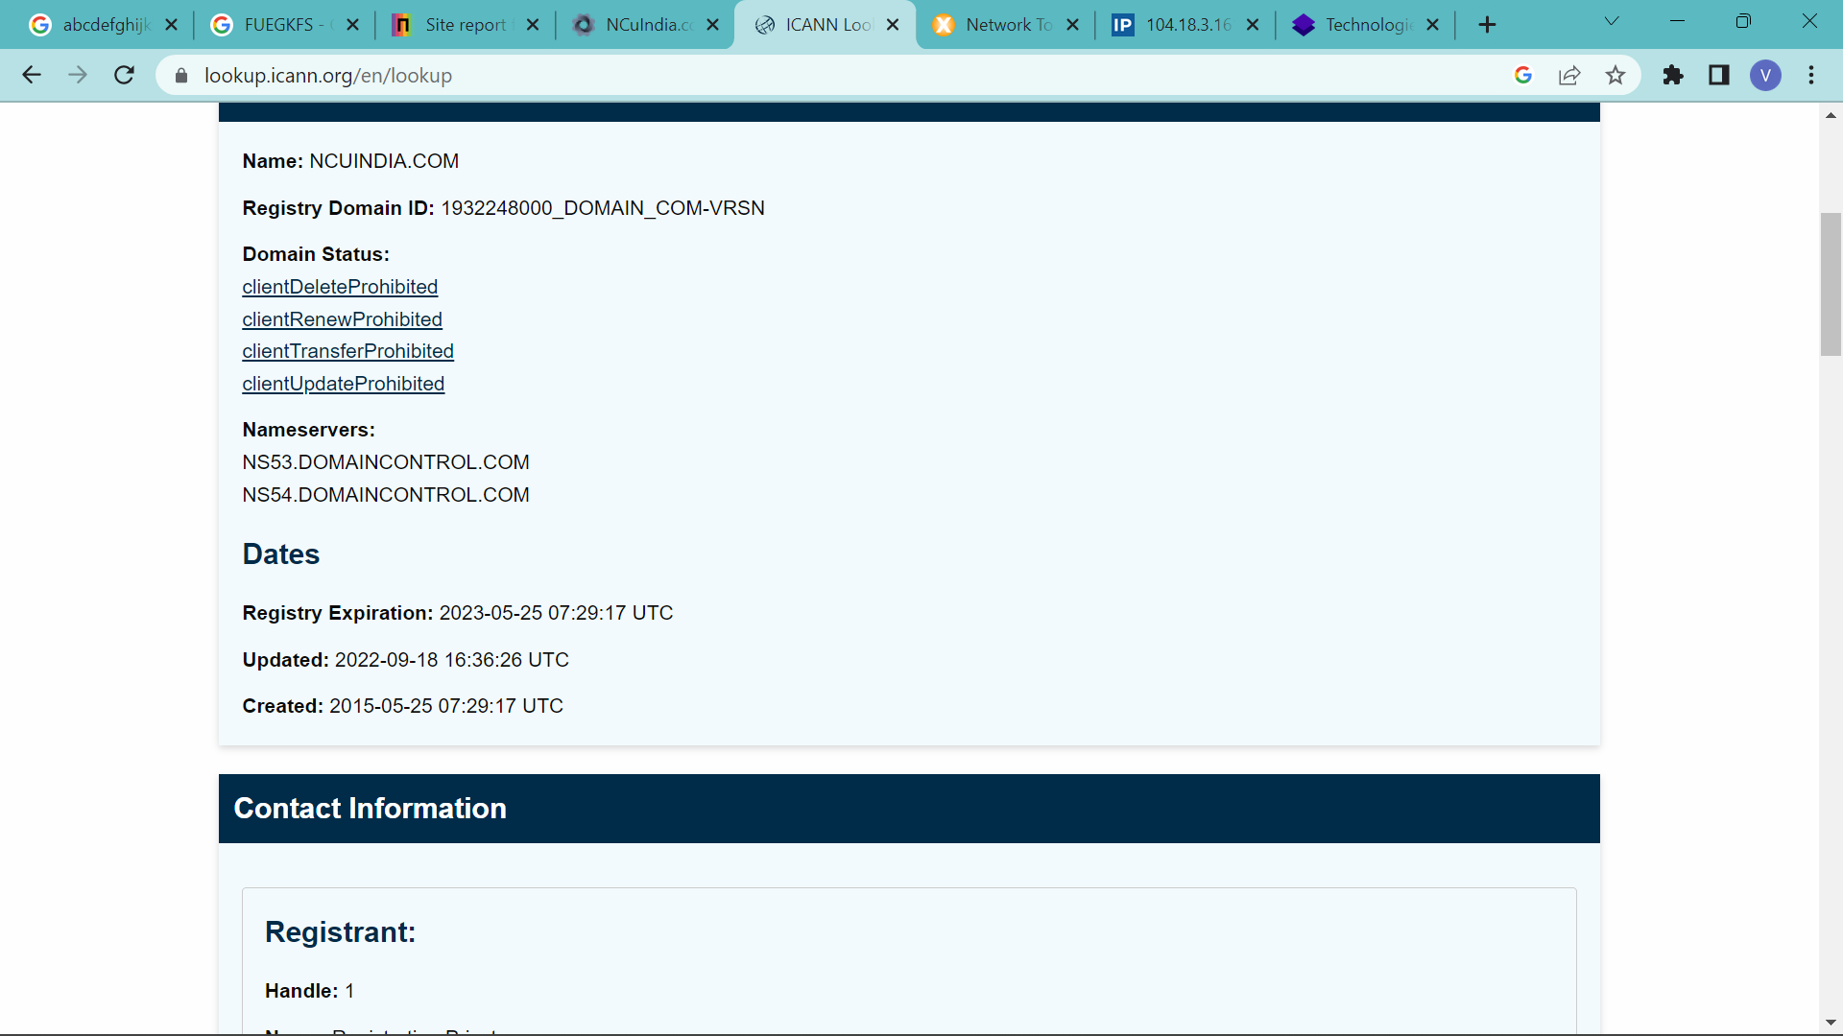

**PASTEBIN**

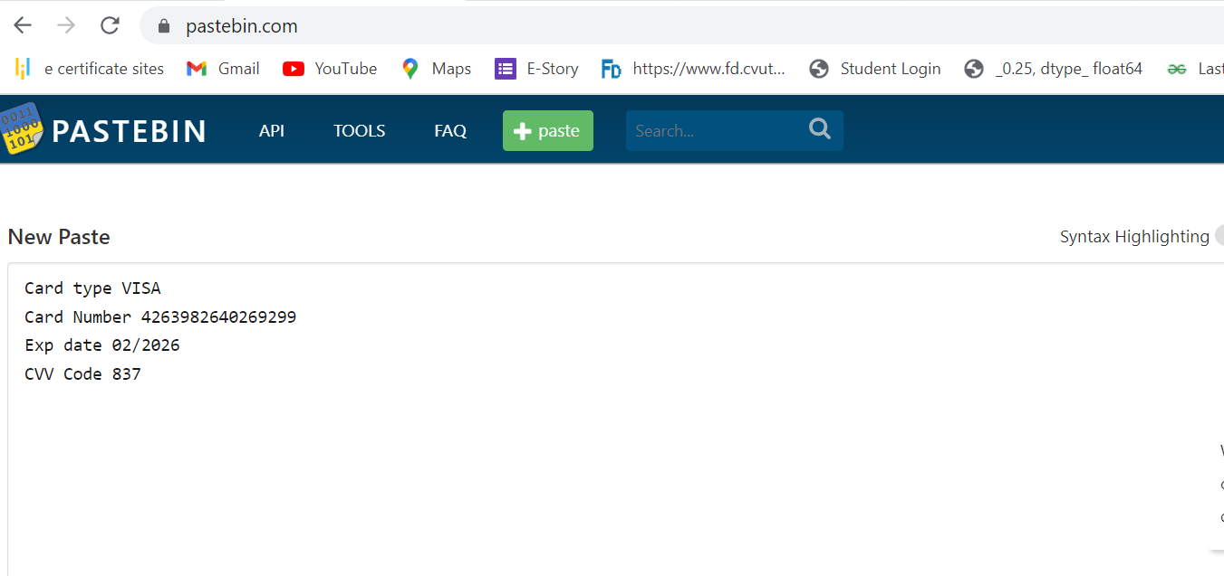

**WHOIS DOMAIN TOOLS**

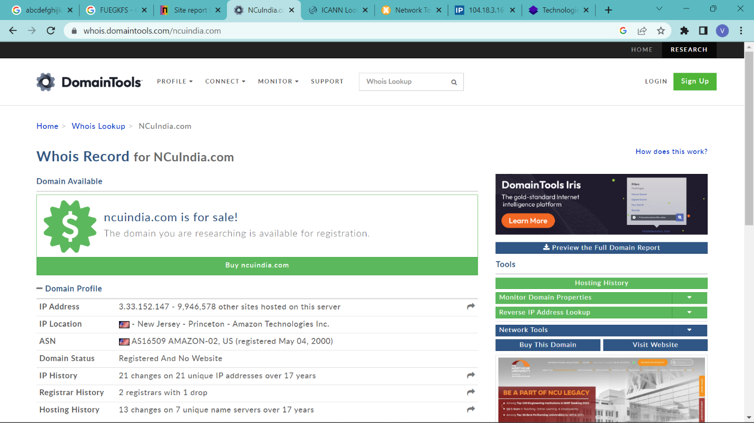

**EXPERIMENT NO. 2**

|  |
| --- |
| **Student Name and Roll Number:** Piyush Gambhir – 21CSU349 |
| **Semester /Section:** Semester-IV – AIML-B (AL-3) |
| **Link to Code:** |
| **Date:** |
| **Faculty Signature:** |
| **Marks:** |

|  |
| --- |
| **Objective:**  To familiarize the students about the first phase of Penetration Testing. |
| **Outcome:**  The students will understand how to gather information available on google freely using google dorks |
| **Problem Statement:**  Gather information using Social Networking sites and google Dorks |
| **Background Study:**   * D Google is an Attacker's Ally * Lot of information freely available via Internet on public platform * Personal information on company website or a social media site, that give hints to user account password. * Names can be entered in a search engine to reveal home addresses and telephone numbers. * Saves patches between sessions, writes them back to executable file and updates fixups * Open architecture - many third-party plugins are available * No installation - no trash in registry or system directories   Here, some google search syntax to crawl the password:   1. "Login: *" "password =*" filetype: xls (searching data command to the system files that are stored in Microsoft Excel)   2. allinurl: auth_user_file.txt (to find files auth_user_file.txt containing password on server).   3. filetype: xls inurl: "password.xls" (looking for username and password in ms excel format). This command can change with admin.xls)   4. intitle: login password (get link to the login page with the login words on the title and password words anywhere. If you want to the query index more pages, type allintitle)   5. intitle: "Index of" master.passwd (index the master password page)   6. index of / backup (will search the index backup file on server)   7. intitle: index.of people.lst (will find web pages that contain user list).   8. intitle: index.of passwd.bak ( will search the index backup password files) |
| **Question Bank:**   1. What is digital footprinting?   Digital footprinting refers to the traces or records that are left behind by a person or organization in the digital world. It can include information such as social media posts, search history, online purchases, and other online activities that can be used to identify an individual or their online behavior.   1. How to use information from GHDB and FSDB?   GHDB (Google Hacking Database) and FSDB (Fuzzing String Database) are databases that contain search queries and techniques that can be used to find vulnerabilities in websites and web applications. Information from these databases can be used to identify and exploit vulnerabilities, test website security, and find hidden files or directories.   1. Google search: Is it possible to search sites by value of tag attribute?   Yes, it is possible to search sites by value of tag attribute using Google search. For example, if you want to find all pages that contain an image with the alt tag "logo", you can use the search query "intext:logo site:example.com" to search for pages on the website example.com that contain the word "logo" in the page content.   1. What Data Can We Find Using Google Dorks?   Google Dorks are search queries that use advanced operators and parameters to search for specific information or vulnerabilities on the web. The data that can be found using Google Dorks includes sensitive information such as login credentials, private files, and database information. They can also be used to search for vulnerable web applications and to identify websites that have been hacked or defaced.   1. What is the following command used for: filetype:txt inurl:"email.txt" ?   The command "filetype:txt inurl:"email.txt"" is used to search for text files with "email" in the URL. This search query is searching for all text files with the extension ".txt" that contain the word "email" in the URL. This can be useful for finding email addresses or other information stored in text files on a website. |

**Student Work Area**

**Algorithm/Flowchart/Code/Sample Outputs**

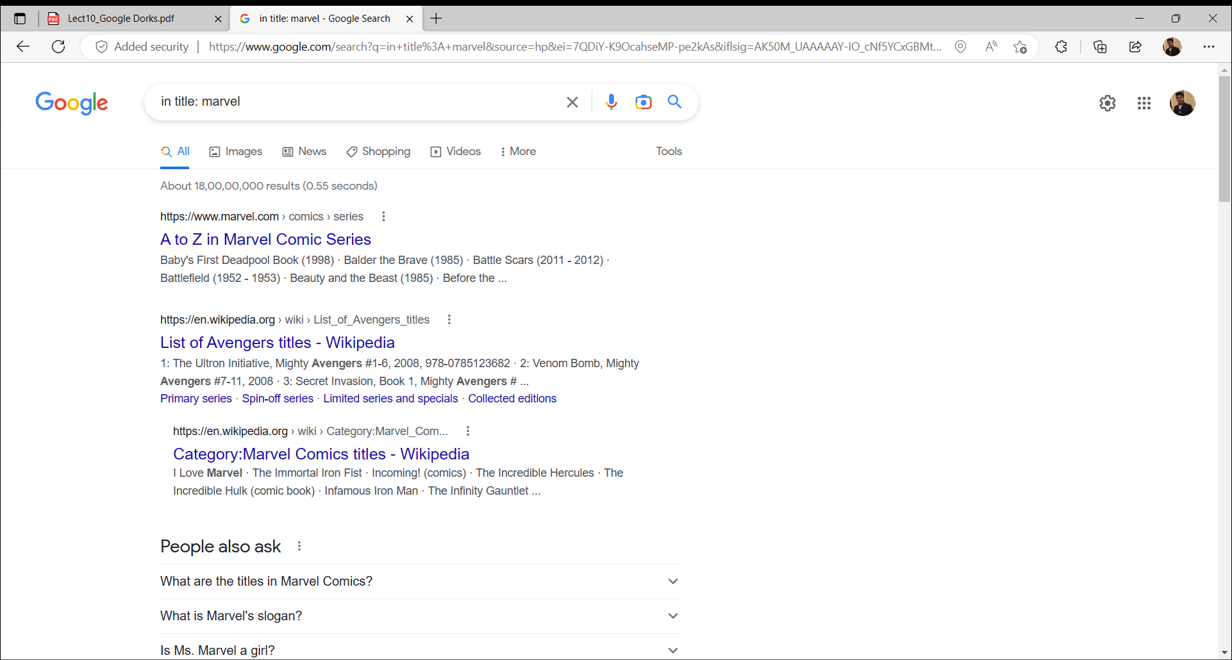

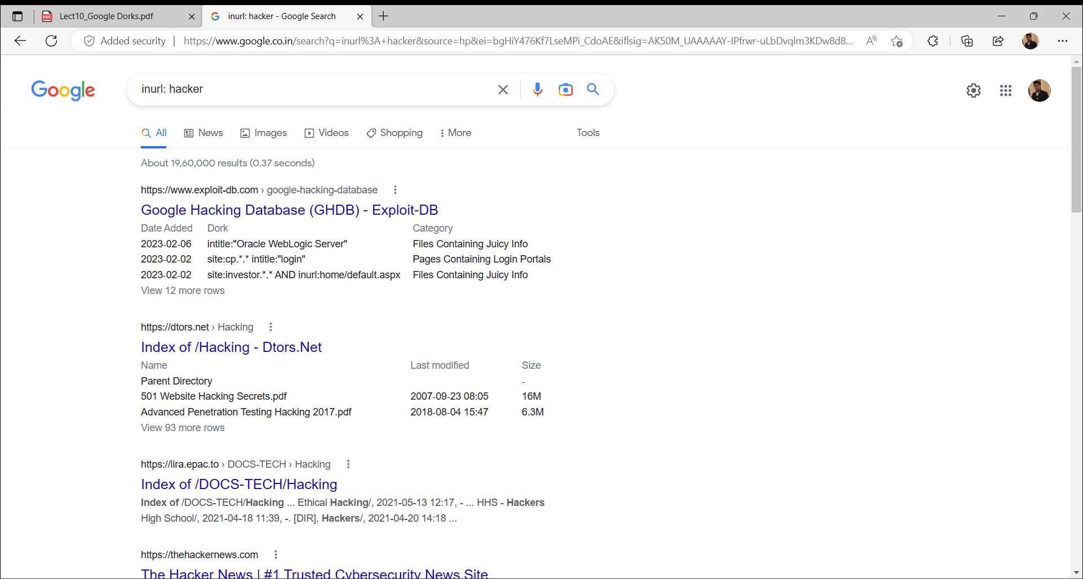

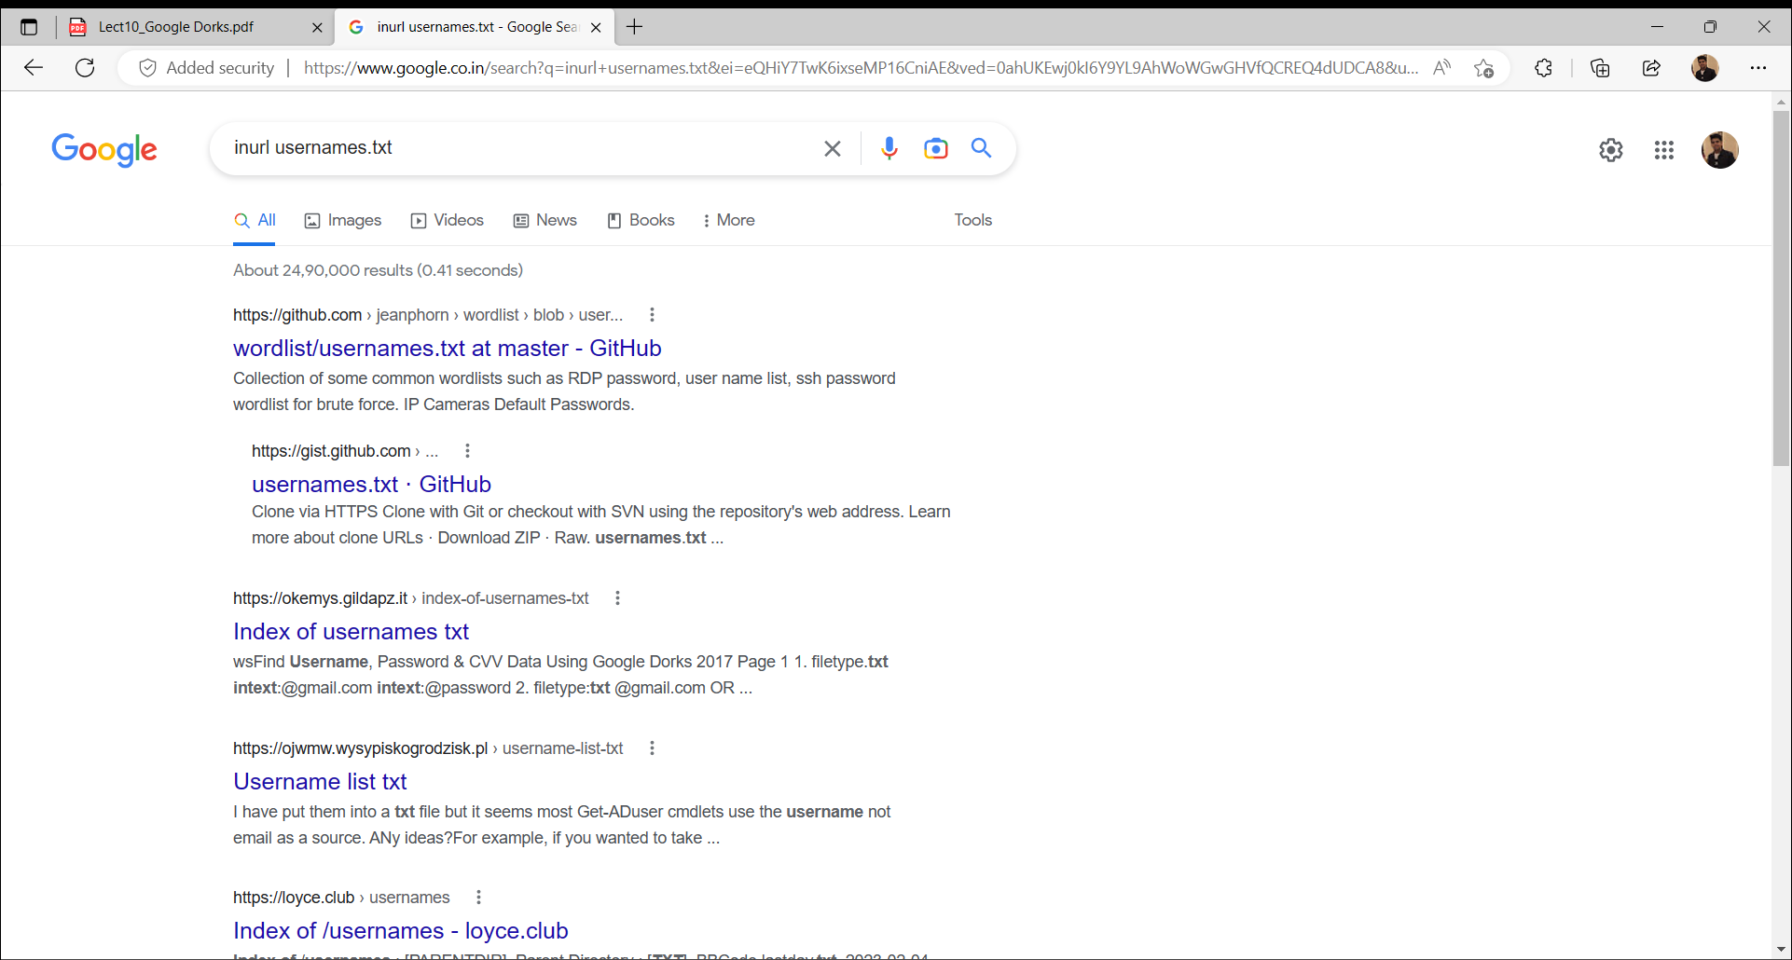

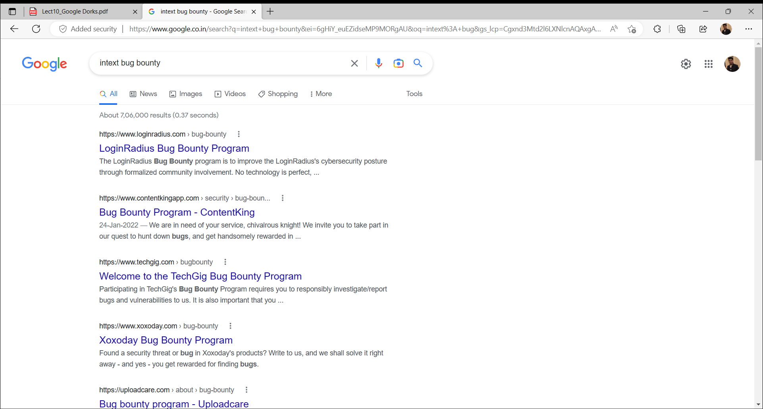

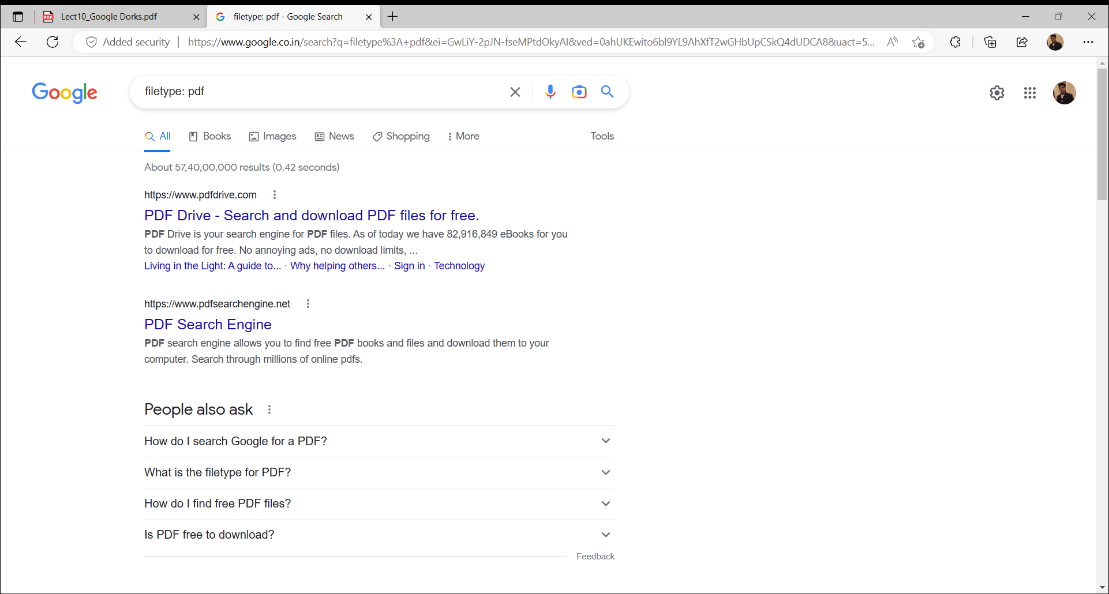

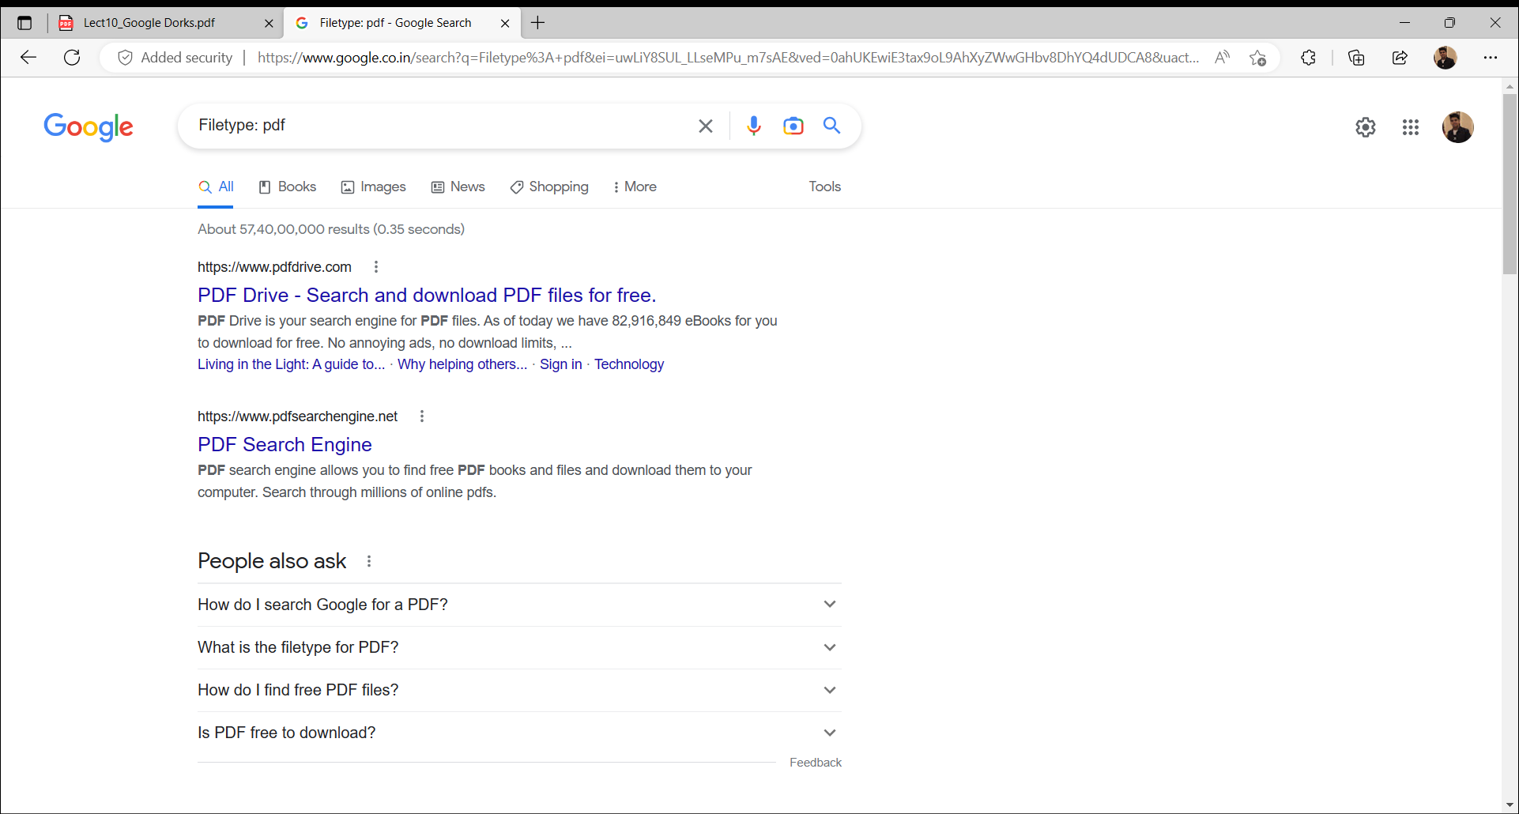

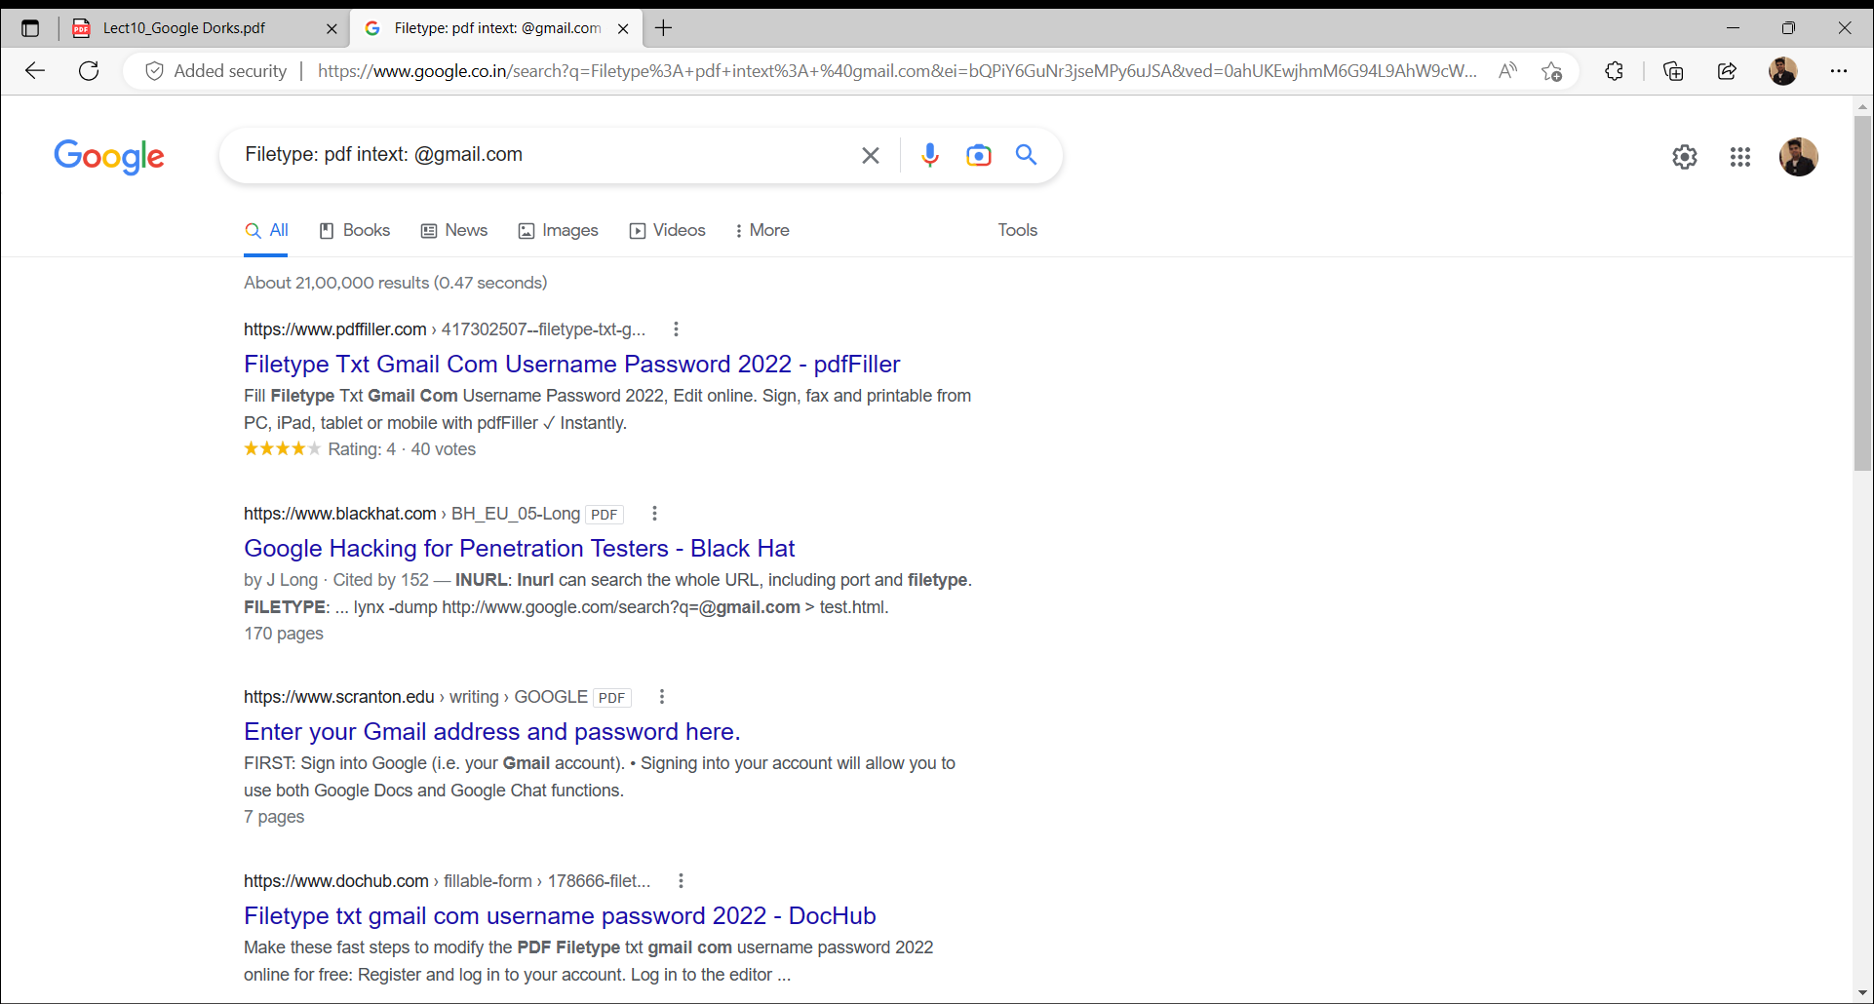

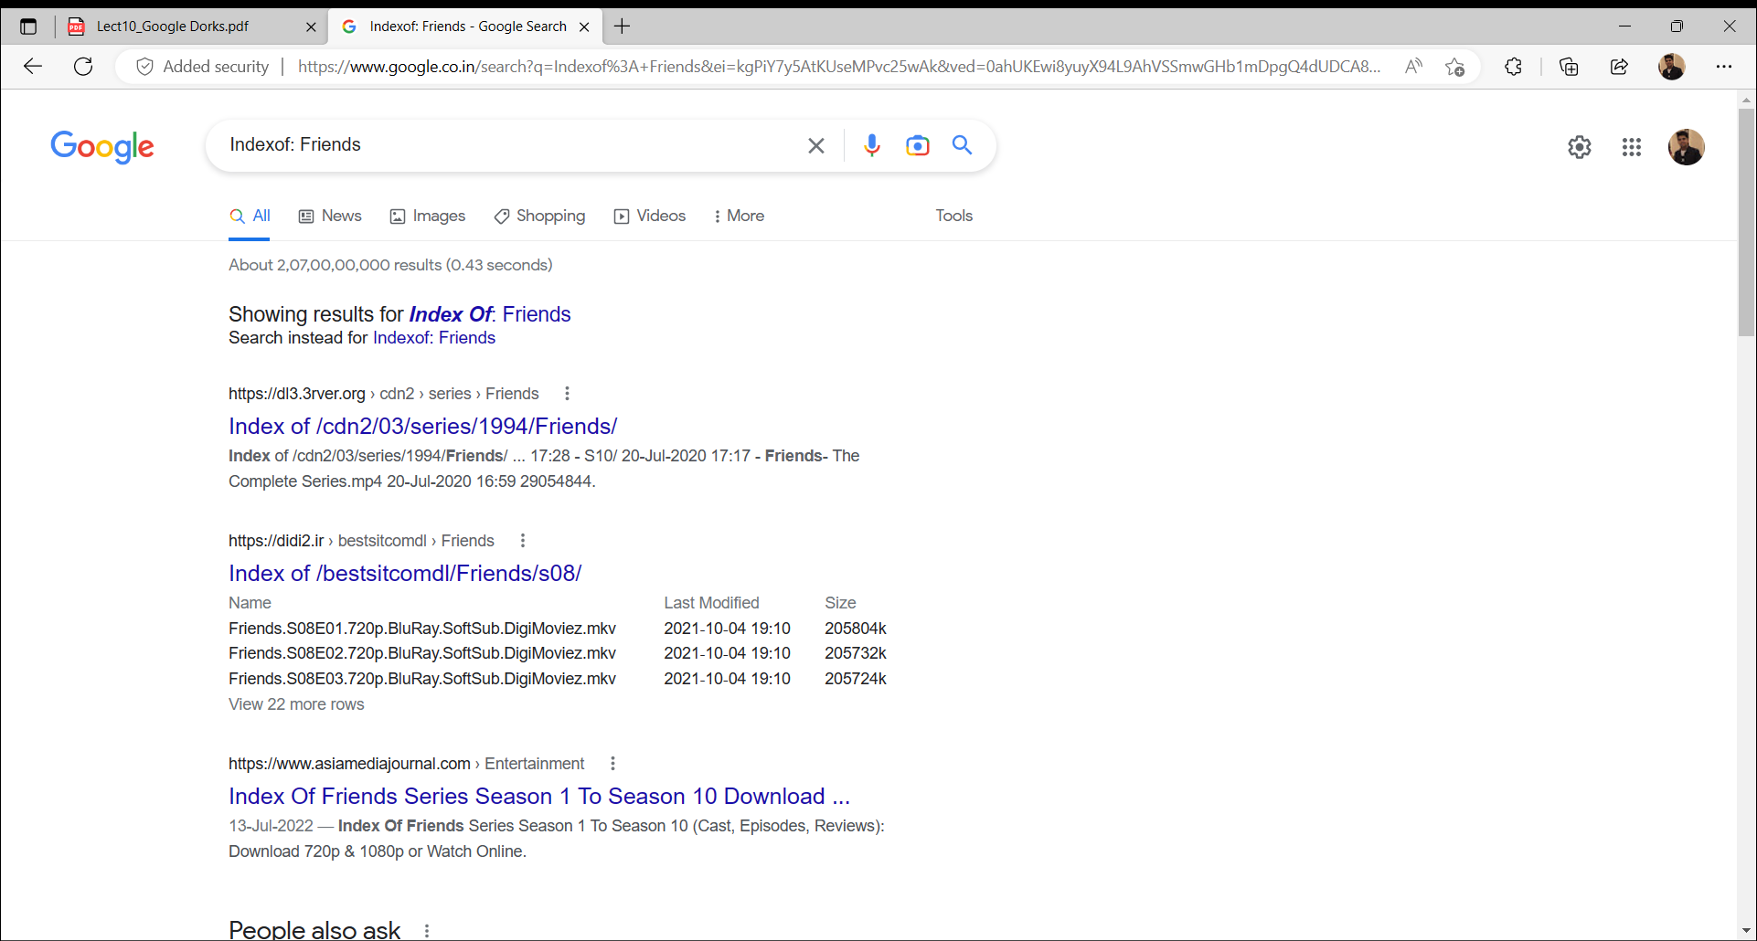

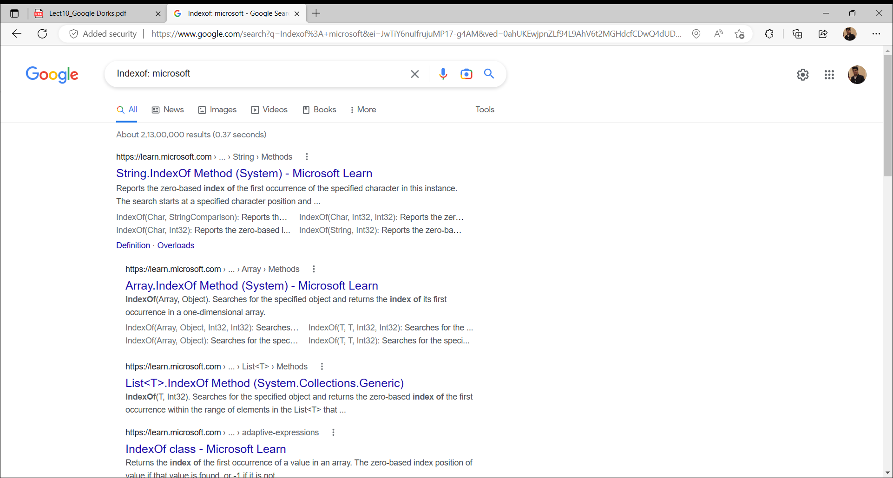

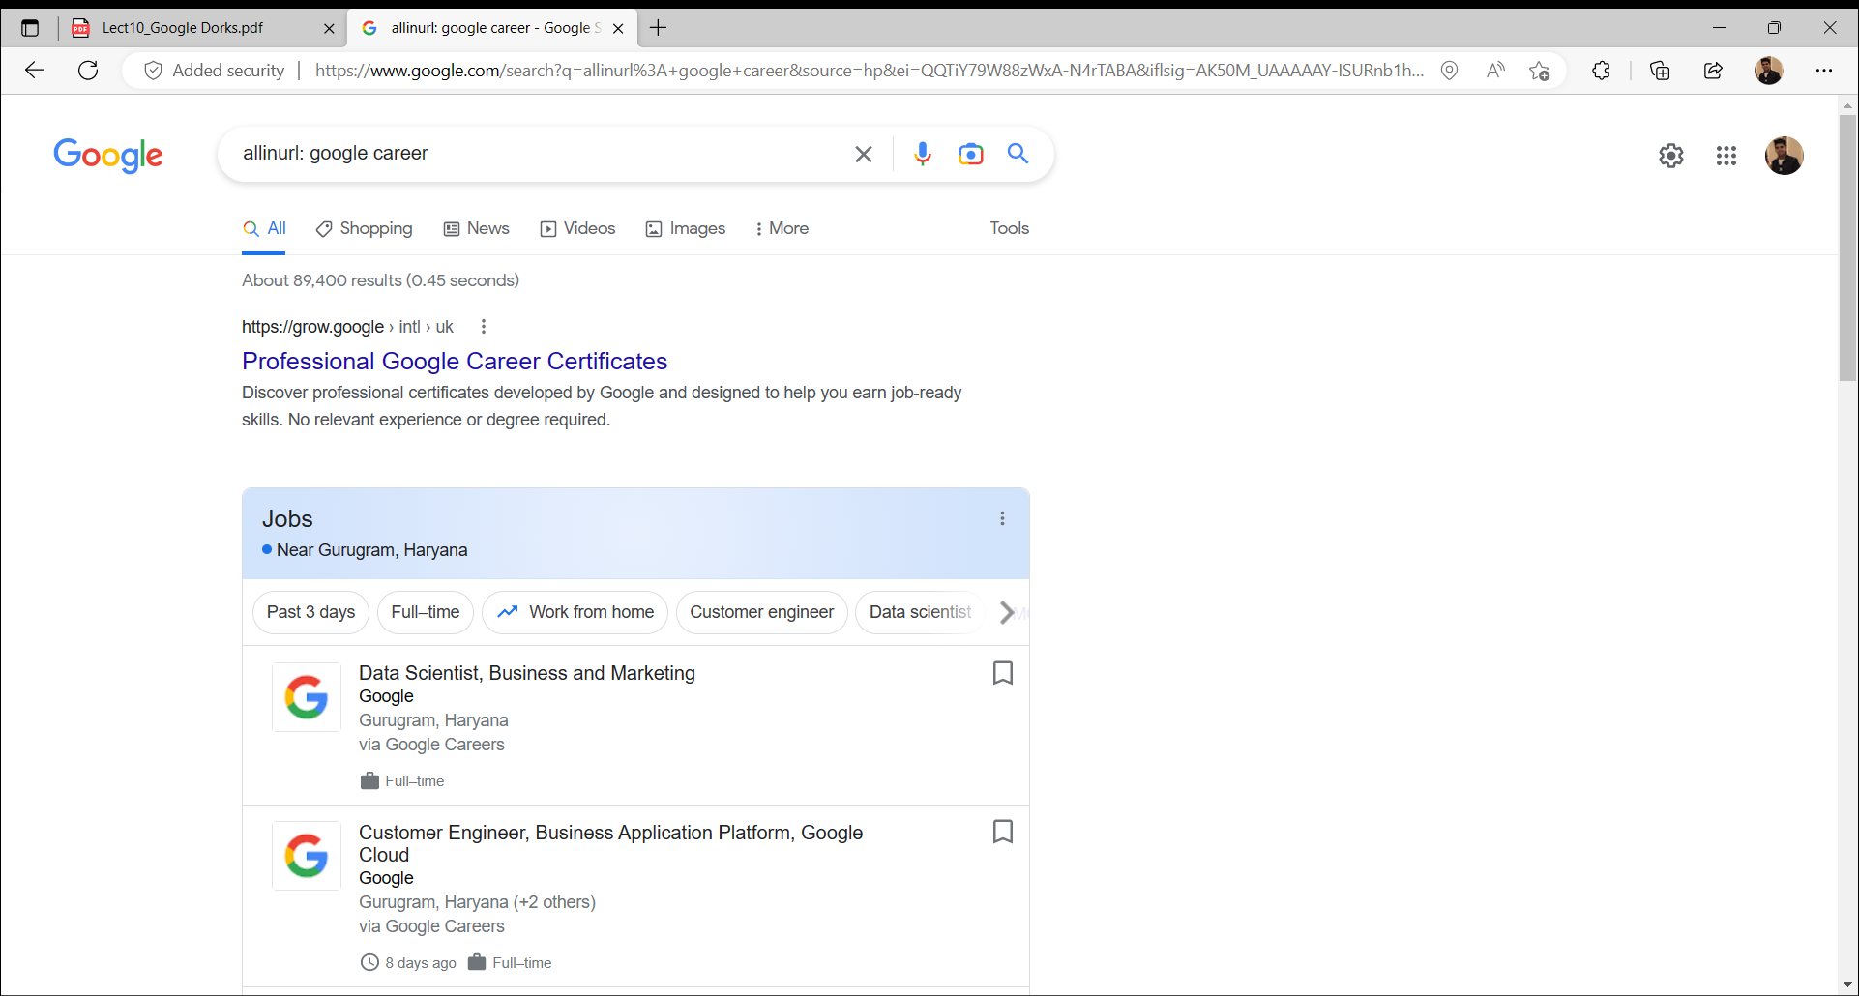

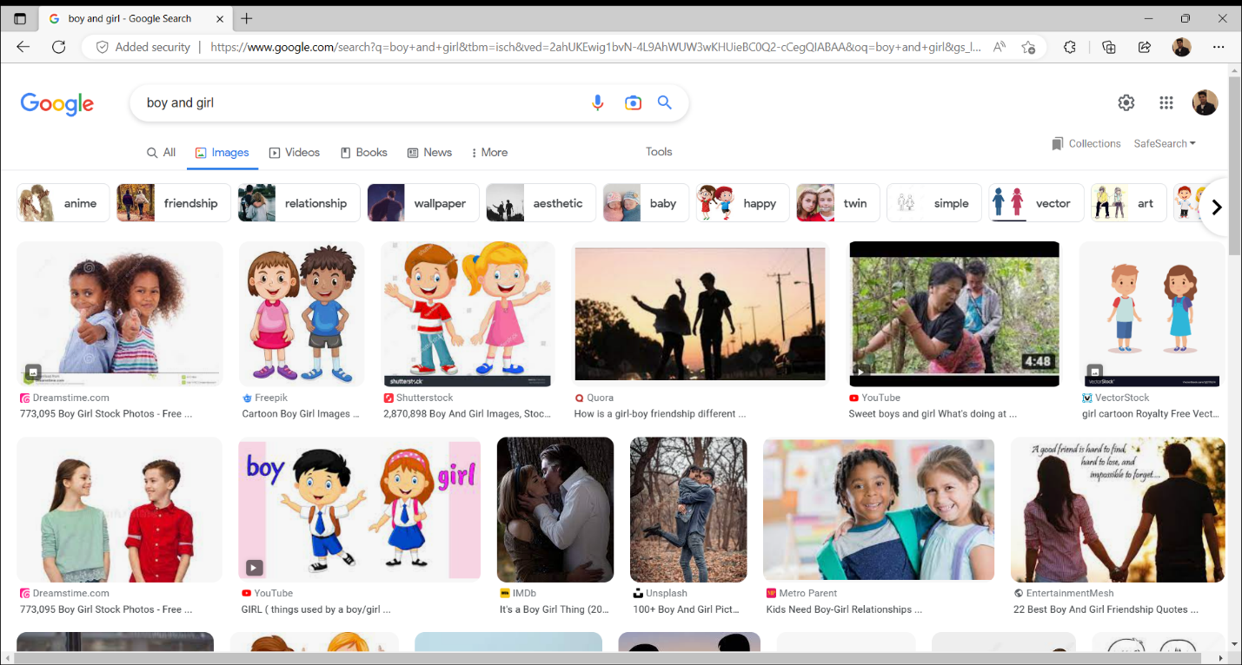

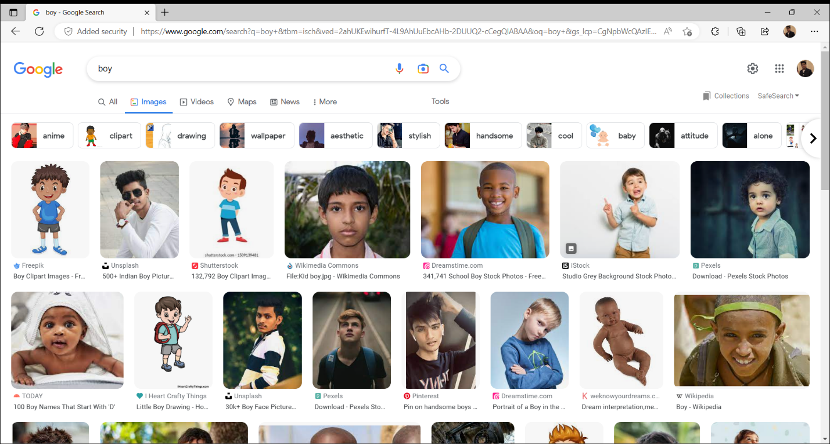

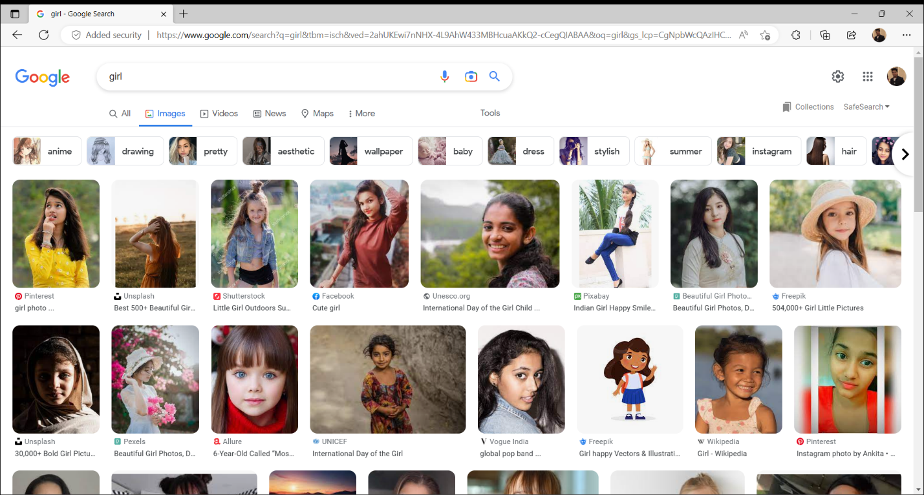

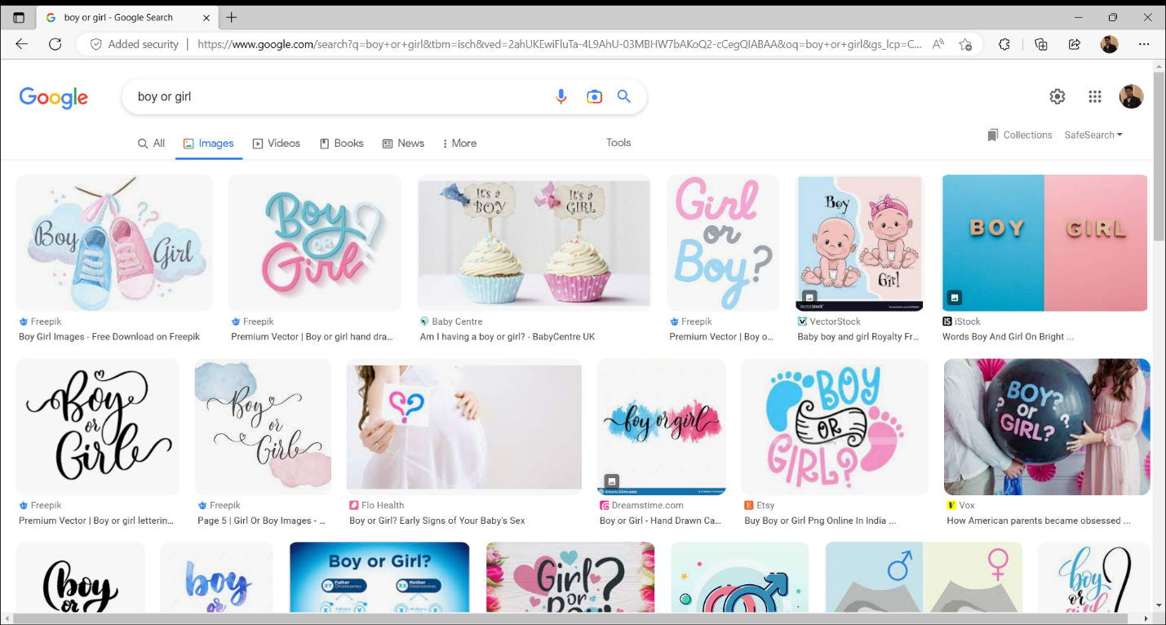

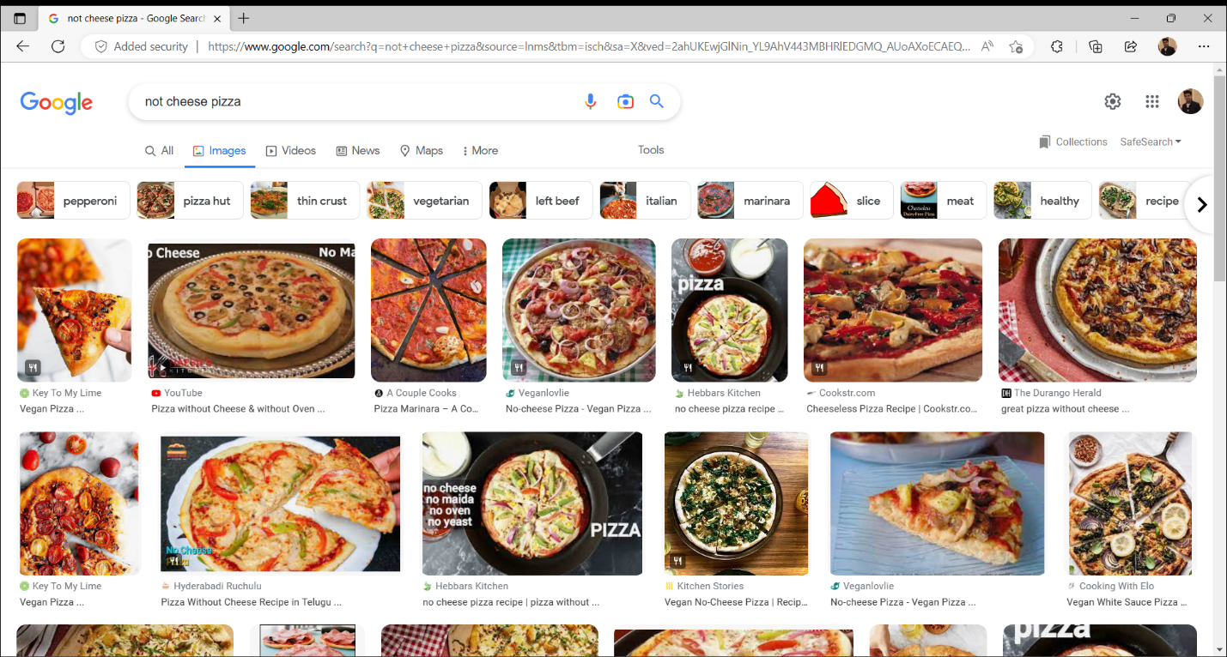

**EXPERIMENT NO. 3**

|  |
| --- |
| **Student Name and Roll Number:** Piyush Gambhir – 21CSU349 |
| **Semester /Section:** Semester-IV – AIML-B (AL-3) |
| **Link to Code:** |
| **Date:** |
| **Faculty Signature:** |
| **Marks:** |

|  |
| --- |
| **Objective:**  To familiarize the students with the concept of Second phase of penetration testing |
| **Outcome:**   * The students will understand difference between active and passive reconnaissance. * The students will be able to gather the information of the target machine by interacting with it. * The students will understand Nmap Tool. |
| **Problem Statement:**   * Perform Network Scanning using NMAP and ZENMAP |
| **Background Study:**   * Active reconnaissance is commonly referred to as *scanning*. * Taking the information discovered during reconnaissance and using it to examine the network. * The process of scanning perimeter and internal network devices for weaknesses.   Looking for information that can help to perpetrate attack. |
| **Question Bank:**   1. How to find the network addresses of live hosts, firewalls, routers, etc.   To find the network addresses of live hosts, firewalls, routers, etc, you can use a variety of network scanning tools such as Nmap, Angry IP Scanner, or Fing. These tools can scan your local network or remote networks to discover active hosts and their associated IP addresses, open ports, operating systems, and other useful information. It is important to note that network scanning can be intrusive and may violate security policies and laws, so it is important to obtain proper authorization before performing any network scans.   1. In which phase where attacker will interact with the target with an aim to identify the vulnerabilities.   The phase where an attacker interacts with the target with the aim of identifying vulnerabilities is called the reconnaissance phase. This is often the first step in a cyber attack, where the attacker tries to gather information about the target's network, systems, and applications. This can involve scanning for open ports and services, performing web application reconnaissance, social engineering, or other techniques that can help the attacker identify potential vulnerabilities that can be exploited in a later stage of the attack.   1. Differentiate between static and dynamic analysis.   Static analysis and dynamic analysis are two different approaches to software testing and security testing. Static analysis involves analyzing code or software without actually executing it, using techniques such as code review, syntax analysis, and data flow analysis. Static analysis can detect certain types of security issues, such as buffer overflows, injection vulnerabilities, and race conditions, but it may miss other types of issues that can only be detected by executing the code in a runtime environment.  Dynamic analysis, on the other hand, involves executing the code or software in a runtime environment and observing its behavior, including its input and output. Dynamic analysis can detect certain types of issues that are difficult to detect with static analysis, such as logic flaws, authentication and authorization issues, and timing attacks. However, dynamic analysis can be more time-consuming and resource-intensive than static analysis, and it may not detect certain types of vulnerabilities that are only present in specific environments or configurations.   1. Explain the different types of scanning.   Scanning is the process of checking a network, system, or application for vulnerabilities or weaknesses. There are several types of scanning, including:   * 1. Port scanning: checking for open ports and services on a target system or network.   2. Vulnerability scanning: checking for known vulnerabilities in a system or application using a database of known security issues and exploits.   3. Network mapping: creating a map of the target network, including the devices and their relationships to each other.   4. Web application scanning: checking for vulnerabilities in web applications, such as SQL injection, cross-site scripting, and other common web application vulnerabilities.   5. Password cracking: attempting to crack passwords using brute-force or dictionary attacks.  1. Differentiate between filtered and unfiltered ports.   Filtered and unfiltered ports are two different states that a port can be in on a network device, such as a router, firewall, or server.   * 1. Unfiltered ports: a port that is open and accepting connections.   2. Filtered ports: a port that is closed and not accepting connections, but is being filtered or blocked by a firewall or other security device.   When a port is filtered, the device is intentionally blocking traffic to that port to prevent unauthorized access or attacks. In contrast, when a port is unfiltered, traffic is allowed to flow freely to and from that port. It is important to note that not all filtering is necessarily malicious - legitimate security policies and configurations may result in some ports being filtered to protect the network or system from unauthorized access. |

**Student Work Area**

**Algorithm/Flowchart/Code/Sample Outputs**

**Nmap**

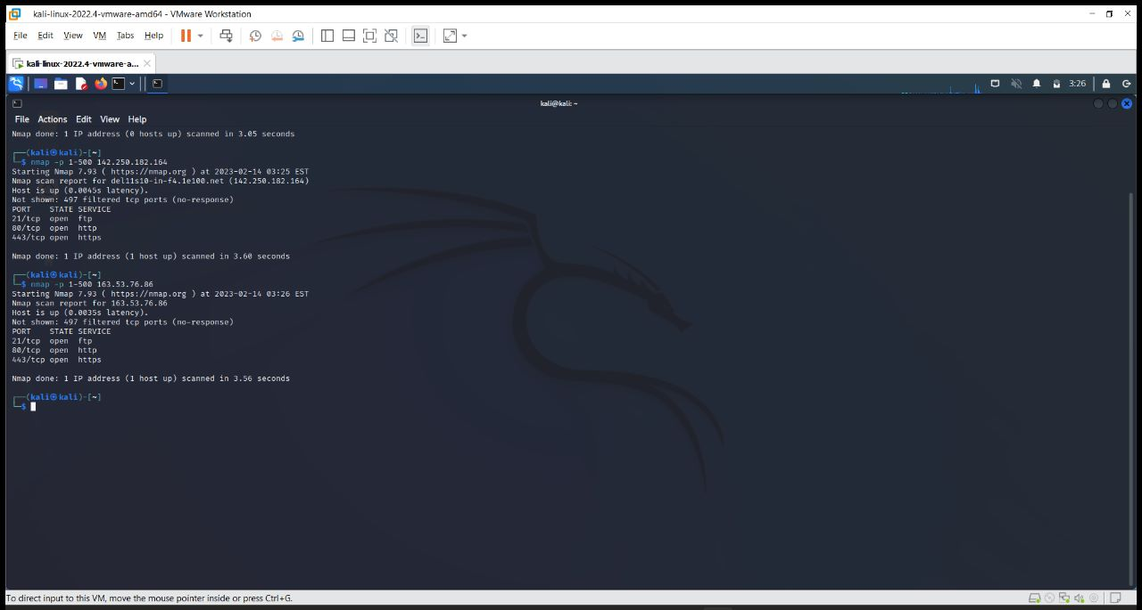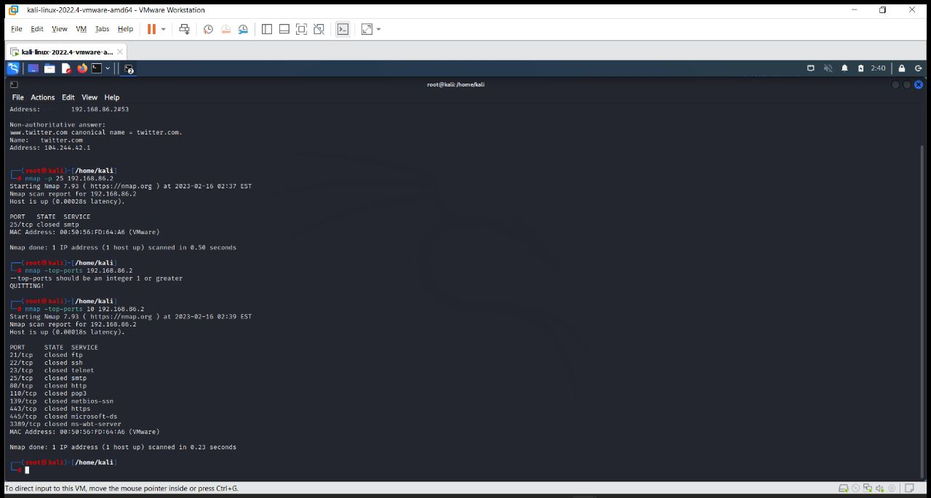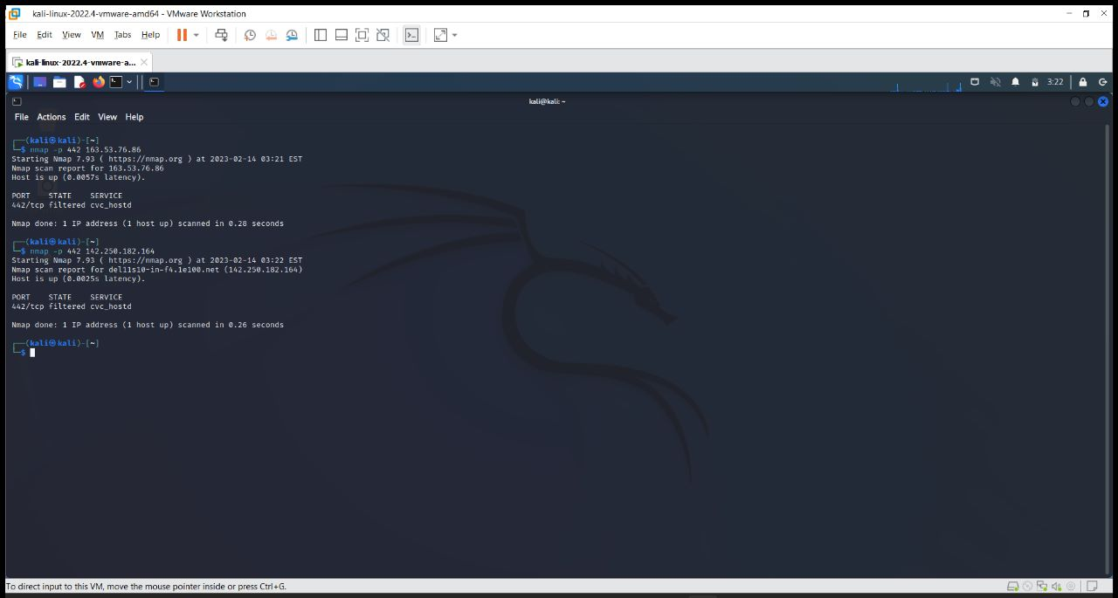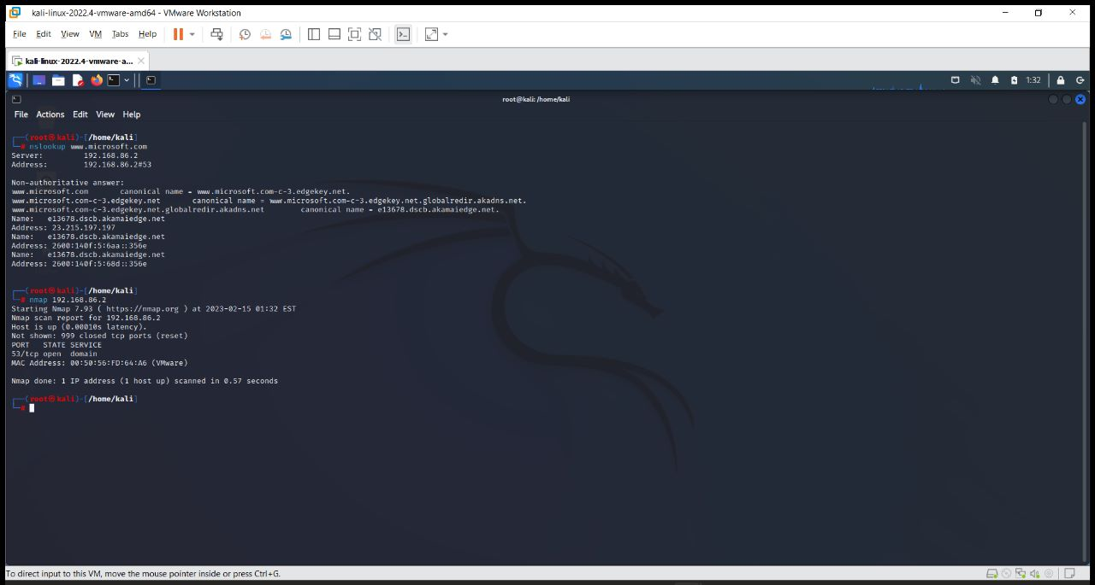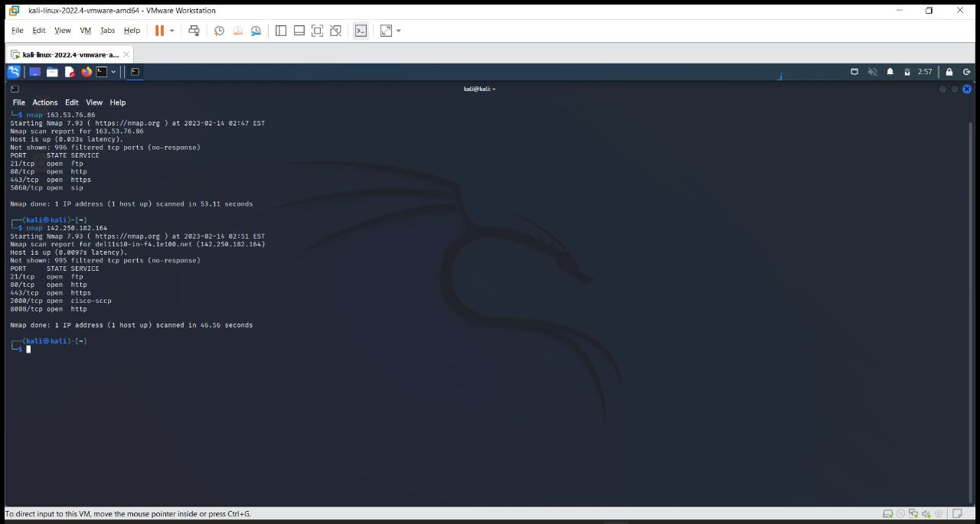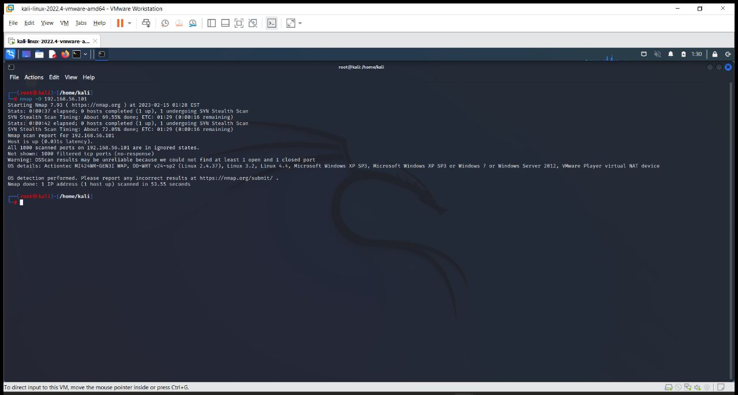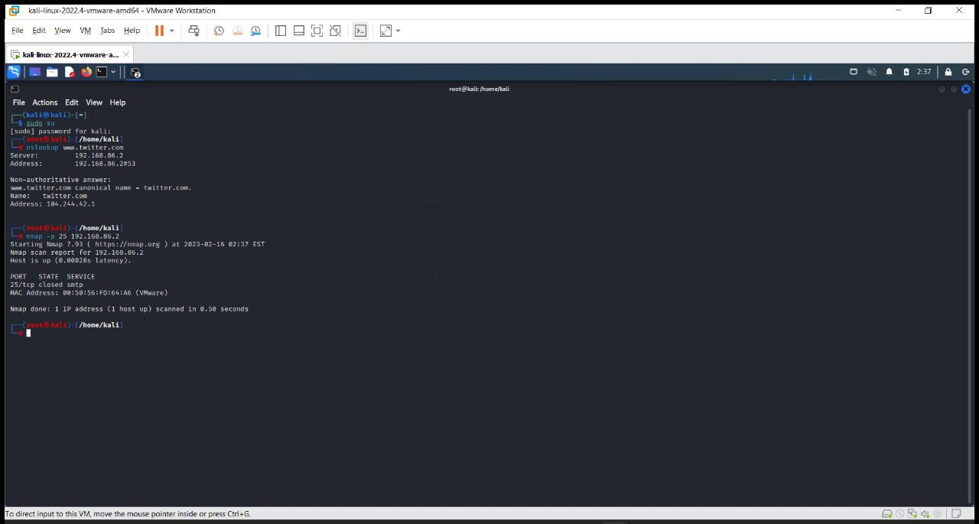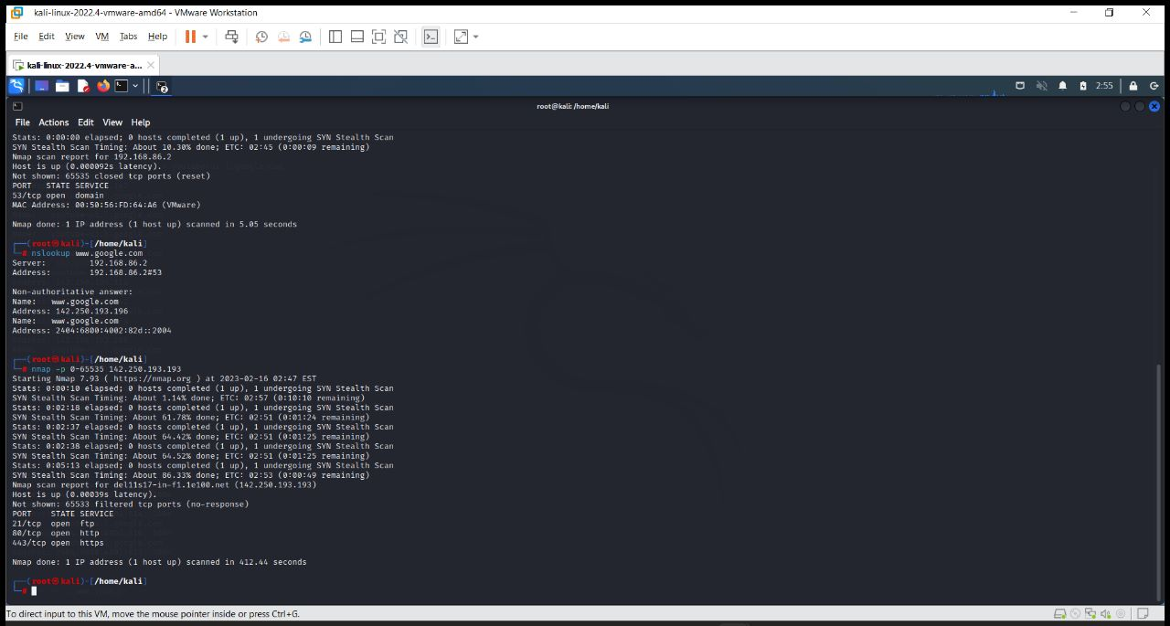

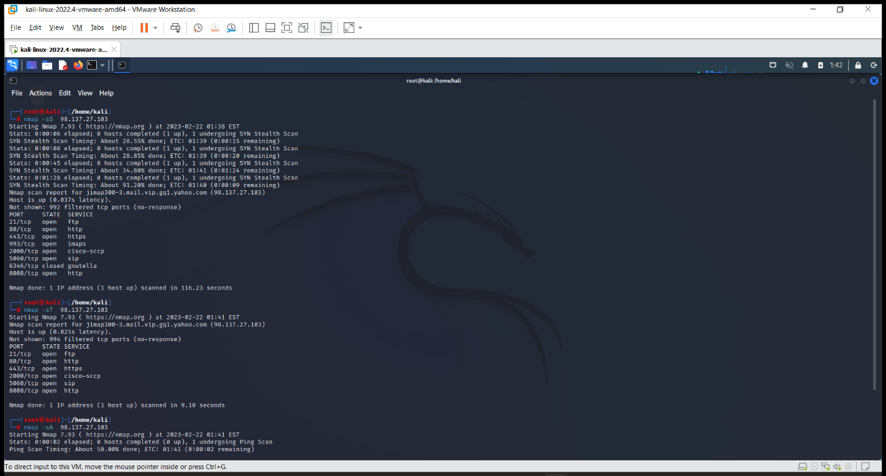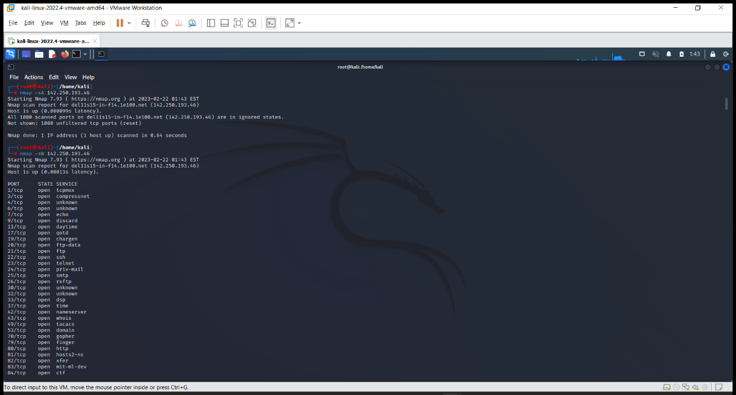

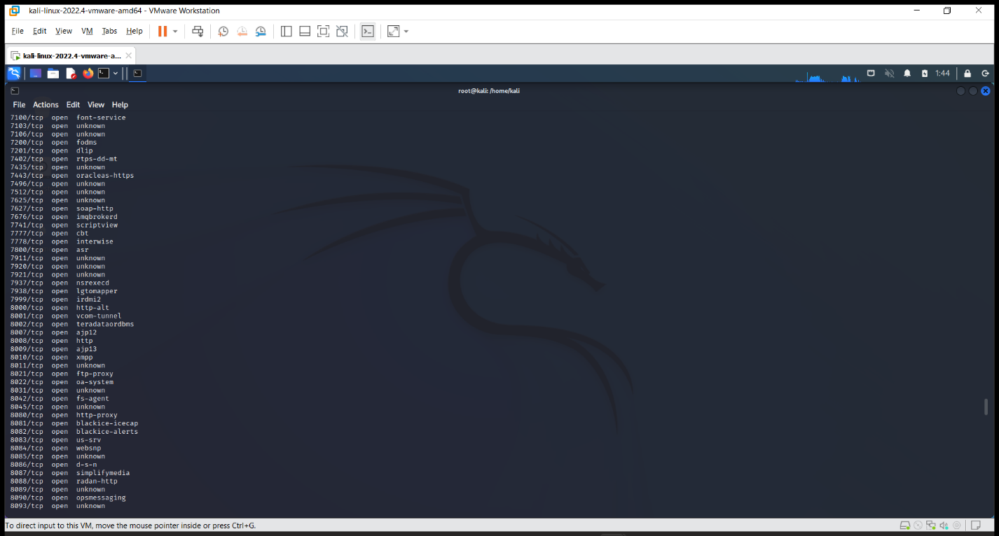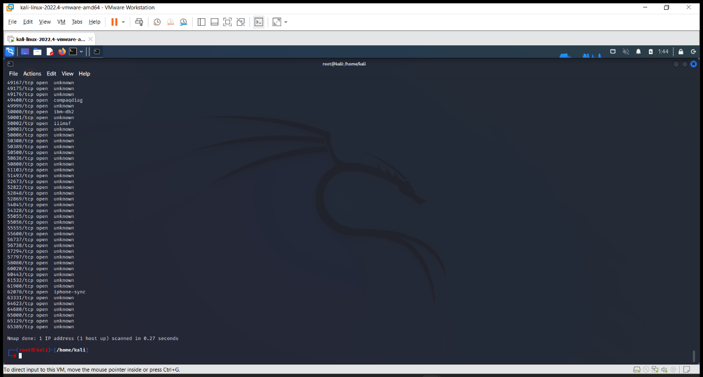

**Zenmap**

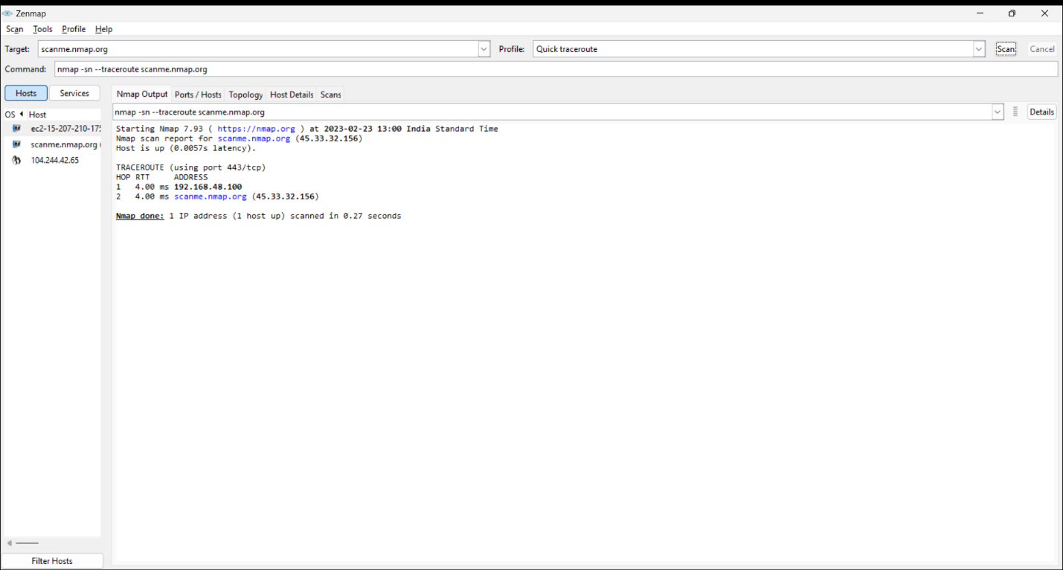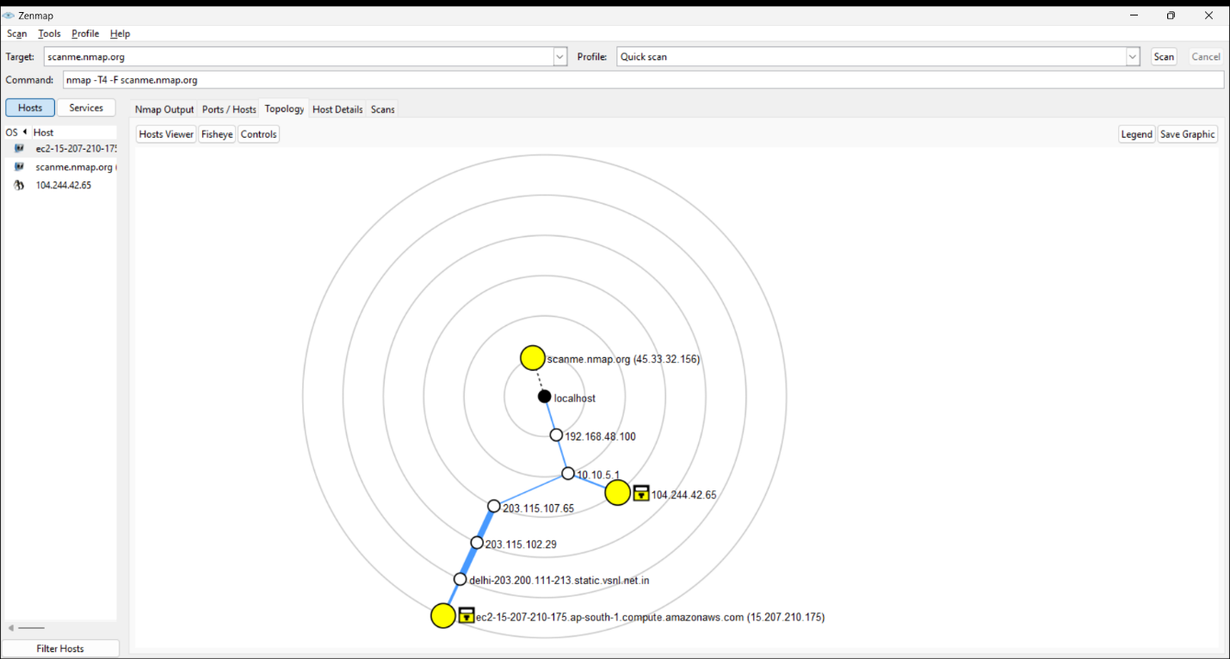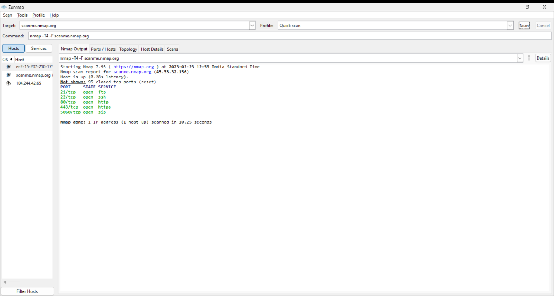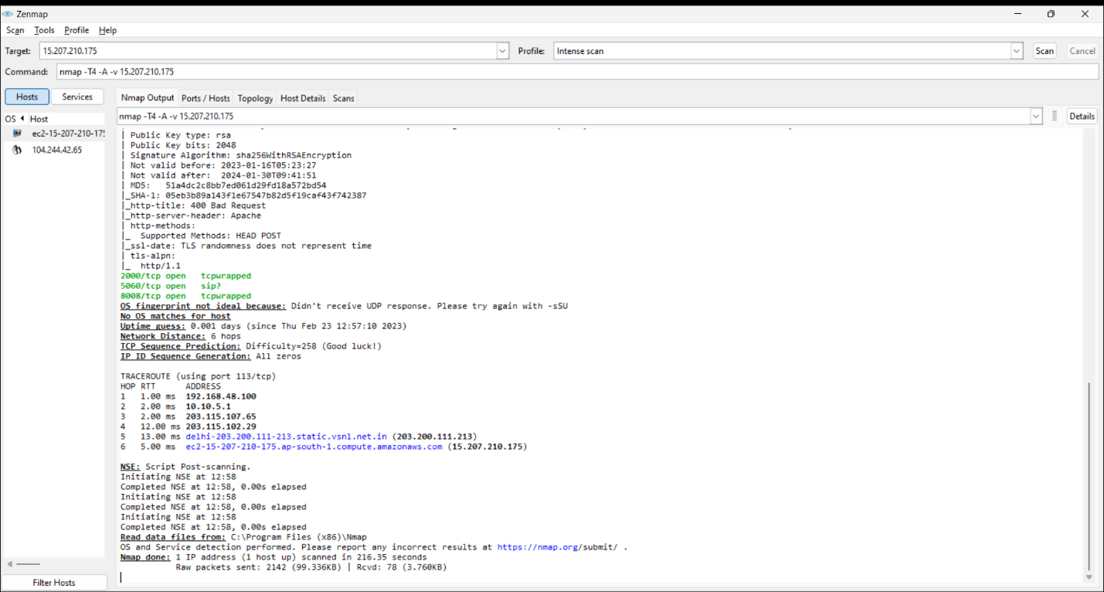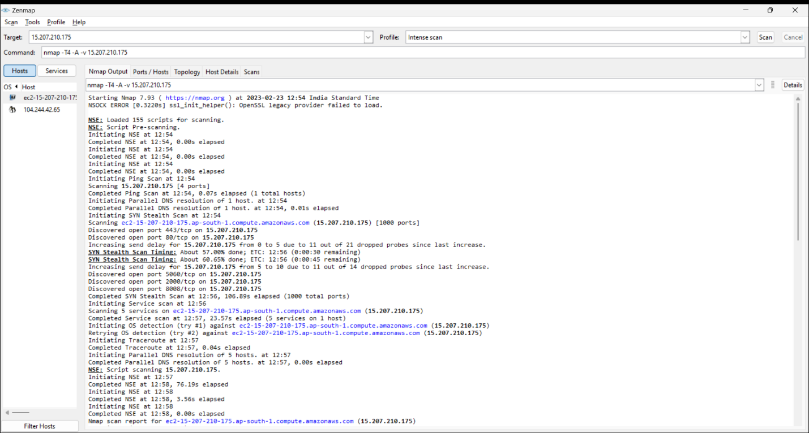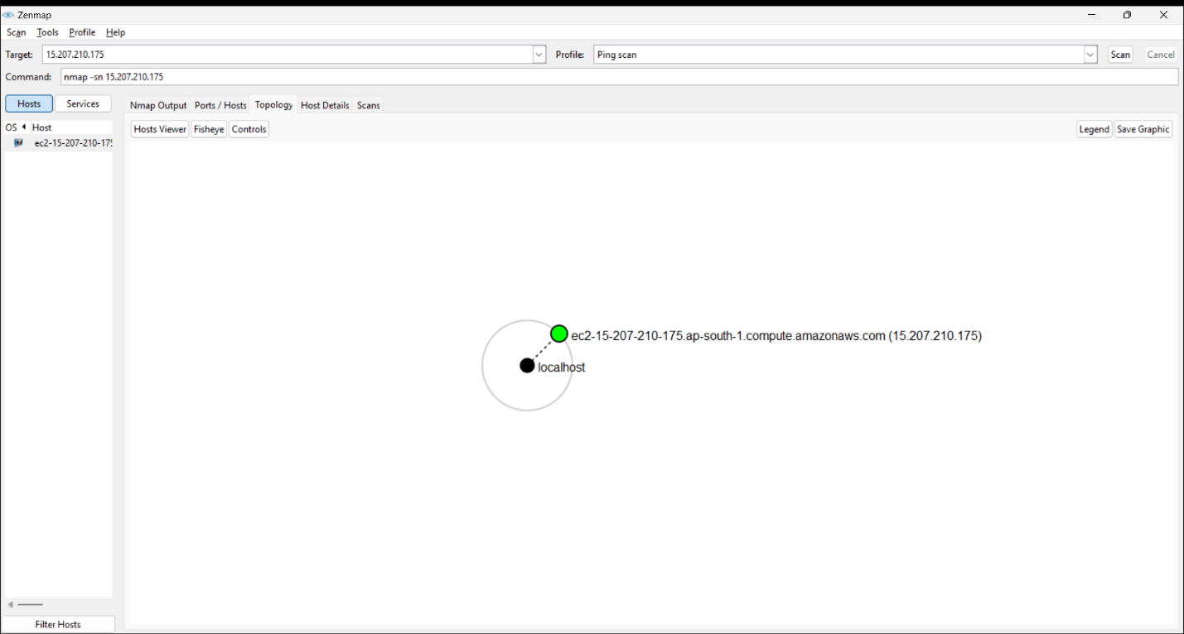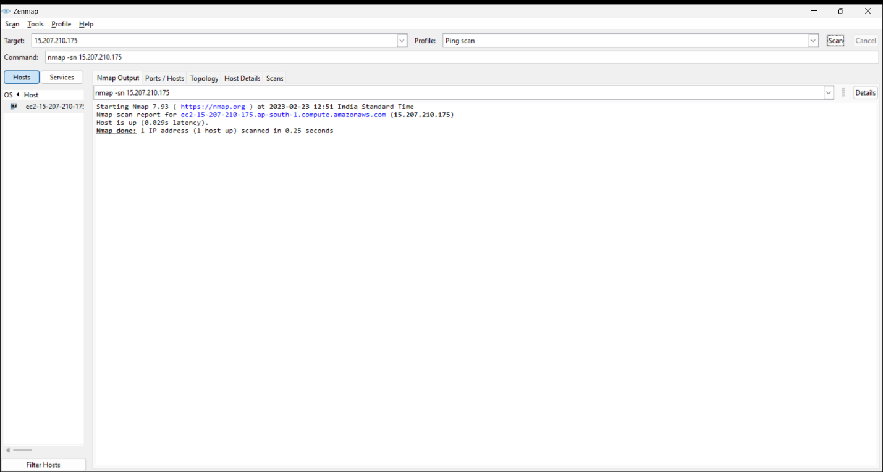

**EXPERIMENT NO. 4**

|  |
| --- |
| **Student Name and Roll Number:** Piyush Gambhir – 21CSU349 |
| **Semester /Section:** Semester-IV – AIML-B (AL-3) |
| **Link to Code:** |
| **Date:** |
| **Faculty Signature:** |
| **Marks:** |

|  |
| --- |
| **Objective:**  To familiarize the students with the concept of Second phase of penetration testing |
| **Outcome:**   * The students will be able to find all the vulnerabilities present in the target machine. * Will also understand the Nessus Vulnerability scanner tool. |
| **Problem Statement:**  Use NIKTO & Nessus tool to find all the vulnerabilities with its level and generate a report for an organization. |
| **Background Study:**  **Packet sniffer:**   * It has a database of vulnerabilities based on which it performs the check on the remote host. * Its database contains all the information required (service, port, packet type, a potential path to exploit, etc.) to check the security issue. * They can scan the network and websites against thousands of vulnerabilities, provide the list of issues based on the risk and suggest the remediation as well. |
| **Question Bank:**   1. What are the features of popular Vulnerability scanning tools?   Popular vulnerability scanning tools typically offer a range of features including:   * Identification of vulnerabilities in software and hardware systems. * Automated scans and assessments of network devices, operating systems, applications, and databases. * Detection of security misconfigurations and weaknesses in authentication, authorization, encryption, and access controls. * Risk assessment and prioritization of vulnerabilities based on severity, impact, and exploitability. * Reporting and documentation of scan results, including recommended remediation steps and compliance checks. * Integration with other security tools and platforms, such as SIEM, IDS/IPS, and patch management systems.  1. Differentiate between NESSUS and NMAP.   NESSUS and NMAP are both network scanning tools, but they differ in their functionality and usage. NESSUS is primarily a vulnerability scanner that detects and assesses vulnerabilities in systems and applications, while NMAP is a port scanner that identifies open ports, services, and hosts on a network. NESSUS uses a database of known vulnerabilities and exploits to perform scans, while NMAP uses various techniques to determine the status of network hosts and services, including TCP/IP fingerprinting, OS detection, and version scanning.   1. List the top Vulnerability scanner tools.   Some of the top vulnerability scanner tools include:   * NESSUS * OpenVAS * Qualys * Rapid7 Nexpose * Acunetix * Burp Suite * Metasploit * Retina  1. List 4 applications of NESSUS tool.   Some applications of NESSUS tool include:   * Vulnerability assessment and management * Compliance checking for industry standards and regulations such as PCI-DSS, HIPAA, and SOX * Network and system auditing * Malware detection and analysis  1. What is a Plugin?   In the context of vulnerability scanning tools, a plugin is a software module that is used to perform a specific task or analysis on a system or application. Plugins are used to extend the functionality of the scanning tool, allowing it to identify and assess vulnerabilities in different types of software and hardware configurations. Plugins can be developed by the vendor of the scanning tool or by third-party developers, and they may be specific to certain operating systems, applications, or network devices. The plugins are typically updated frequently to keep up with new vulnerabilities and exploits. |

**Student Work Area**

**Algorithm/Flowchart/Code/Sample Outputs**

**Nikto**

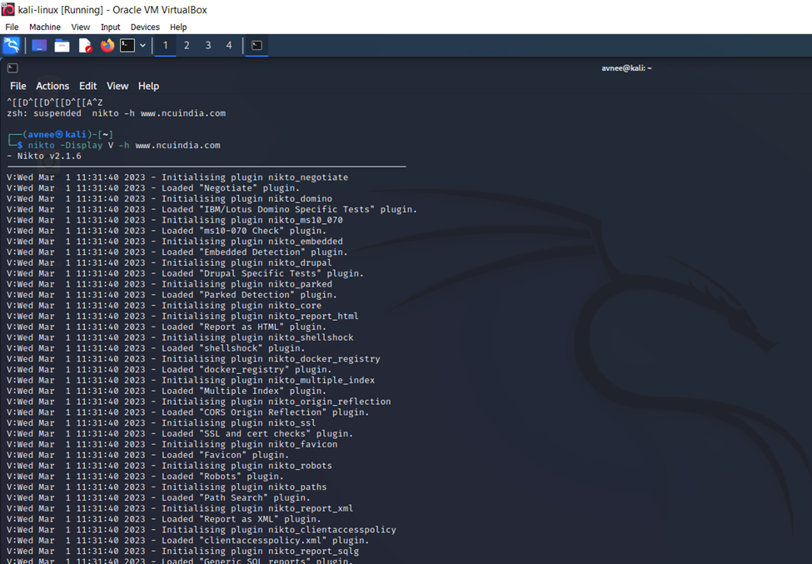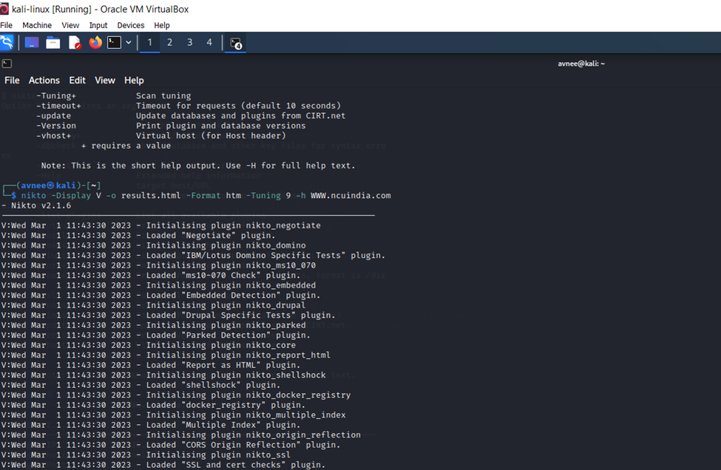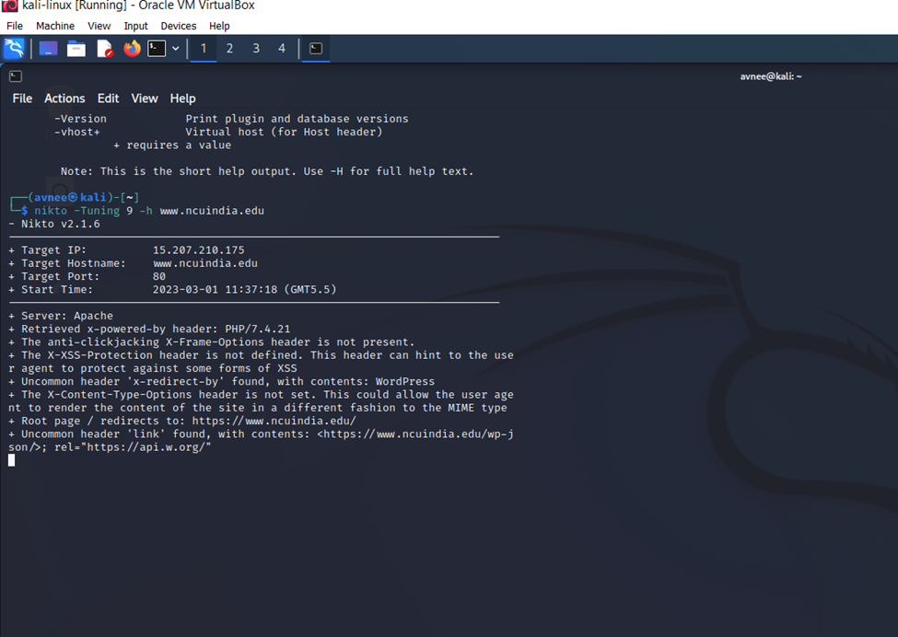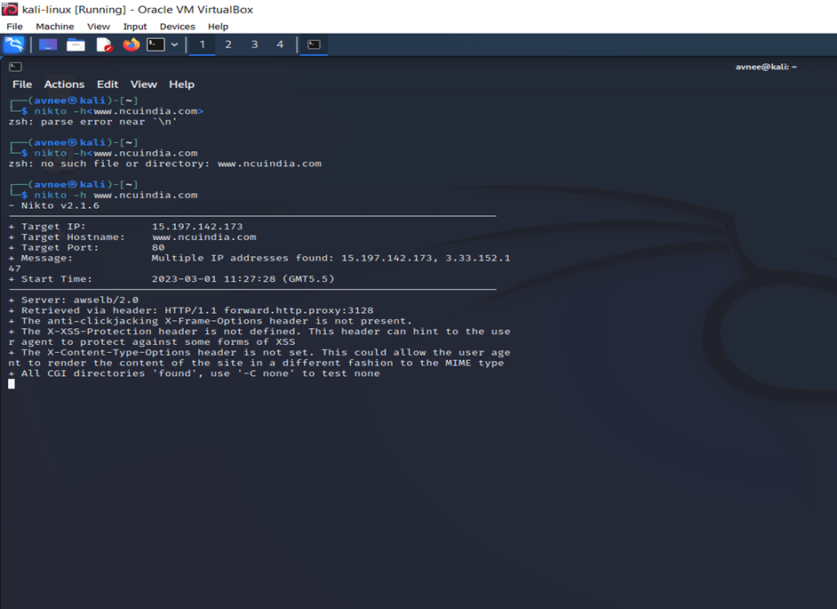

**Nessus**

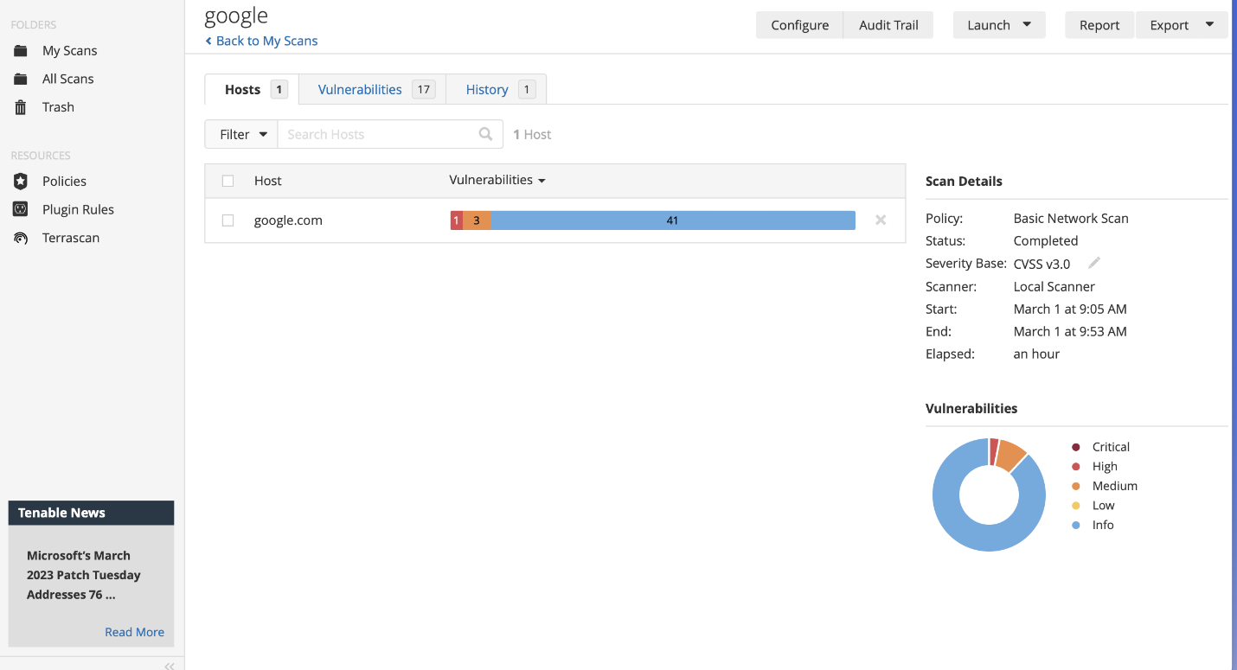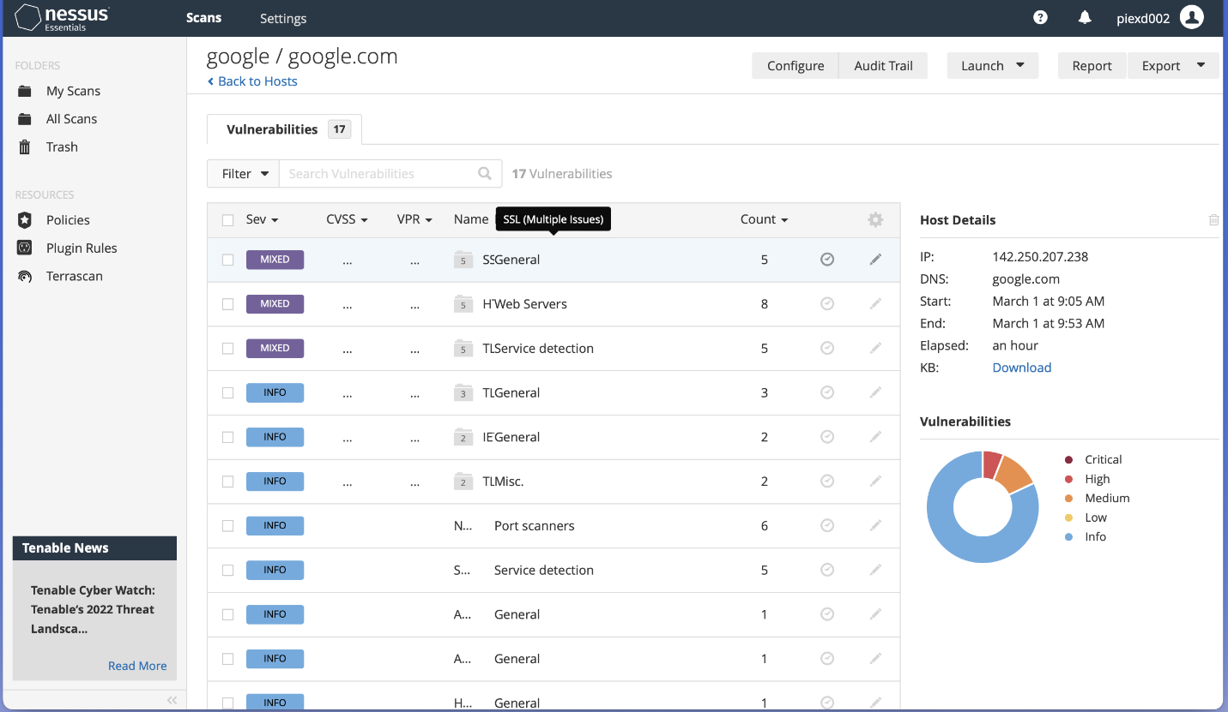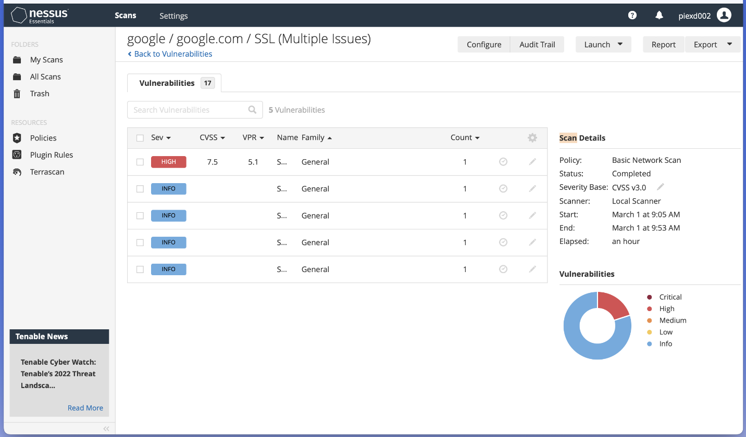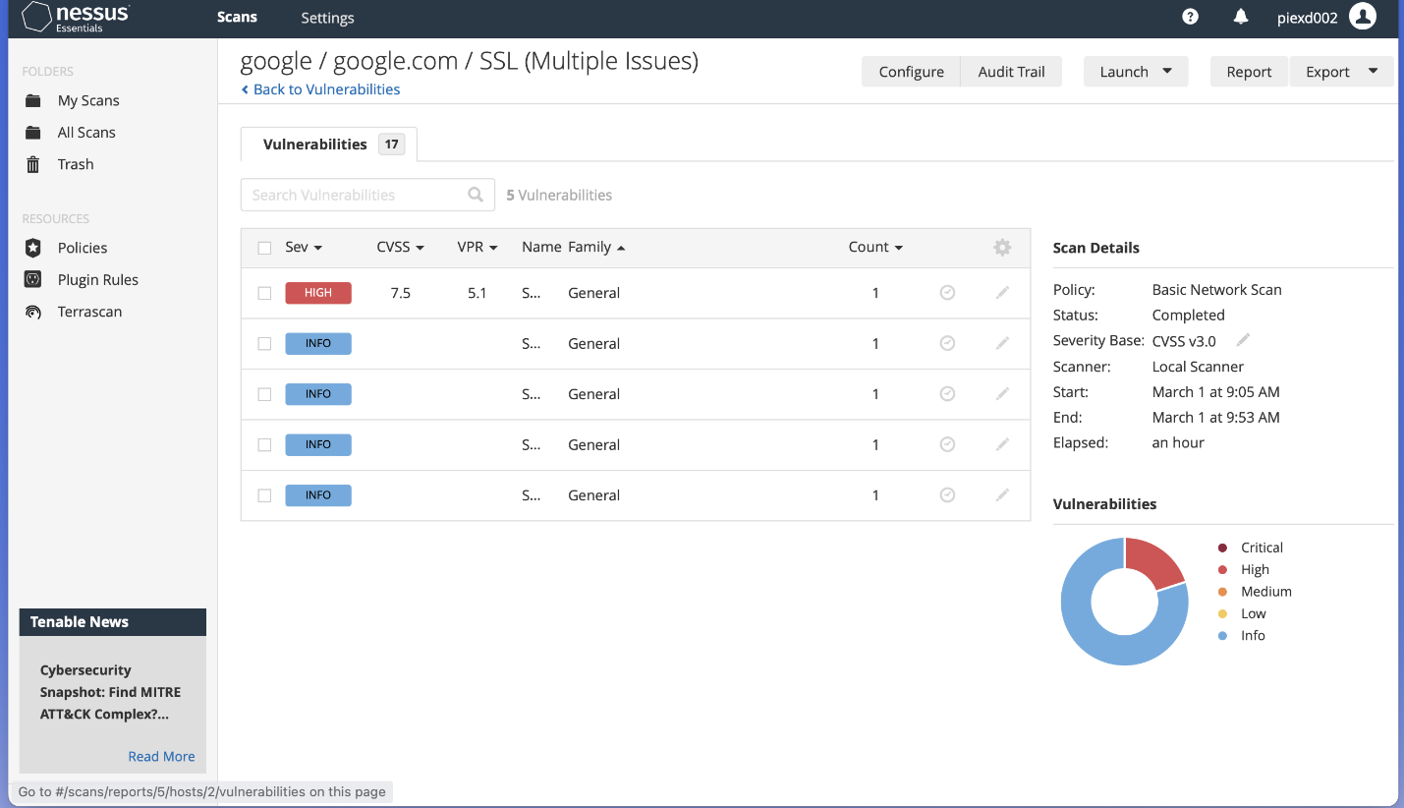

**EXPERIMENT NO. 5**

|  |
| --- |
| **Student Name and Roll Number:** Piyush Gambhir – 21CSU349 |
| **Semester /Section:** Semester-IV – AIML-B (AL-3) |
| **Link to Code:** |
| **Date:** |
| **Faculty Signature:** |
| **Marks:** |

|  |
| --- |
| **Objective:**  To familiarize the students with the concept of Second phase of penetration testing |
| **Outcome:**   * The students will be able to gather the information of the network by analyzing the traffic moving in and out from target machine * The students will understand Wireshark inbuilt Tool of Kali Linux |
| **Problem Statement:**   * Install Wireshark on any network and apply filters to gather different information of the target machine * Perform Session hijacking/ find credentials of unsecure real time website using Wireshark |
| **Background Study:**   * World’s foremost and widely-used network protocol analyzer. * Tells what’s happening on your network at a microscopic level * Standard across many commercial and non-profit enterprises, government agencies, and educational institutions. * got famous in black hat. * observes the messages exchanged. * Passive and Preinstalled in Kali Linux, for windows [http://www.wireshark.org](http://www.wireshark.org/). |
| **Question Bank:**   1. Differentiate between RST and FIN flag.   RST (Reset) and FIN (Finish) are both TCP (Transmission Control Protocol) flags used to terminate a connection, but they are used in different ways. RST is used to abruptly terminate a connection, often in response to a serious network problem or an attack, while FIN is used to signal a graceful termination of a connection. When a FIN flag is sent, it indicates that the sender has no more data to send, but is willing to receive data. When the receiving party acknowledges the FIN, it sends its own FIN to signal that it also has no more data to send, thus closing the connection.   1. What information can be retrieved from a sniffer?   A sniffer is a network tool that can capture and analyze network traffic. It can retrieve various types of information from the captured traffic, such as source and destination IP addresses, protocol types, packet size, packet content, etc. Sniffers can also detect and analyze network problems, such as packet loss, delays, and bandwidth issues. They can be used for debugging, troubleshooting, security auditing, and performance analysis of networked applications.   1. Is Wireshark an active or passive network scanning tool and why?   Wireshark is a passive network scanning tool. It captures and analyzes network traffic without actively sending any packets on the network. It operates by capturing packets that are already flowing on the network and then analyzing them. Passive tools are preferred over active tools in most cases because they do not interfere with the network or the devices on it, which can cause disruptions or even network failures.   1. What is a pcap file?   A pcap (packet capture) file is a file format used to store network packets captured by a sniffer or a network analyzer. Pcap files can be read and analyzed by various network tools, such as Wireshark, tcpdump, and Snort. They are useful for troubleshooting, network analysis, security auditing, and forensics.   1. How to combine filters in Wireshark to check the traffic from a particular IP and for http then.   To combine filters in Wireshark to check the traffic from a particular IP and for HTTP, you can use the following steps:   * 1. Launch Wireshark and start capturing traffic.   2. In the filter toolbar, type in the filter "ip.addr == [IP address]" where [IP address] is the IP address you want to filter traffic from. For example, if you want to filter traffic from the IP address 192.168.1.1, the filter would be "ip.addr == 192.168.1.1".   3. Press enter to apply the filter. Now, Wireshark will only display traffic from the specified IP address.   4. To further filter the traffic to only show HTTP traffic, type in the filter "http" in the filter toolbar and press enter.   5. Now, Wireshark will only display HTTP traffic from the specified IP address.   You can also combine the two filters into one by typing in "ip.addr == [IP address] && http" in the filter toolbar and pressing enter. This will display only HTTP traffic from the specified IP address. |

**Student Work Area**

**Algorithm/Flowchart/Code/Sample Outputs**

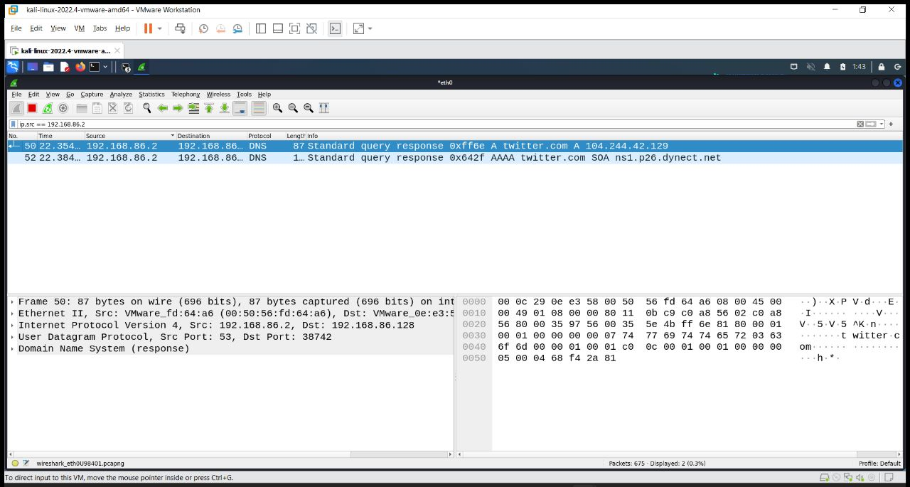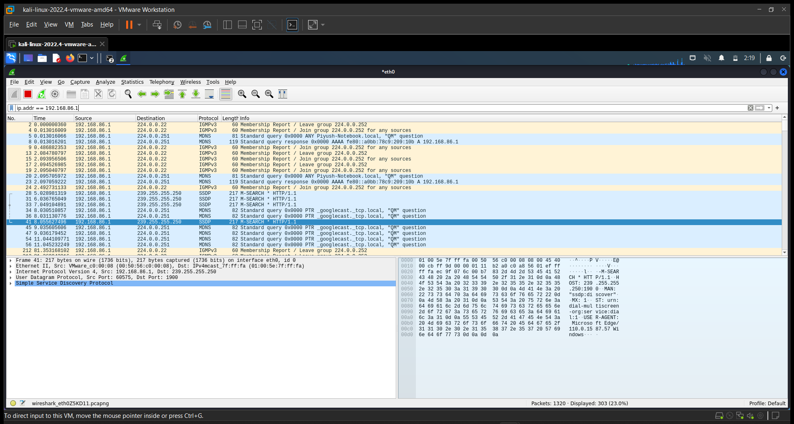

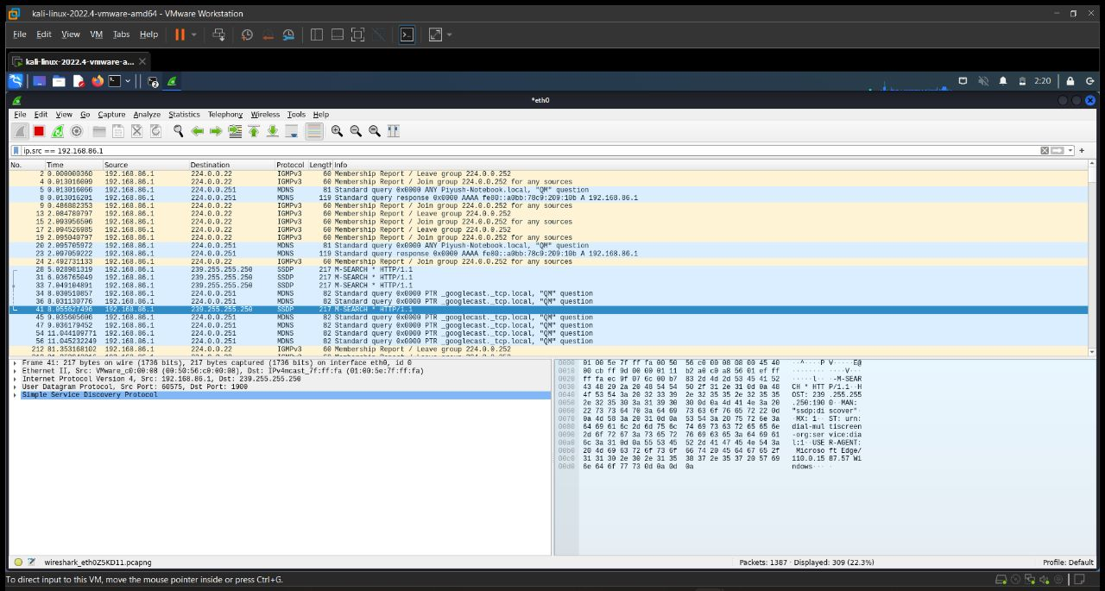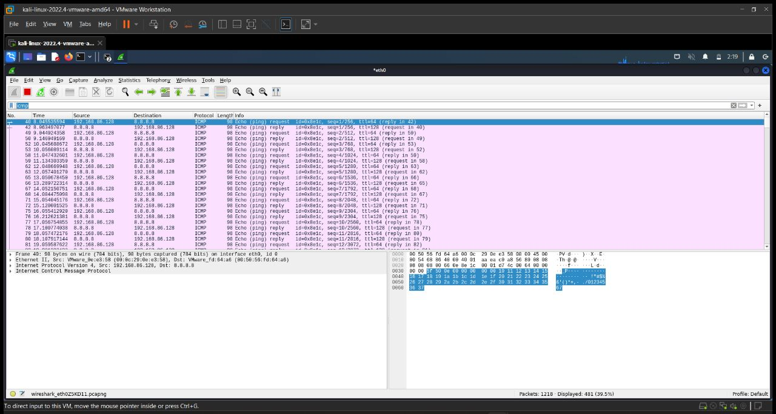

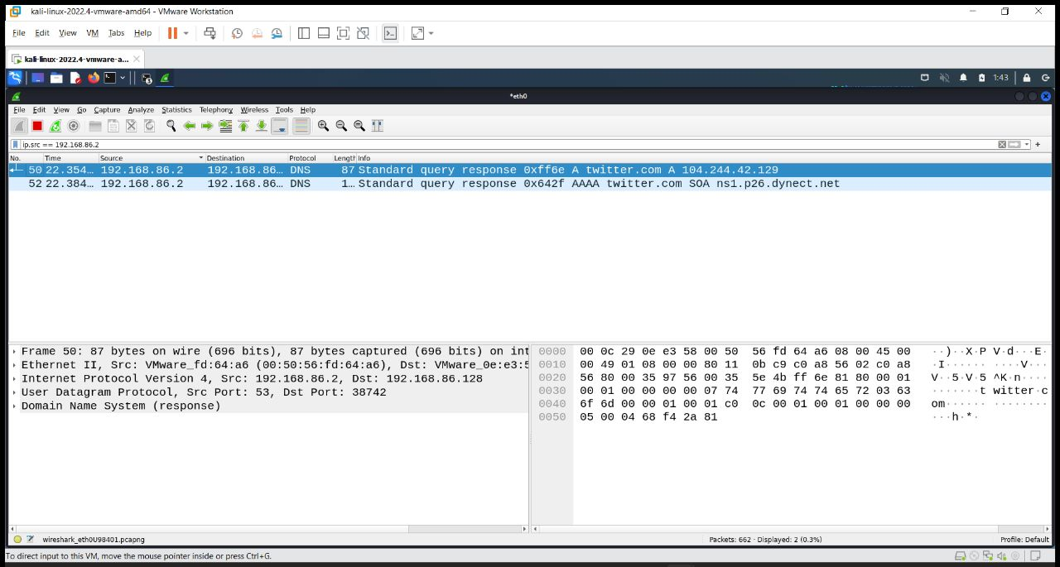

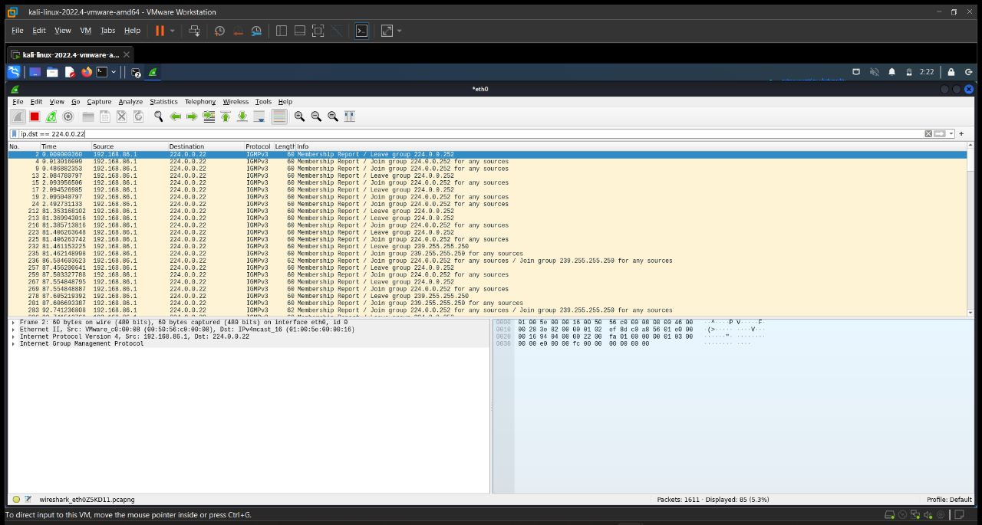

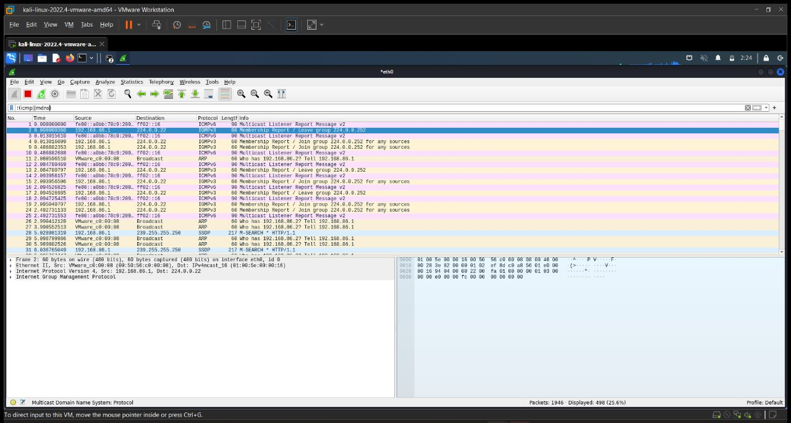

**EXPERIMENT NO. 6**

|  |
| --- |
| **Student Name and Roll Number:** Piyush Gambhir – 21CSU349 |
| **Semester /Section:** Semester-IV – AIML-B (AL-3) |
| **Link to Code:** |
| **Date:** |
| **Faculty Signature:** |
| **Marks:** |

|  |
| --- |
| **Objective:**  To familiarize the students with the concept of exploitation |
| **Outcome:**  The students will be able to gain access of target machine using Malware |
| **Problem Statement:**  Create Trojan and Exploit victim’s machine by taking its complete access |
| **Background Study:**   * Trojans are the malicious applications or programs which looks like a normal application but is harmful in nature as it can give the whole remote access of the Target's Machine to the Attacker's Machine. * E.g. Poke and take remote control of your machine * ways of remote connection   + Forward Connection   + Reverse connection |
| **Question Bank:**   1. What are the different types of Exploitation.   There are different types of exploitation techniques that attackers can use, including:  Code injection: This technique involves injecting malicious code into a system or application by exploiting vulnerabilities in the code, such as buffer overflows, SQL injection, or cross-site scripting (XSS) attacks. The injected code can then be used to execute arbitrary commands or gain unauthorized access to the system.  Privilege escalation: This technique involves exploiting vulnerabilities in a system to gain higher levels of privilege or access than are normally allowed. For example, an attacker may exploit a vulnerability in a web application to gain administrative privileges or use a zero-day exploit to gain root access to a system.  Social engineering: This technique involves manipulating people into divulging sensitive information or performing actions that can be exploited. For example, an attacker may use phishing emails or phone calls to trick users into giving away their login credentials or installing malware on their systems.  Password attacks: This technique involves using automated tools or manual methods to guess or crack passwords used to protect access to a system. Password attacks can include brute-force attacks, dictionary attacks, and other methods of guessing or cracking passwords.  Man-in-the-middle (MITM) attacks: This technique involves intercepting and modifying network traffic between two parties to gain access to sensitive information or perform unauthorized actions. MITM attacks can be used to steal credentials, modify data, or inject malware into network traffic.   1. Write a short note on RAT.   RAT (Remote Access Trojan) is a type of malware that provides attackers with unauthorized remote access and control over a victim's computer. RATs typically enter a system disguised as legitimate software or via phishing emails or drive-by downloads. Once installed, they create a backdoor on the victim's computer, allowing the attacker to remotely access and control the system.   1. Differentiate between socket and stub.   A socket is a software endpoint that enables communication between networked applications, while a stub is a software component that provides a stand-in for a remote procedure or function call in a distributed system. While both sockets and stubs play important roles in network communication, they serve different functions and are used in different parts of the protocol stack.   1. Which folder is created when the victim click on a dark comet?   The exact name and location of the folder created by DarkComet may vary depending on the specific version of the malware and the attacker's configuration. However, some common names and locations for the DarkComet folder include:  %AppData%\Roaming\Microsot\Windows\Start Menu\Programs\Startup\lsmose.exe  %ProgramFiles%\Intel\iCLS Client\lsmose.exe  %SystemDrive%\Program Files\Common Files\System\lsmose.exe   1. Find an application which can see the "Established" and "Listening" connection of a machine just like "netstat".   There are several applications available that can display established and listening network connections on a machine, similar to the netstat command. Here are a few examples:  TCPView: TCPView is a free Windows application that displays all current TCP and UDP connections, including those in the listening state. It provides a detailed view of each connection, including the local and remote IP addresses, port numbers, and process IDs.  Process Explorer: Process Explorer is another free Windows tool from Microsoft that provides a more advanced view of system processes and network connections than the built-in Task Manager. It can display established and listening connections, as well as provide detailed information about the processes that are using them.  CurrPorts: CurrPorts is a free Windows application that displays all open TCP/IP and UDP ports on a machine, including those in the listening state. It can also show the process that opened each port and the remote address of any established connections.  lsof: lsof is a command-line utility available on Unix and Unix-like systems that can display open files, including network connections. It can show established and listening connections, as well as provide detailed information about the processes that are using them. |

**Student Work Area**

**Algorithm/Flowchart/Code/Sample Outputs**

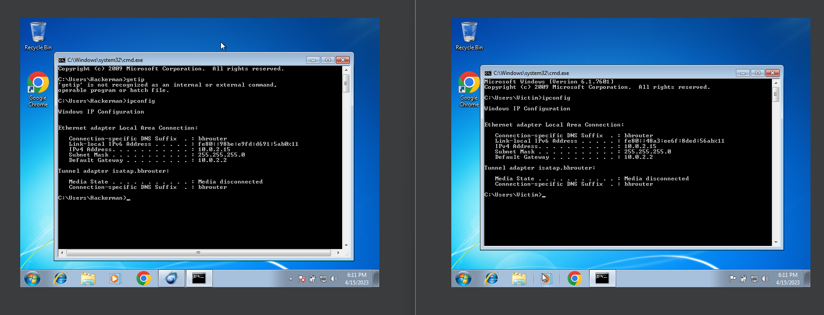

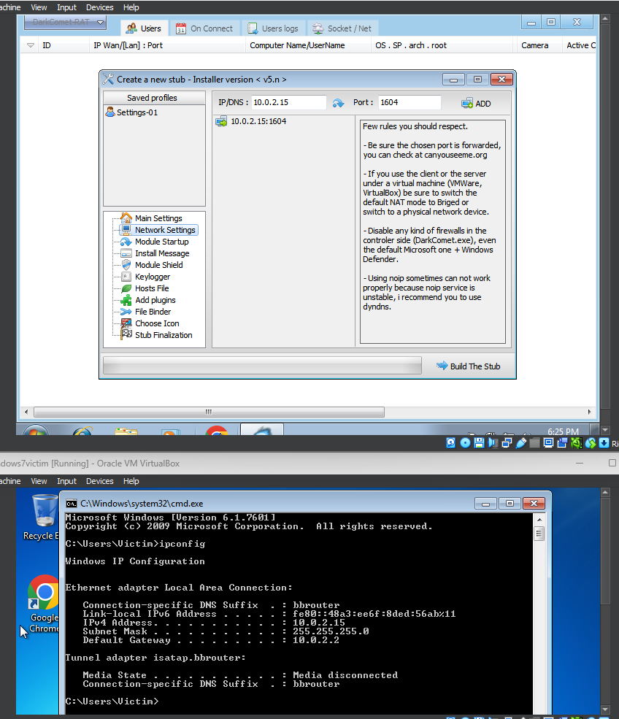

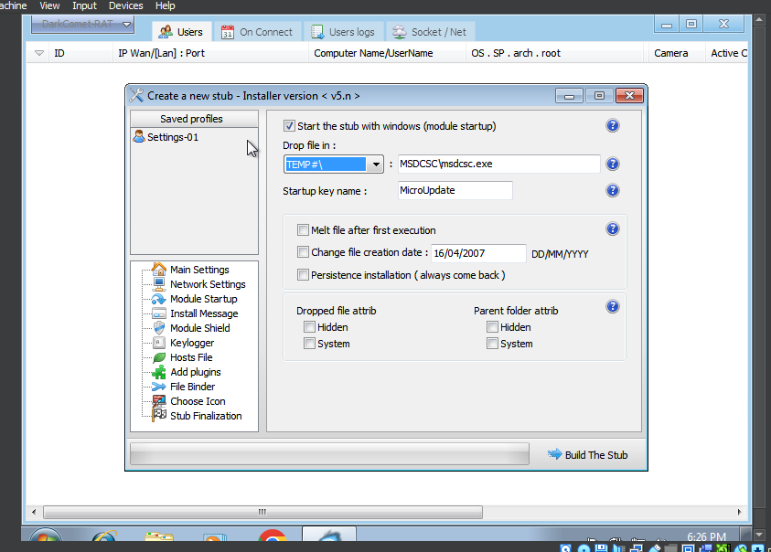

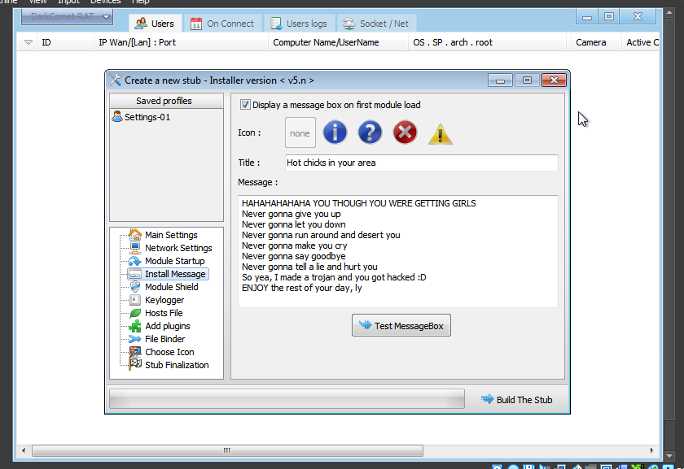

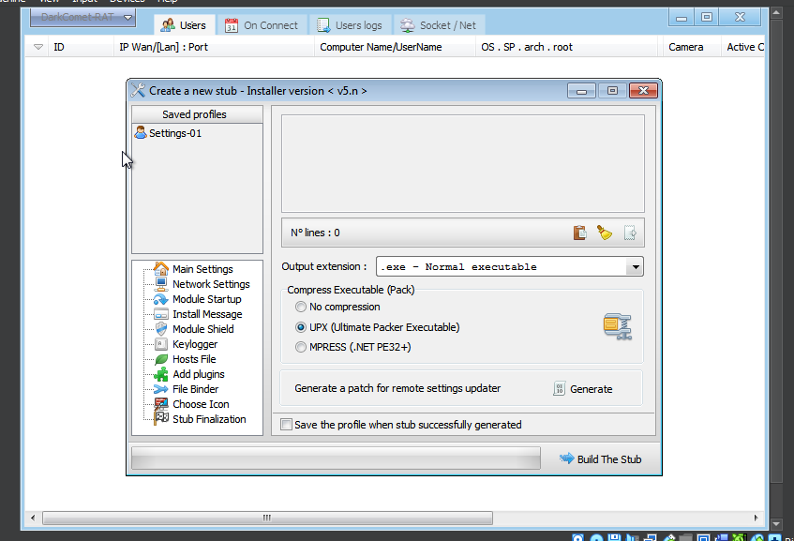

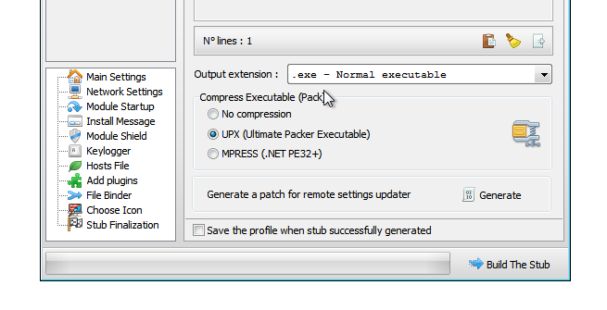

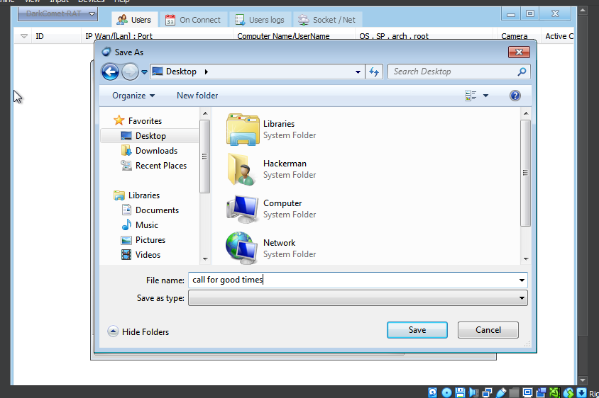

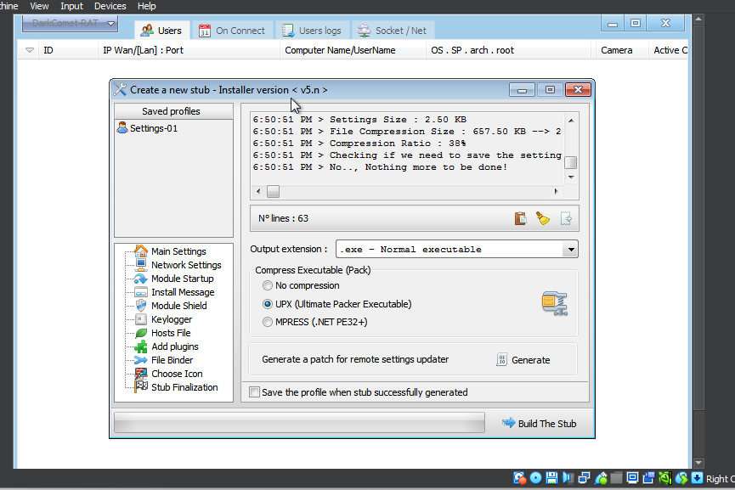

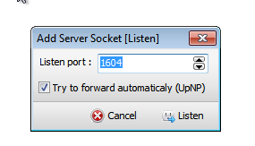

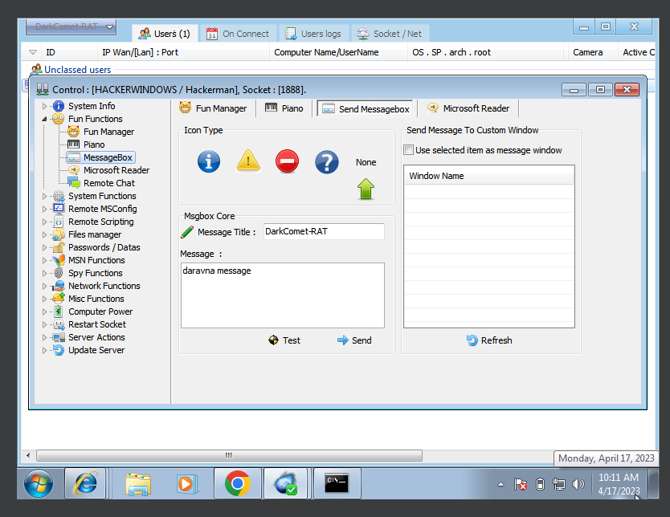

**EXPERIMENT NO. 7**

|  |
| --- |
| **Student Name and Roll Number:** Piyush Gambhir – 21CSU349 |
| **Semester /Section:** Semester-IV – AIML-B (AL-3) |
| **Link to Code:** |
| **Date:** |
| **Faculty Signature:** |
| **Marks:** |

|  |
| --- |
| **Objective:**  To familiarize the students with the concept of Third phase of penetration testing |
| **Outcome:**   * The students will be able to gather the keystrokes of target machine |
| **Problem Statement:**   * Track keystrokes of victim machine using Ardamax Keylogger |
| **Background Study:**   * Installed on a Victims computer. * records these keystrokes and stores them in the logs. * Starts operating in the background (stealth mode) and captures every keystroke of the target computer. * silent, does not show up in the start-menu, windows startup, program files, add/remove programs or the task manager.   Ardamax Keylogger   * <https://www.ardamax.com/keylogger> * Username: ardamax * Password: ardamax * After install you can delete but it is working (can check in task manager or triangle yellow icon on taskbar) * **Open and view logs** * It works on everything notepad, start, online accounts etc * **Hidden mode:** attacker can hide also (right click)- ctrl + H * **Invisibility option:** from task manager. It auto starts |
| **Question Bank:**   1. Differentiate between software and hardware keyloggers.   Software keyloggers are programs that are installed on the computer system, either intentionally or by stealth, and run in the background, capturing every keystroke made on the keyboard. The data collected by the software is then usually sent to a remote location for analysis or review. Software keyloggers can be installed remotely, making them a popular choice for cybercriminals seeking to gain unauthorized access to a computer system or network.  Hardware keyloggers, on the other hand, are physical devices that are inserted between the keyboard and the computer system. They are generally more difficult to detect than software keyloggers because they are not installed on the computer itself. Hardware keyloggers can be easily installed by physically plugging them in, and they do not require any special software to operate. They work by intercepting the signals that are sent from the keyboard to the computer and storing them in an internal memory. Some hardware keyloggers can also capture screenshots or record other types of data.   1. What are the different methods of installing a keylogger?   There are several methods of installing a keylogger, including:  Physical access: An attacker may physically access the victim's computer and install a keylogger software or hardware device.  Email attachments: An attacker may send an email to the victim with an attachment that contains the keylogger. Once the attachment is downloaded and opened, the keylogger gets installed.  Software bundle: Some freeware or shareware software may come bundled with a keylogger. When the software is downloaded and installed, the keylogger also gets installed.  Social engineering: An attacker may use social engineering tactics to trick the victim into installing the keylogger. For example, the attacker may send an email posing as a legitimate company and request the victim to download and install a software update. The update may actually be a keylogger.  Malware: Keyloggers can also be installed through malware infections, such as Trojans or viruses. The malware may be downloaded and installed by the user unknowingly or as a result of visiting a malicious website.   1. List 5 open source keyloggers.   1 Spyrix Free Keylogger  2 Kidlnspector  3 Actual Keylogger  4 REFOG Free Keyloger  5 Iwantsoft Free Keylogger  6 KidLogger   1. Can Ardamax keylogger record audio of a victim's machine?   Yes, Ardamax keylogger has the capability to record audio from the victim's machine. It can record sound from the microphone and save it in an audio file on the attacker's computer. However, it's important to note that recording audio without the victim's knowledge and consent is illegal and unethical.   1. What is the use of Crypter software?   Crypter software is used to encrypt and obfuscate malicious code such as viruses, Trojans, and keyloggers. It is typically used by attackers to evade detection by antivirus software and to make their malware more difficult to analyze. Crypters work by encrypting the malicious code and embedding it in a harmless file such as an image or document. When the victim opens the file, the encrypted code is decrypted and executed, allowing the attacker to gain control of the victim's computer. Crypters can be purchased on the dark web or developed by attackers themselves. |

**Student Work Area**

**Algorithm/Flowchart/Code/Sample Outputs**

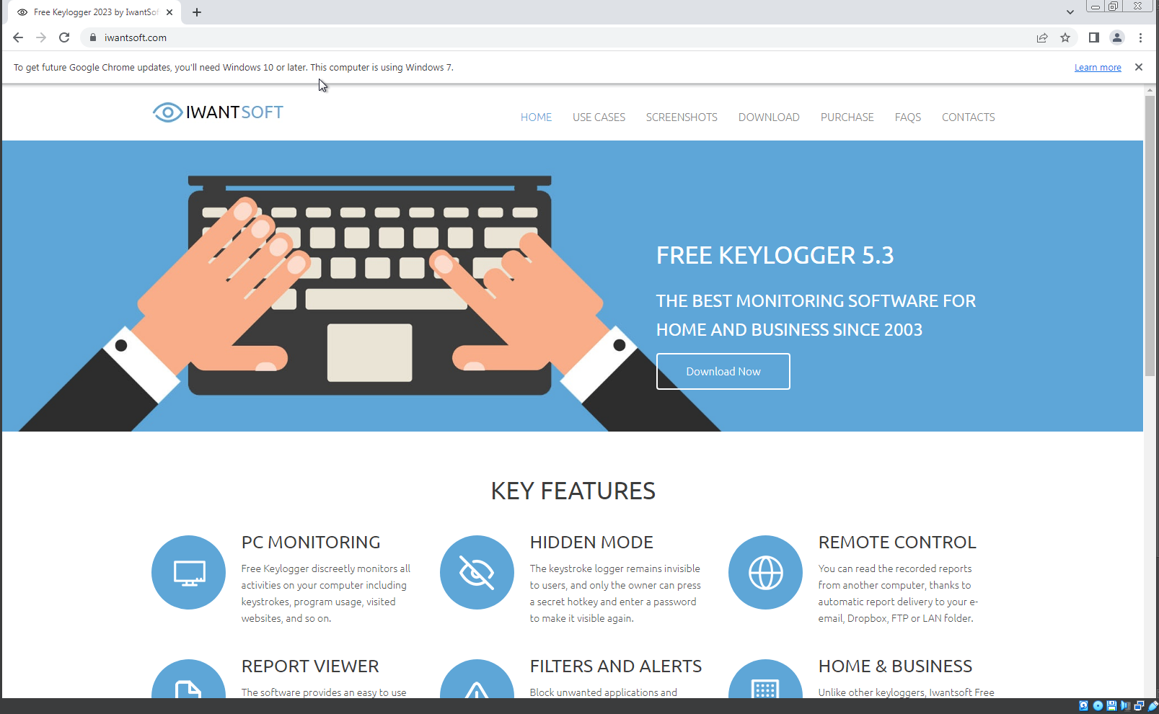

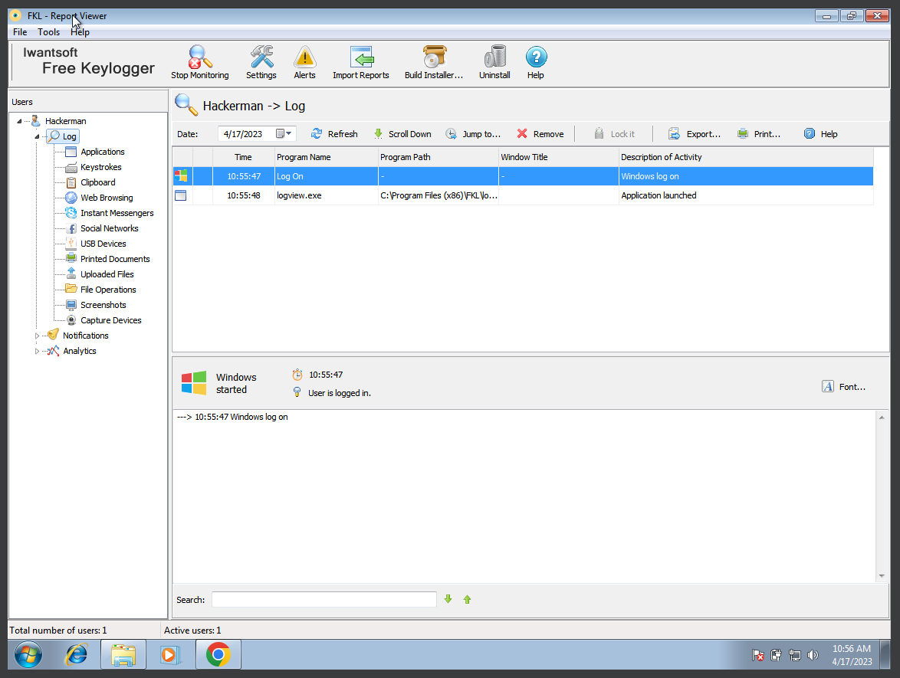

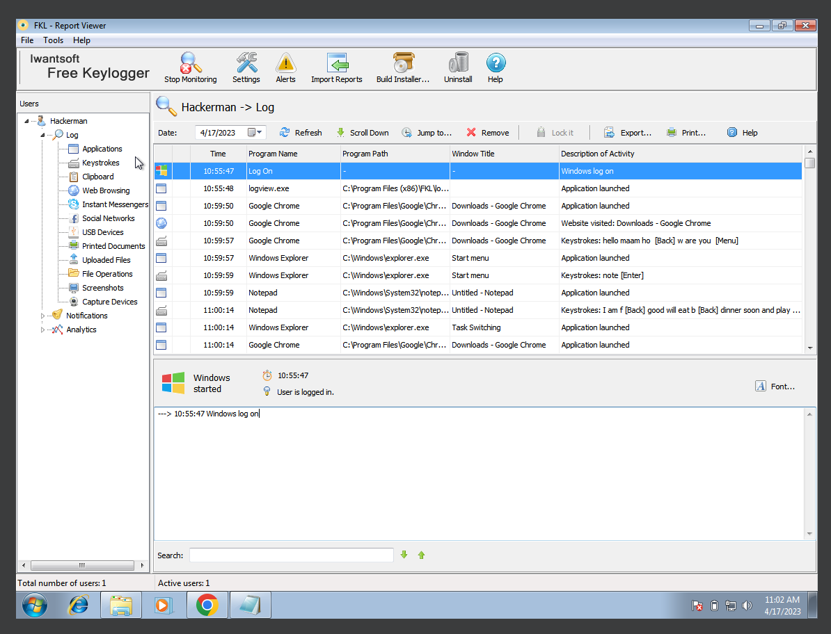

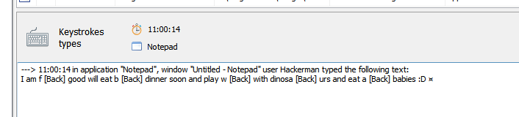

**EXPERIMENT NO. 8**

|  |
| --- |
| **Student Name and Roll Number:** Piyush Gambhir – 21CSU349 |
| **Semester /Section:** Semester-IV – AIML-B (AL-3) |
| **Link to Code:** |
| **Date:** |
| **Faculty Signature:** |
| **Marks:** |

|  |
| --- |
| **Objective:**  To familiarize the students with the concept of Linux to extract information |
| **Outcome:**   * The students will be able to learn commands of Linux required for exploitation * Student will be able to change permissions of the Files and Folders |
| **Problem Statement:**   * Execute basic commands of Linux * Use CHMOD command to change the privileges and permissions |
| **Background Study:**   * Linux word derived and evolved from UNIX. * Unix was the first operating system came to existence with CLI environment and mainly used for server side working as per today's requirements. * It is the most flexible and customizable OS used by skilled individuals. * It is an open source   Linux File Hierarchy Structure - GeeksforGeeks  Crunch Min.Value Max.Value Characters   Example –  crunch 4 4 0123456789 |
| **Question Bank:**   1. Which command is used to make a directory in LINUX?   The command used to make a directory in LINUX is "mkdir". For example, to create a directory named "mydir", the command would be "mkdir mydir".   1. What is the use of grep command?   The command used to make a directory in LINUX is "mkdir". For example, to create a directory named "mydir", the command would be "mkdir mydir".   1. Which command is used to find out all the information about the OS?   The command used to find out all the information about the OS in LINUX is "uname". It is used to display system information such as the kernel name, operating system, machine hardware name, and more. The command syntax is "uname [option]". For example, to display the kernel name, the command would be "uname -s".   1. Explain the following syntax: "chmod 754 filename".   The command used to find out all the information about the OS in LINUX is "uname". It is used to display system information such as the kernel name, operating system, machine hardware name, and more. The command syntax is "uname [option]". For example, to display the kernel name, the command would be "uname -s".   1. Elaborate on the different privileges and permissions in LINUX.   In LINUX, there are three types of permissions: read, write, and execute. These permissions are assigned to three different groups: owner, group, and others.  Use **–b option** for wordlist fragmentation that split a single wordlist into multi wordlist   1. crunch 5 7 raj@123 -b 3mb -o START   Crunch let you generate compress wordlist with **option –z** and other parameters are gzip, bzip2, lzma, and 7z     1. crunch 5 7 raj@123 –z gzip -o START   **-p** option is used for generating wordlist with help of permutation, here can ignore min and max length of the character string     1. crunch 3 6 -p raj chandel hackingarticles      1. crunch 5 5 IGNITE -c 25 -o /root/Desktop/8.txt   **use –d** option to set the filter for repetition. |

**Student Work Area**

**Algorithm/Flowchart/Code/Sample Outputs**

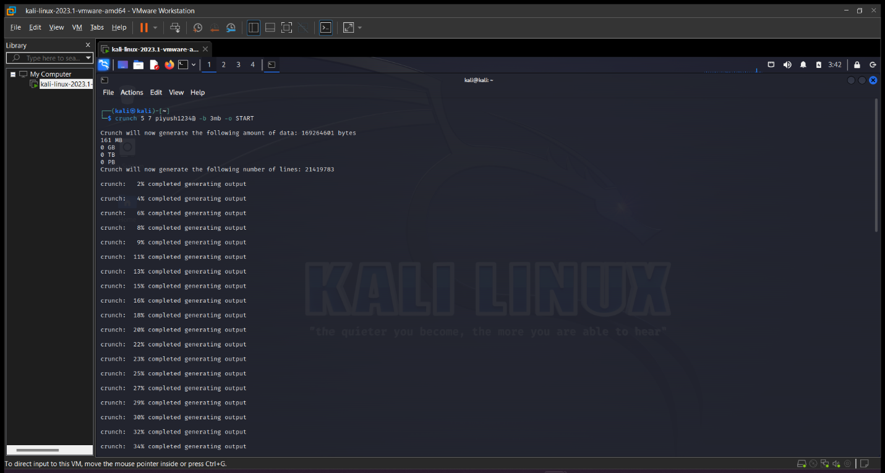

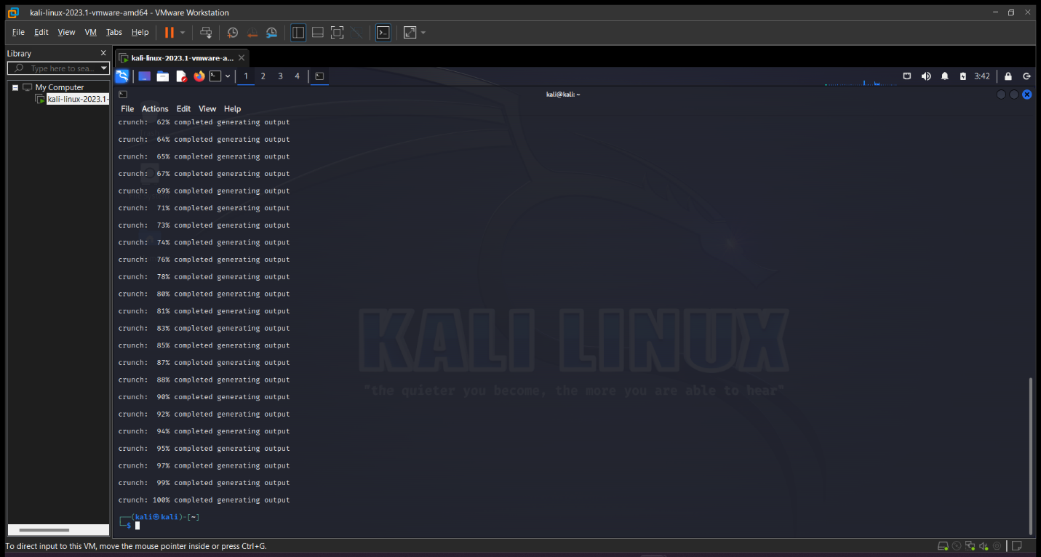

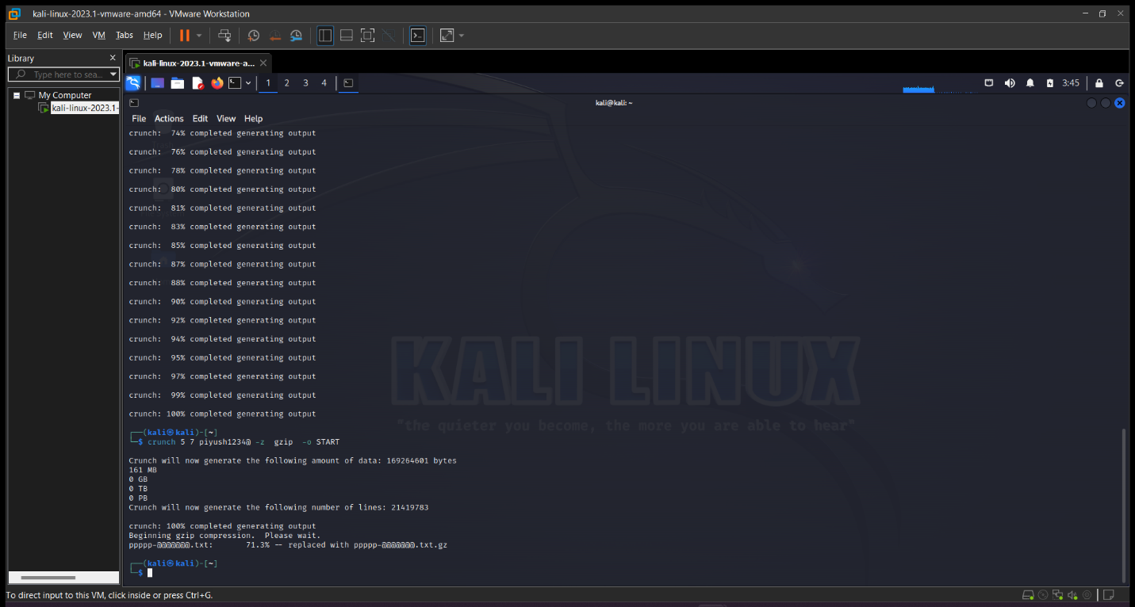

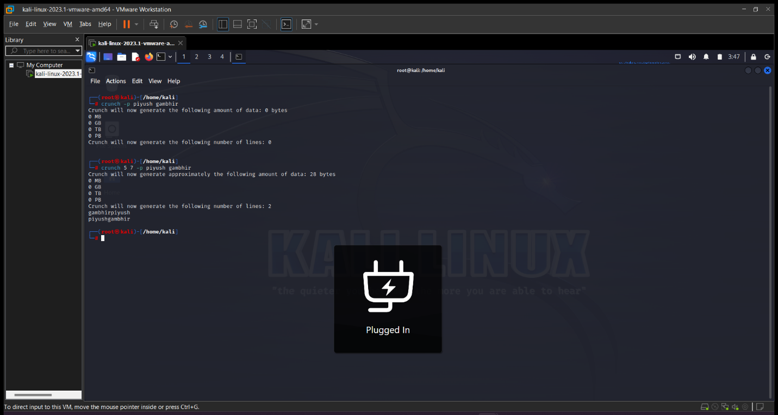

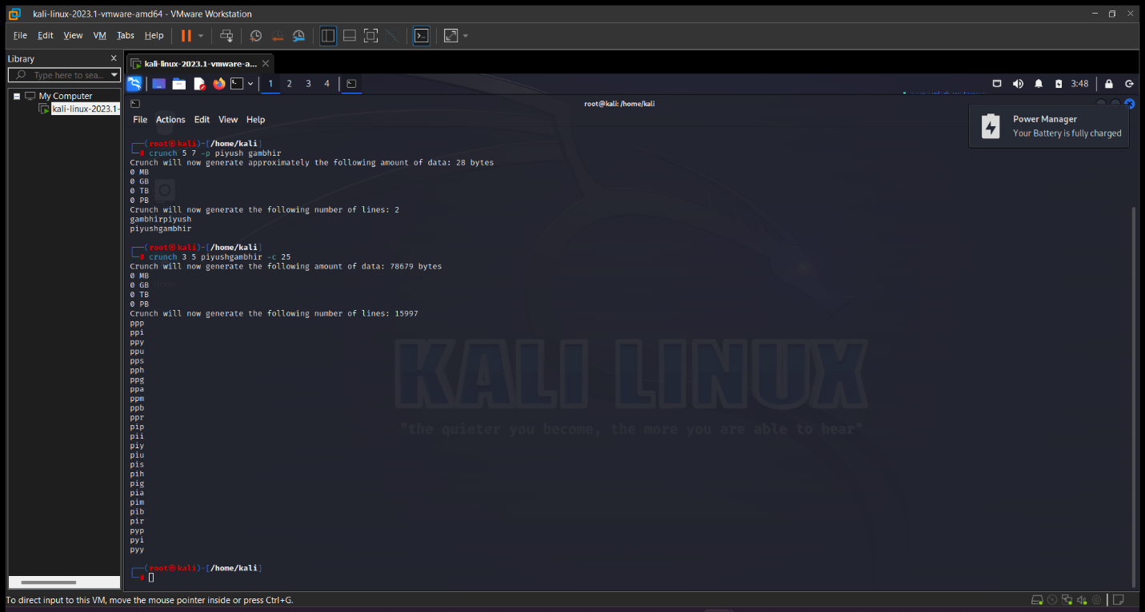

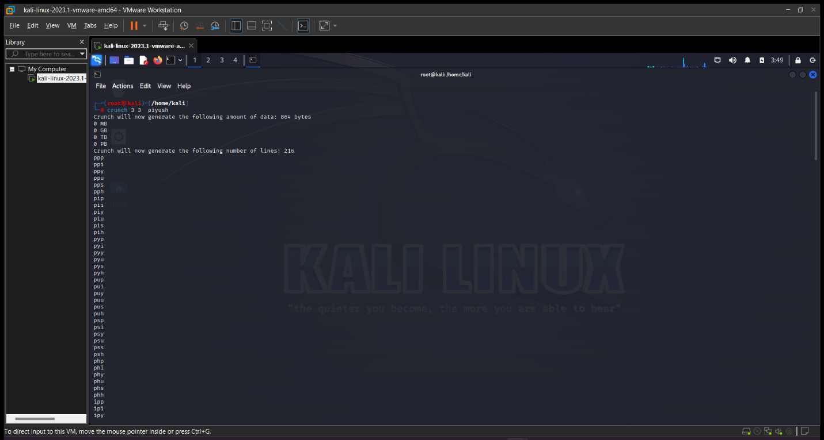

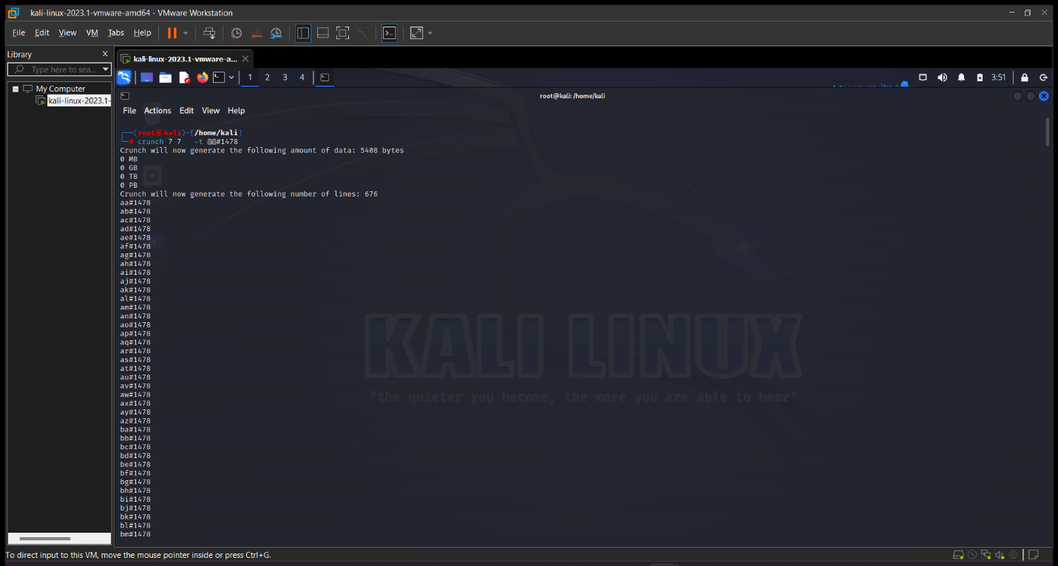

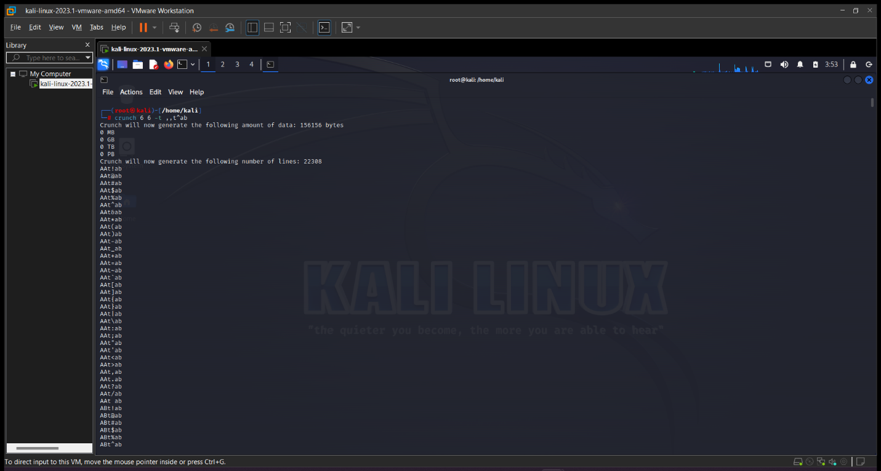

**EXPERIMENT NO. 9**

|  |
| --- |
| **Student Name and Roll Number:** Piyush Gambhir – 21CSU349 |
| **Semester /Section:** Semester-IV – AIML-B (AL-3) |
| **Link to Code:** |
| **Date:** |
| **Faculty Signature:** |
| **Marks:** |

|  |
| --- |
| **Objective:**  To familiarize the students with the concept of Bypass the Login of Windows. |
| **Outcome:**   * The students will be able to Bypass the login details of target in active and passive mode on all type of operating system |
| **Problem Statement:**   * Perform windows Login Bypass using netuser and John the Ripper Tool |
| **Background Study:**   * Login Bypass   + Online Method     - System Unlocked   + Offline Method     - System locked |
| **Question Bank:**   1. Which command is used to create new user after Windows Login bypass?   In Windows, the "net user" command can be used to create a new user after a login bypass. The syntax for creating a new user is "net user username password /add". For example, to create a new user named "newuser" with the password "password123", the command would be "net user newuser password123 /add".   1. How to remove the password of a victim's Window machine?   To remove the password of a victim's Windows machine, you can use the command "net user" in combination with the username of the victim's account. The syntax for removing a password is "net user username *". When prompted to enter a new password, simply press Enter without entering any value. This will remove the password for the user account.   1. How to change the password of a victim's Window machine?   To change the password of a victim's Windows machine, you can use the "net user" command in combination with the username of the victim's account. The syntax for changing a password is "net user username newpassword". For example, to change the password for a user named "johndoe" to "newpassword123", the command would be "net user johndoe newpassword123".   1. What is the purpose of the following command: net user gg /delete   The command "net user gg /delete" is used to delete a user account named "gg" from a Windows machine. This command will permanently delete the user account and all associated files and data. This command should be used with caution, as it cannot be undone.   1. Write a short note on **RainbowCrack** tool.   RainbowCrack is a popular password cracking tool that is used to crack password hashes using precomputed tables called "rainbow tables". These tables contain a large number of precomputed hash chains that can be used to crack password hashes quickly. RainbowCrack supports a wide range of hash types and can be used on both Windows and LINUX systems. However, it is important to note that RainbowCrack is illegal to use on password hashes without permission from the owner of the system. |

**Student Work Area**

**Algorithm/Flowchart/Code/Sample Outputs**

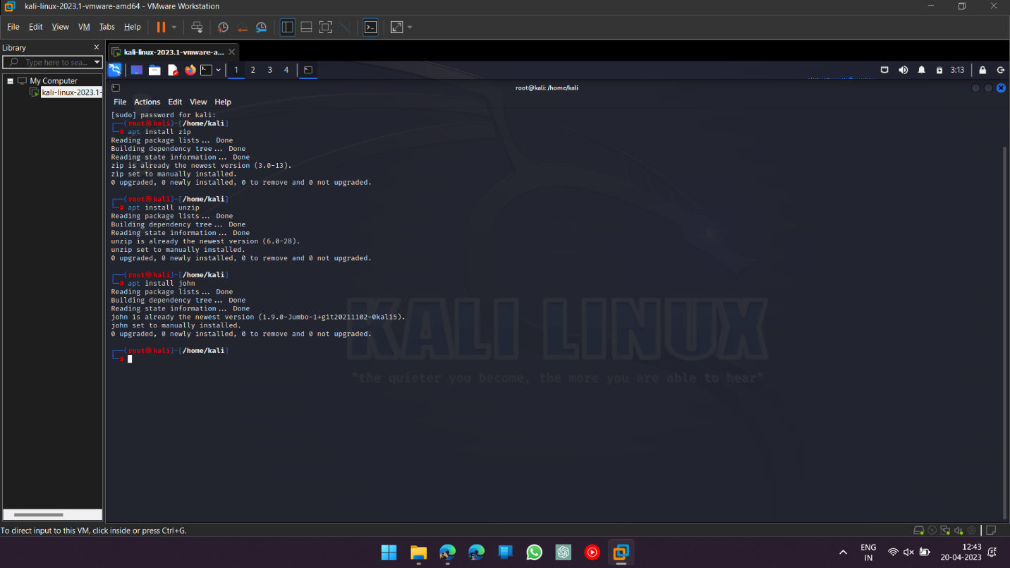

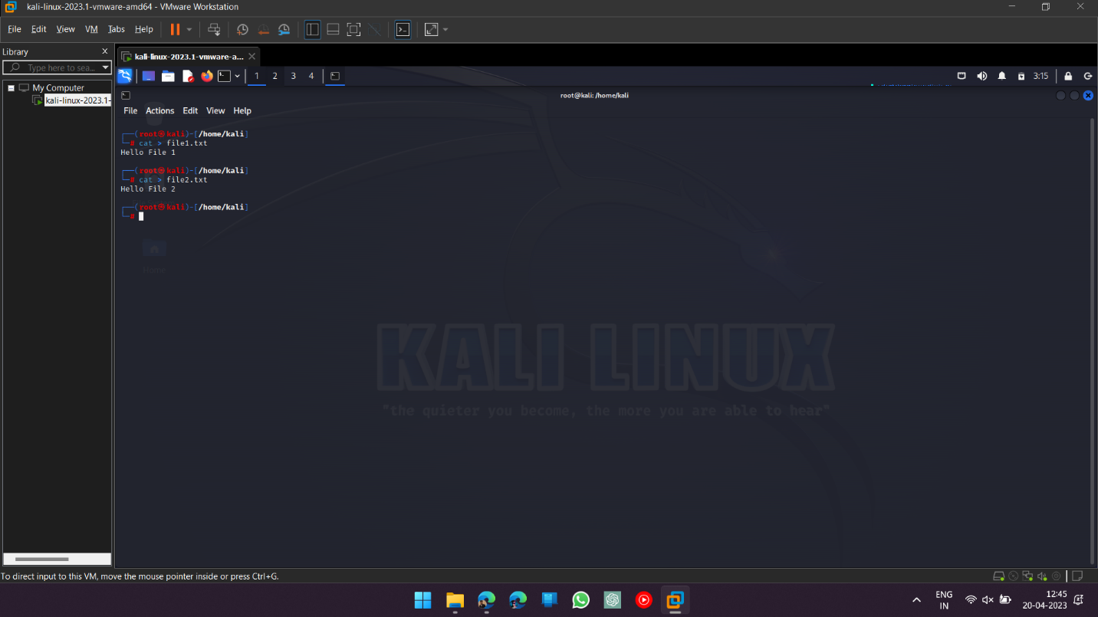

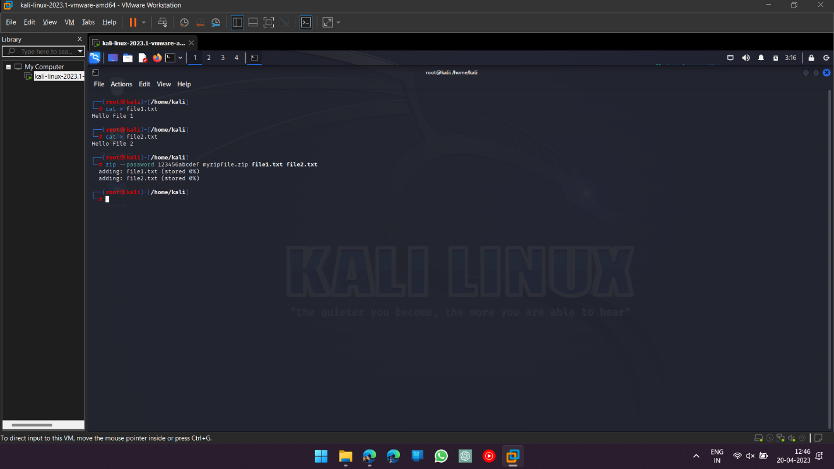

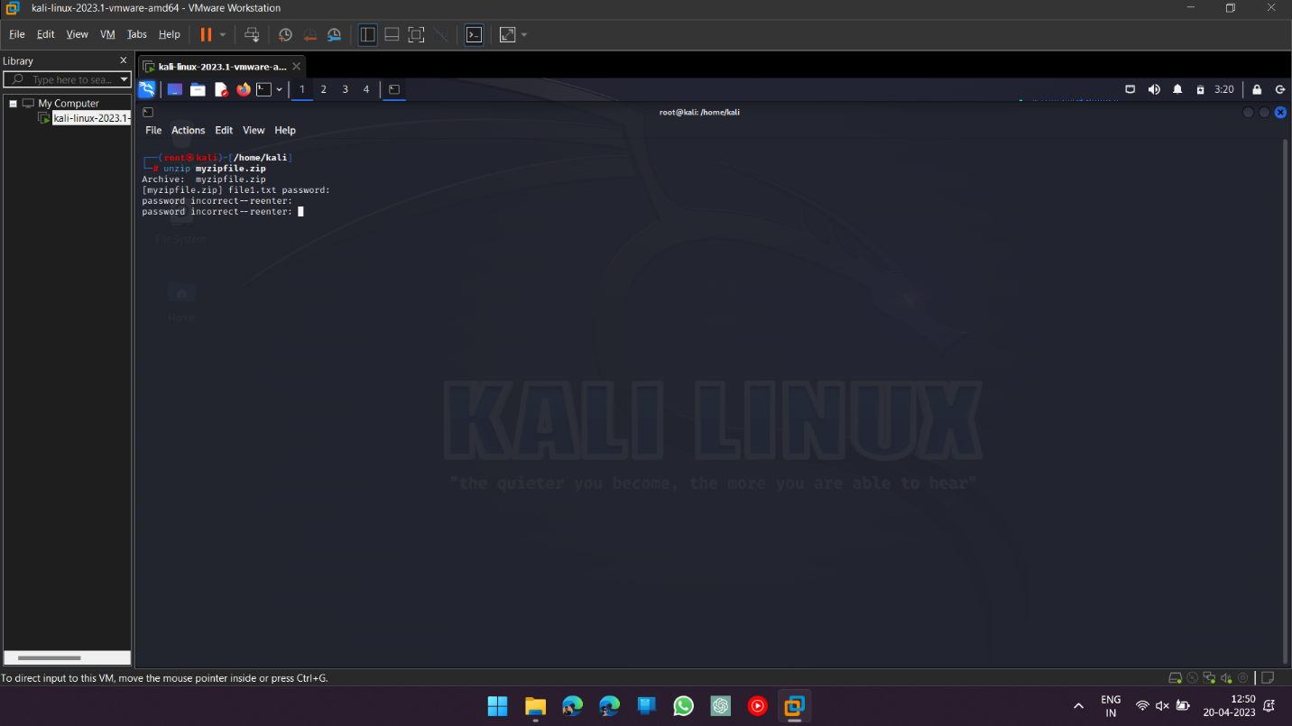

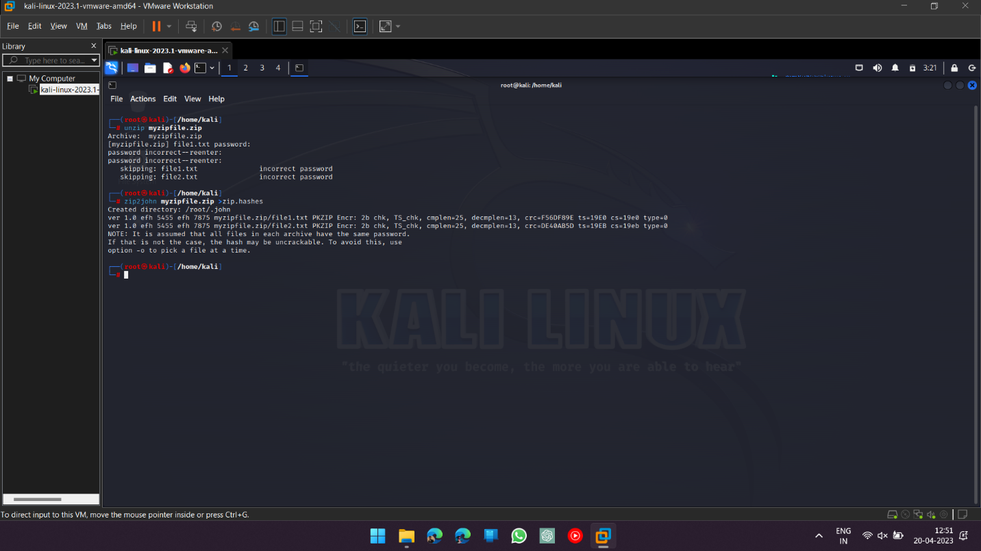

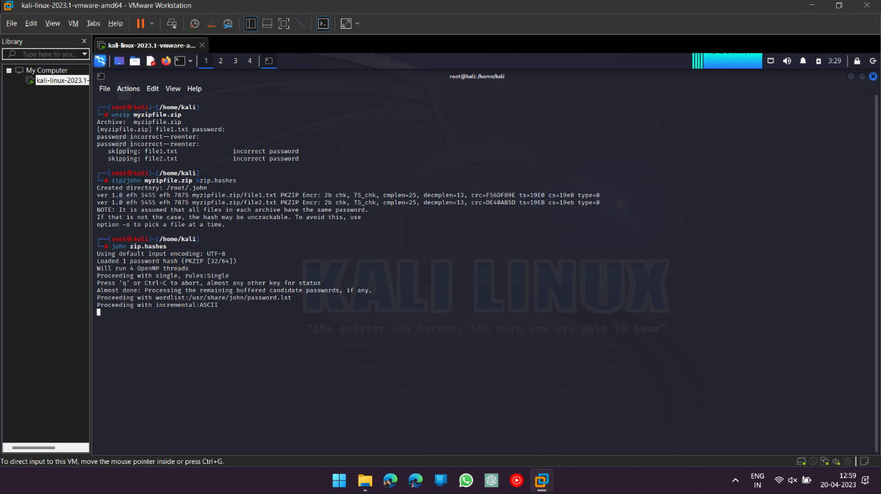

**EXPERIMENT NO. 10**

|  |
| --- |
| **Student Name and Roll Number:** Piyush Gambhir – 21CSU349 |
| **Semester /Section:** Semester-IV – AIML-B (AL-3) |
| **Link to Code:** |
| **Date:** |
| **Faculty Signature:** |
| **Marks:** |

|  |
| --- |
| **Objective:**  To familiarize the students with the concept of Bypass the Login of Linux and MAC |
| **Outcome:**   * The students will be able to Bypass the login details of target in active and passive mode on all type of operating system |
| **Problem Statement:**   * Perform Kali Linux Login Bypass in virtual machine * Perform MAC Login Bypass in virtual machine |
| **Background Study:**  Bypassing Login of Kali Linux and MAC:  **forgot kali linux password** |
| **Question Bank:**   1. Write a short note on **John the Ripper** tool.   John the Ripper is a popular open-source password cracking tool that is used to find weak passwords. It can crack passwords by using dictionary attacks, brute force attacks, and hybrid attacks. The tool supports many different password hash types and can run on a variety of operating systems, including LINUX. John the Ripper is often used by security professionals to test the strength of their organization's passwords.   1. Can **THC Hydra** tool be used for cracking LINUX machine password?   Yes, THC Hydra is a popular network login cracking tool that can be used to crack LINUX machine passwords. It is a command-line tool that supports a variety of network protocols, including SSH, Telnet, and FTP. THC Hydra can use a variety of different attack methods, including brute force and dictionary attacks, to crack passwords.   1. Which file allows the hacker to see user information such as full name, phone number etc. in LINUX?   In LINUX, the file that contains user information such as full name, phone number, and other personal details is the "/etc/passwd" file. This file contains a list of all the users on the system and their associated information. However, this file does not contain passwords, as passwords are stored in a separate file called "/etc/shadow".   1. Which permission value in LINUX allows to read and execute?   The permission value in LINUX that allows a user to read and execute a file or directory is "5". This permission value is represented by the digit "5" in the permission string. In the permission string, the first digit represents the owner's permissions, the second digit represents the group's permissions, and the third digit represents the permissions for others. The number "4" represents read permission, the number "2" represents write permission, and the number "1" represents execute permission. Therefore, the number "5" represents read and execute permission.   1. What is the UID of root user in LINUX?   The UID (user ID) of the root user in LINUX is "0". The root user is a superuser who has full control over the system and can perform any action on the system. The root user is often used for system administration tasks and should be used with caution, as any mistakes or errors made by the root user can have serious consequences. |

**Student Work Area**

**Algorithm/Flowchart/Code/Sample Outputs**

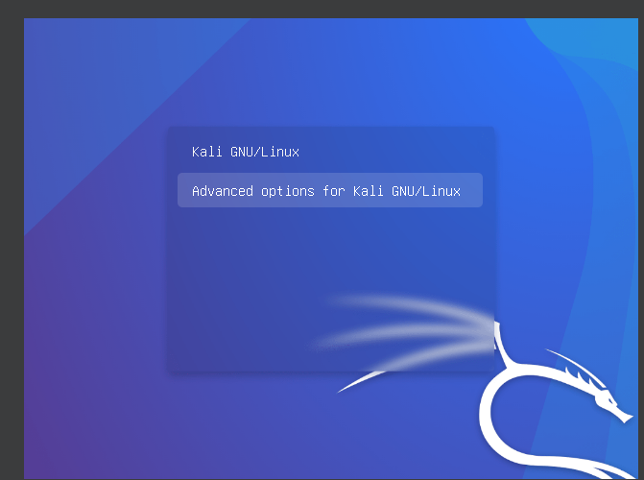

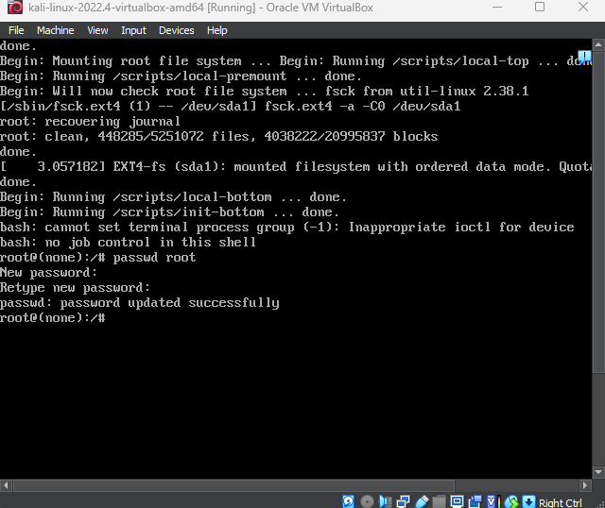

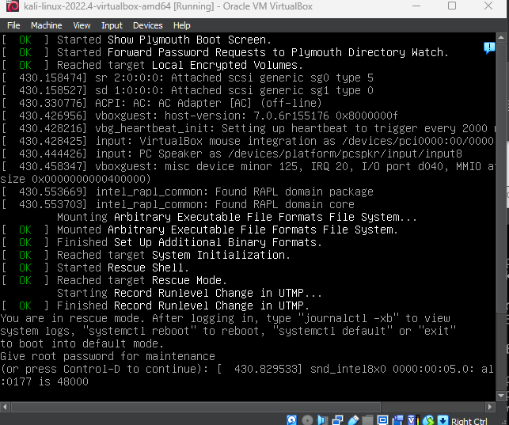

**EXPERIMENT NO. 11**

|  |
| --- |
| **Student Name and Roll Number:** Piyush Gambhir – 21CSU349 |
| **Semester /Section:** Semester-IV – AIML-B (AL-3) |
| **Link to Code:** |
| **Date:** |
| **Faculty Signature:** |
| **Marks:** |

|  |
| --- |
| **Objective:**  To familiarize the students with the concept of Third and Fourth phase of penetration testing |
| **Outcome:**   * The students will be able to gain and maintain access of the target machine using pdf file |
| **Problem Statement:**  Exploit Windows to gain access of victim’s machine using Metasploit framework |
| **Background Study:**   * Exploit Windows 7 using Metasploit framework |
| **Question Bank:**   1. What is Metepreter?   Meterpreter is a post-exploitation tool that is used as a payload to gain control of a victim's computer and execute commands on the compromised system. It is a powerful and flexible tool used by penetration testers and hackers to perform various tasks such as remote access, file system manipulation, privilege escalation, and data theft.   1. Explain the Msfvenom commands required to generate payload.   Explanation of the command:  -p: specifies the payload to use, in this case, windows/meterpreter/reverse_tcp.  LHOST: specifies the IP address of the attacker's machine.  LPORT: specifies the port number to listen on for incoming connections from the target machine.  -f: specifies the output format of the payload, in this case, exe.  > shell.exe: redirects the output to a file named shell.exe.   1. Write the command to start key scanner on victim’s machine.   keyscan_start   1. What is the output of following command - keyscan_dump.   It Will print the logged keys onscreen   1. Write the command to upload a file in window’s F drive after getting meterpreter access.   upload command |

**Student Work Area**

**Algorithm/Flowchart/Code/Sample Outputs**

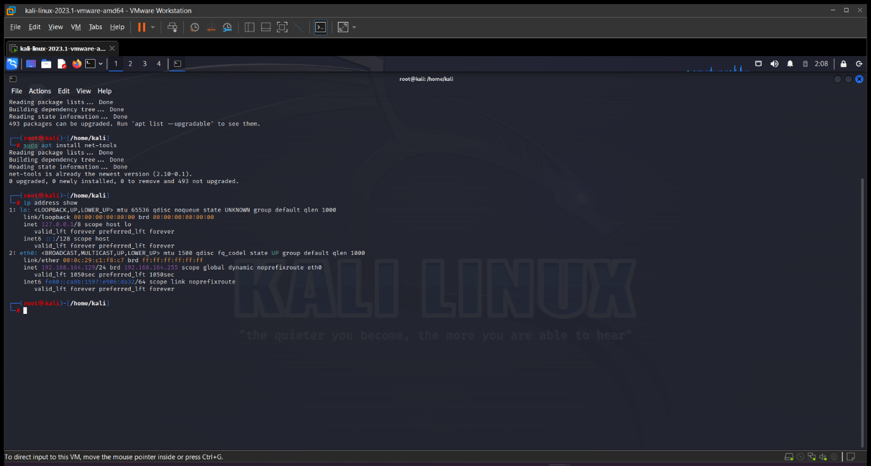

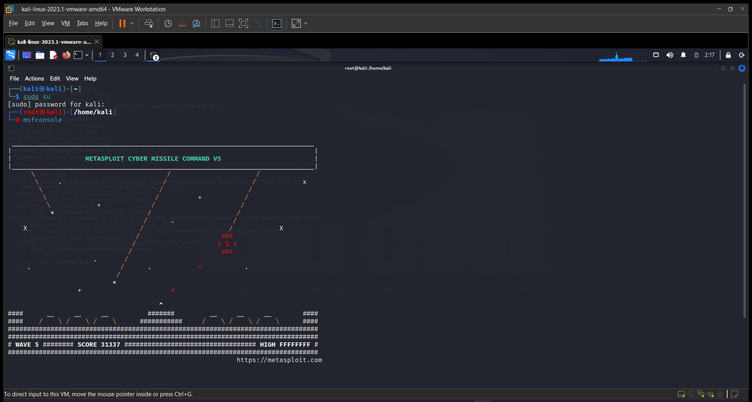

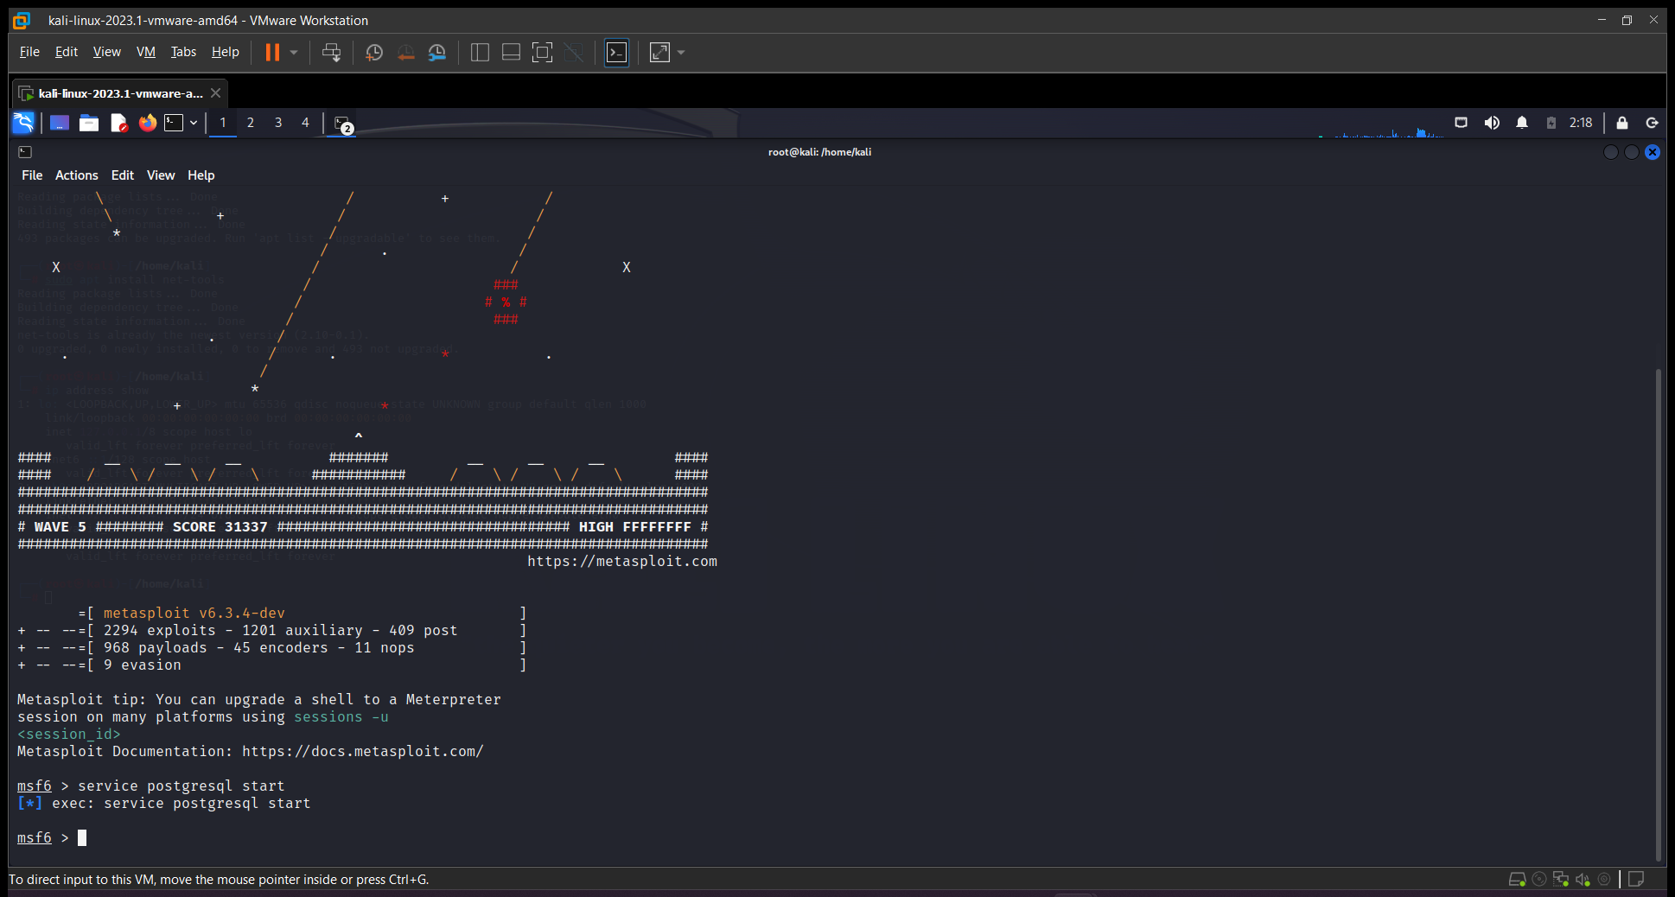

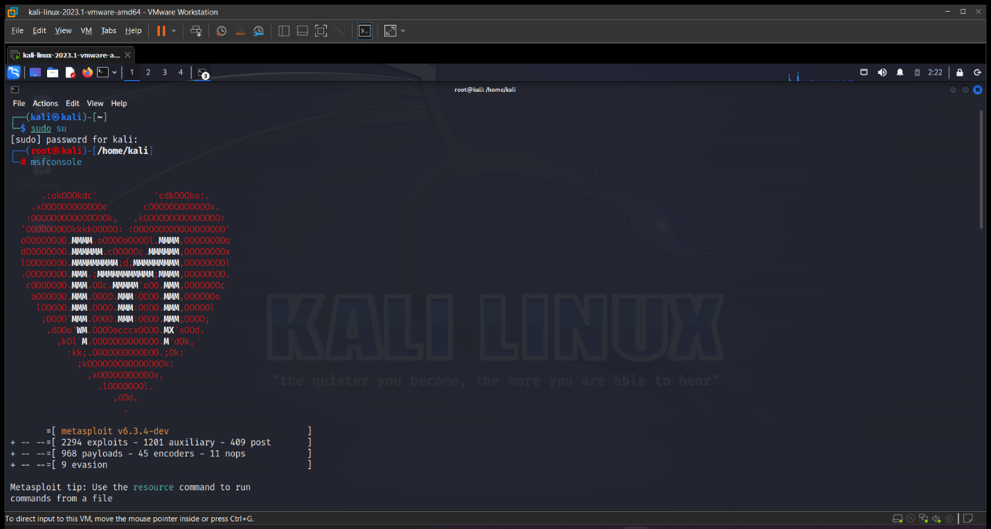

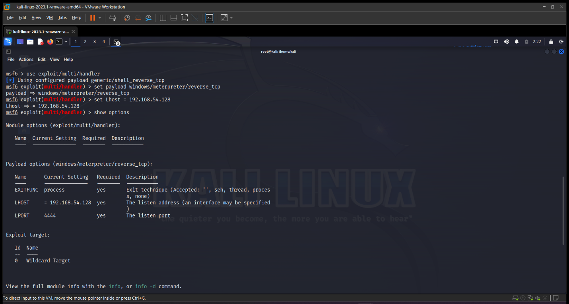

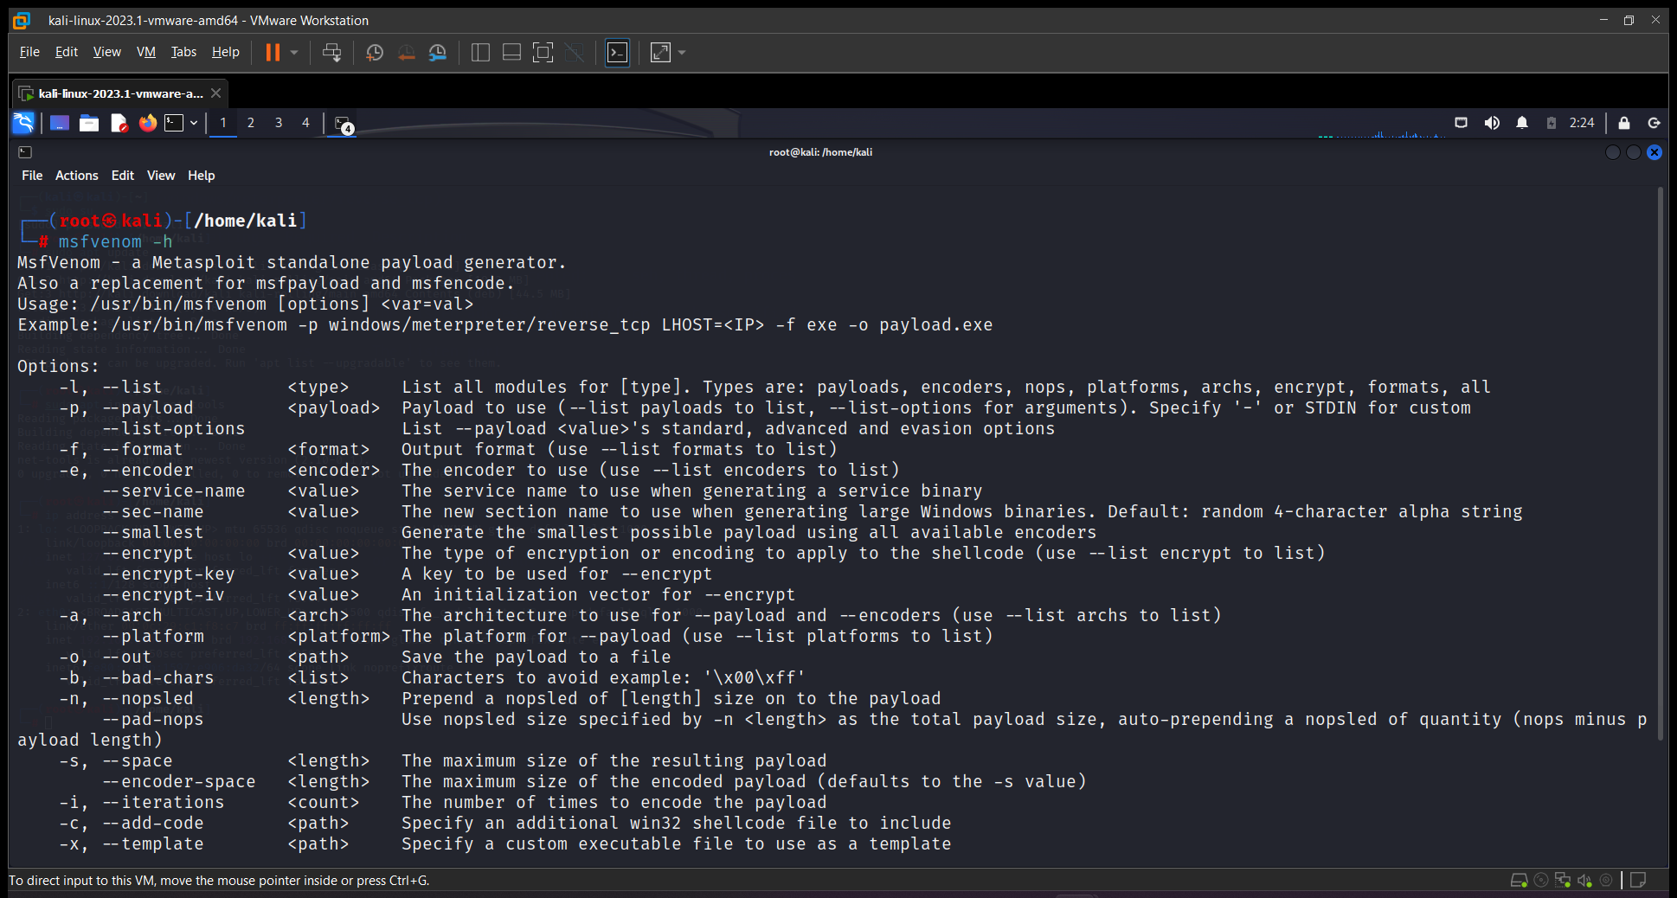

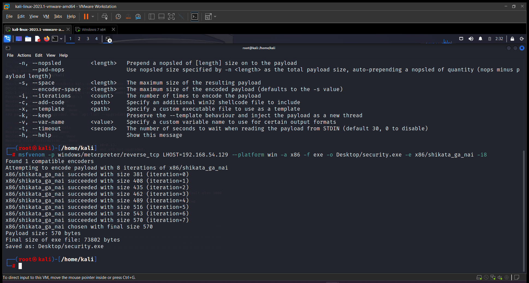

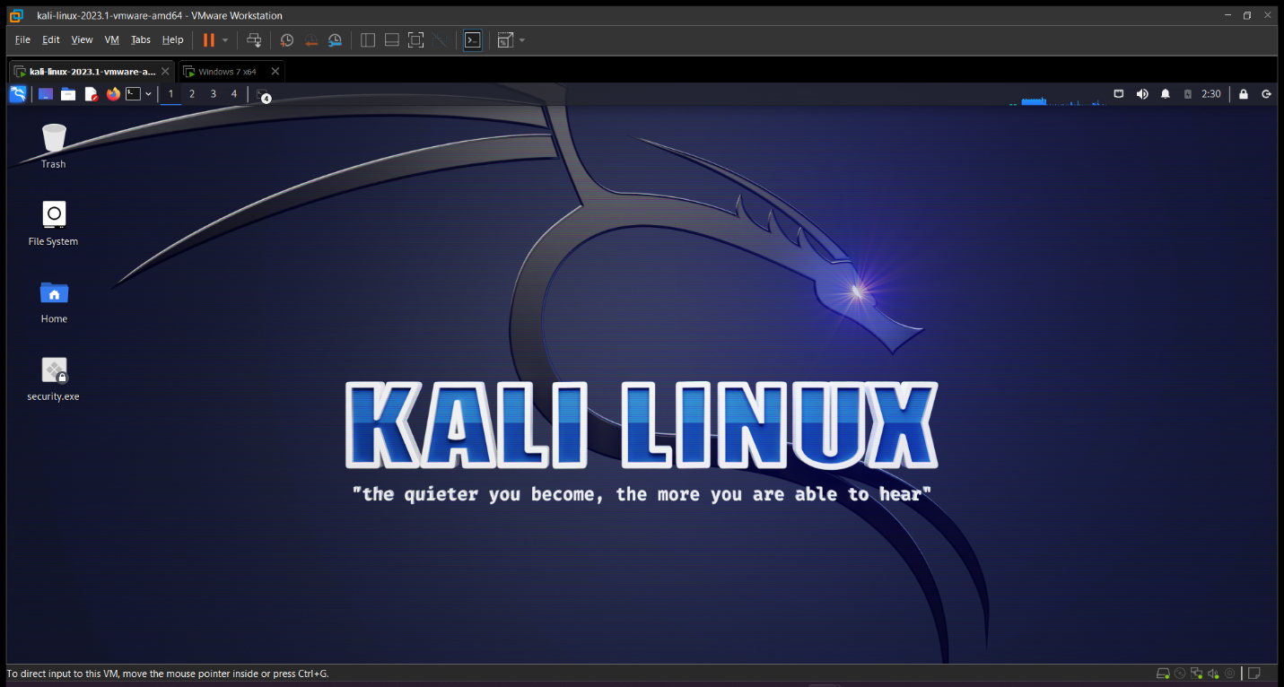

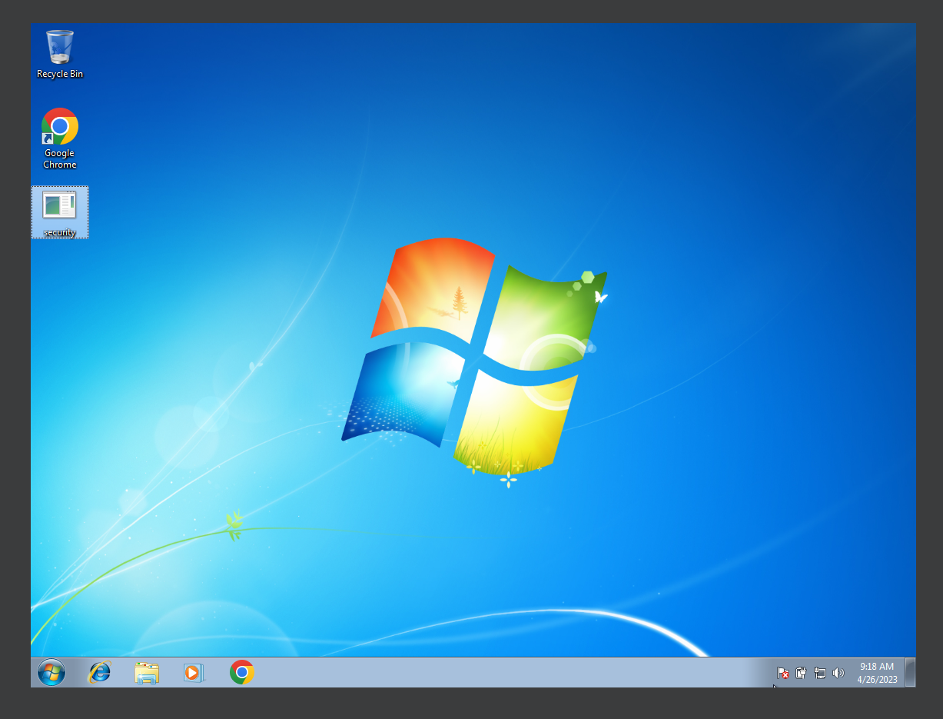

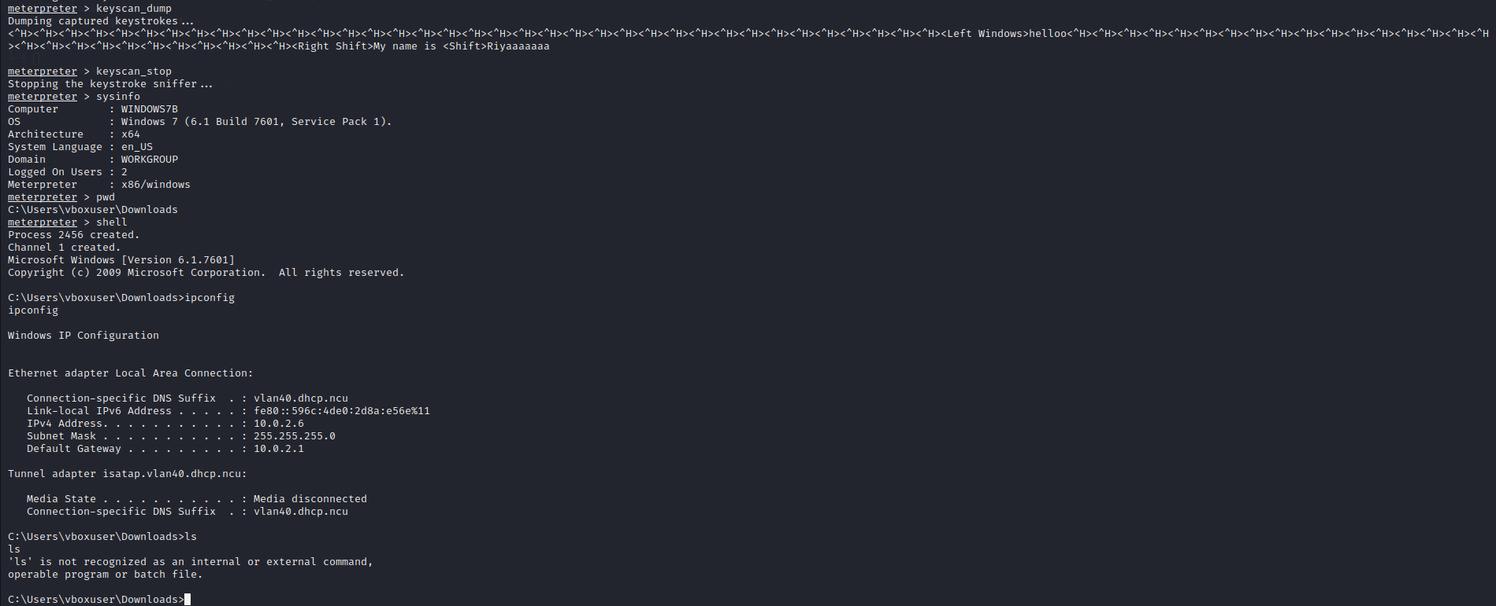

**EXPERIMENT NO. 12 (VALUE ADDED EXPERIMENT)**

|  |
| --- |
| **Student Name and Roll Number:** |
| **Semester /Section:** |
| **Link to Code:** |
| **Date:** |
| **Faculty Signature:** |
| **Marks:** |

|  |
| --- |
| **Objective:**  To familiarize the students with the concept of Fifth phase of penetration testing |
| **Outcome:**   * The students will be able to Cover tracks and post exploit the target machine |
| **Problem Statement:**  Perform steps to remove the tracks in windows and Kali Linux |
| **Background Study:**   * In the phases previous to this one the pen tester successfully managed to avoid detection by firewalls and intrusion detection systems, * The purpose of this phase is to cover up all the little clues that would give away the nature of his deeds. * There are few ways that we can cover our tracks, making it VERY difficult to track our malicious activities.   + Clear the File, events logs or clear history   + Hide the Files |
| **Question Bank:**   1. What is pivoting? 2. What is the use of getsystem command in Meterpreter script. 3. Write the command for taking screenshots of victim's machine after getting meterpreter access. 4. Write the command to clear event logs for clearing hacker's tracks. 5. What is the outcome of the follwoing command: **shred -zu root/.bash_history** |

**Student Work Area**

**Algorithm/Flowchart/Code/Sample Outputs**